Knowledge Organiser – Year 2 – PSHE/RSE
– Health and Wellbeing – What can help us grow and stay healthy?
– Being healthy: eating, drinking, playing and sleeping
What do I already know? | 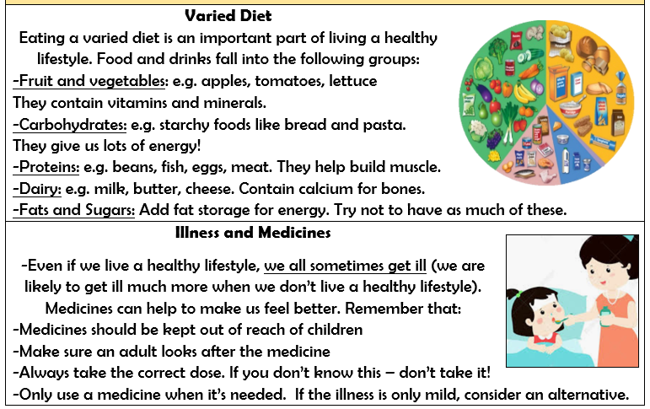  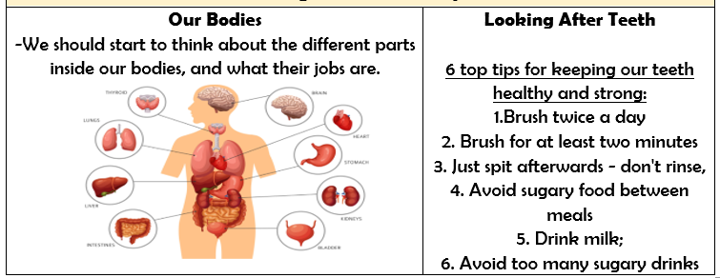
- I can name some ways to stay healthy
- I know it is important to exercise
- I know I need to clean my teeth every day
- I know I need a good night’s sleep to get the rest I need
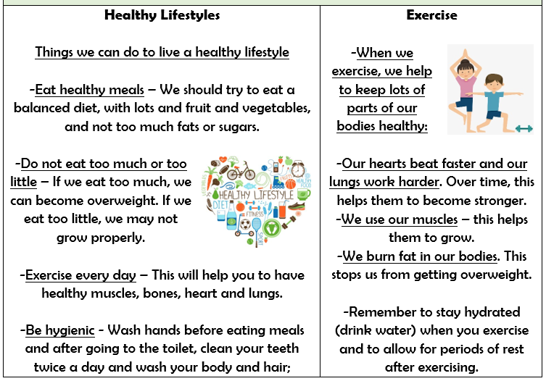

What should I be able to do at the end of the topic?
- That different things help my body to be healthy, including food and drink, physical activity, sleep and rest
- That eating and drinking too much sugar can affect my health, including dental health
- How to be physically active and how much rest and sleep I should have everyday
- That there are different ways to learn and play; how to know when to take a break from screen-time
- How sunshine helps bodies to grow and how to keep safe and well in the sun
Key Vocabulary

