Eco Knowledge Organiser Year 5/6
Energy
Three key questions
1) Where does the energy to power our home or school come from? |  |  | 2) What can we do to help reduce the need for so much energy? |  |  | 3) Is the source of energy sustainable?
Vocabulary |  |  | Issues |  |  | Solutions
Renewable  Energy  Natural  Sustainable | Not depleted with use.  Still there for use. Power.  Not made by man.  We can maintain it, keep it going. |  | 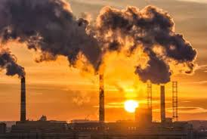  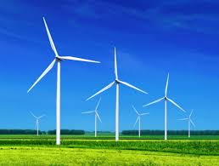  A lot of the energy we use to power the world around us is sourced from non-renewable sources. Non-renewable energy sources don’t replenish, and are formed when prehistoric plants and animals died and were gradually buried by layers of soil rock. The kind of fuel that was created varied depending on the conditions, like what kind of organic material (from plants or animals), how long it was buried, at what temperature and under what pressure. Types of non-renewable energy are natural gas, coal and oil. As a world, we should be using more renewable energy sources. Renewable energy is collected from renewable resources. A source of energy is considered renewable if it comes from natural sources or processes that are constantly replenished. Examples are solar (from the sun), wind, water, geothermal (from the earth) and biomass (from organic materials). |  |  | Until this problem is resolved globally, what can we do to reduce our energy use?  - Turn off the tap when not in use  - Turn off electrical  - Walk or ride to school  - Wear a jumper instead of putting on or turning up heating  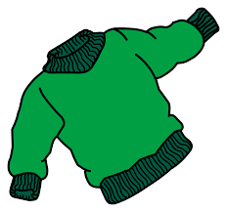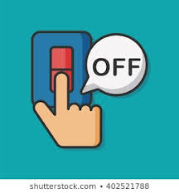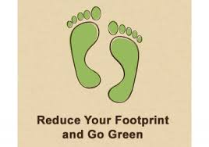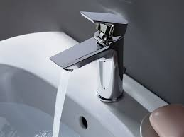
Curriculum links
English |  | Maths |  | Geography/History | Design and technology/Art and design |  | Science
Discuss and debate the use of fossil fuels and renewable energy sources  Write a persuasive letter to their head teacher encouraging them to switch to a renewable energy supplier  Write a biography on a famous figure who developed electricity  Write a balanced argument for and against wind turbines. |  | Measure and record the number of rooms at school/home that have the lights off when empty  Calculate the percentage of children who walk/cycle to school |  | Explore the different types of energy used throughout time  Locate and map the different local energy sources  Plan a trip to a renewable energy source company | Design a poster to promote a renewable energy source  Plan and design a mode of transport that uses clean energy  Create a wind turbine/water wheel |  | Compare non-renewable and renewable energy and their effects on the planet  Investigate renewable energy sources or processes  Create a variety of mechanisms to  understand how a smaller force can  have a greater effect
Whole school initiatives
Encourage walking/cycling/scooting to school Take part in ‘switch off fortnight’ Education/posters to encourage turning off lights Education/posters to encourage recycling

