Hinguar Primary School and Nursery - SECAT
Knowledge Organiser
History | Year 2 | Autumn Term |  | Topic: London
Prior Knowledge |  | Application of Knowledge
- I know that we live in the 21st Century  - I know that children played with toys a long time before I was born  - I know that London has been a city for hundreds of years  - I can use a simple timeline  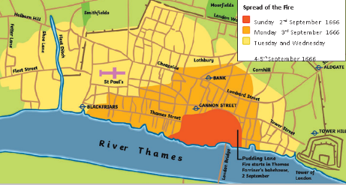 |  | - Identify things that are the same and things that are different in London 1666 and London now  - I can retell the events of the Great Fire of London in detail and in order  - Create a fact file about Samuel Pepys and why he wrote his diary and buried his cheese  - Write a diary entry and imagine I was alive and living in London during the fire  - Discuss that there are different types of evidence that can be used to help find out about the past.
What will I know by the end of this topic? |  | Key Vocabulary
What are some of the ways in which London has changed over time?  How is the way we live now different and similar to how people lived in 1666?  What were some of the key events of the  Great Fire of London?  Why did the Great Fire of London spread across the city and how was it eventually stopped?  How do we know about the Great Fire of London?  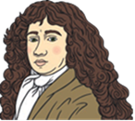  Who was Samuel Pepys and why is his diary so important?  How was London rebuilt after the Great Fire?  How can I show what I have learned about the Great Fire of London? |  | bakery | A place that makes bread, cakes, etc.
 |  | St Paul’s Cathedral | A very large church in London. A new St Paul’s Cathedral was built after the fire.
 |  | diary | A book that people write about their lives in.
 |  | firebreak | A gap that stops a fire spreading to nearby buildings.
 |  | 