If you have the book The Singing Mermaid  by Julia Donaldson please read this with your child. If not there are lots of links to the story on YouTube.  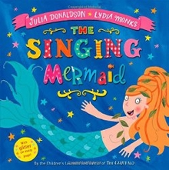 | The Singing Mermaid  * Write a character description about mermaid.  *Create a poster advertising the circus.  * Write a letter to the mermaid persuading her not to join the circus.  * If you could be a mermaid where would you swim to? Write a story about your adventures. | The Singing Mermaid  * The story mentions a number of different types of fish. Can you find out the names of any more? How are they similar / different?  * Design a new luxury tank for the singing mermaid to live in while she worked in the circus.  *Build a model of the circus tent. What materials will you need to use?
If you have the book Commotion in the Ocean by Giles Andreae please read this with your child. If not there are lots of links to the story on YouTube.  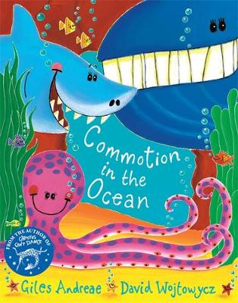 | Commotion in the Ocean  * Write your own sea creature poem. It could be about one of the creatures in the book or you could choose a different creature.  * Which is your favourite sea creature and why? Create a fact file about them.  * Imagine you have discovered a new sea creature. Give it a name and describe what it is like. | Commotion in the Ocean  * Draw and label a sea creature picture.  * Play a sea creature guessing game. Can everyone guess which sea creature you have chosen?  * Think about the sounds you might hear under the sea. How are they different/similar to the sounds you might hear at the farm or at the zoo?
Equal groups  Explore numbers to 15 to see which ones you can split into equal groups with none left over. For example the number 10 can be split into two equal groups of 5 or five equal groups of 2. Which other numbers can you split into equal groups? | Show the equal groups you found on the last challenge by making an array like this one showing four equal groups of 3  OOO  OOO  OOO  OOO | Explore double numbers. You could draw some ladybirds to help you like the one below.  Double 5  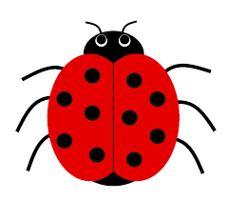
Number hunt  Numbers are all around us. They are on signs, houses, number plates, clocks,, everywhere. See if you can collect the numbers 0 50. If you have a camera you could take a picture of them as you find them. If you can’t find a number you could find your own way to show the number. | Fact families  The calculation 14 + 6 = 20 is part of a fact family. It belongs with these calculations  14 + 6 = 20 20 – 6 = 14  6 + 14 = 20 20 – 14 = 6  Explore other calculations to see if you can find their fact families. | Write down the numbers from 0 – 50 cut them up and scramble them up. How quickly can you put them back in the correct order?  Can you beat your time? Can you do it faster than other people in your house? Try putting them in order from 50 to 0.  Now try with numbers up to 100.
Number bonds to 20 challenge. Ask someone in your family to test you on your number bonds. How quickly can you find all the pairs of numbers which make 20? | Look at the numbers on a 100 square. Find all the numbers you say when you count in 2s. What do you notice about the pattern they make on the number square? How about the numbers you use when you count in 5s? Do they make the same pattern? Now try the 10s numbers. What do you notice about the tens and the 5s?

