VE day was celebrated with a street party. People decorated the street with flags and bunting. They took tables and chairs into the streets and all brought party food to share.  Design a street party invitation.  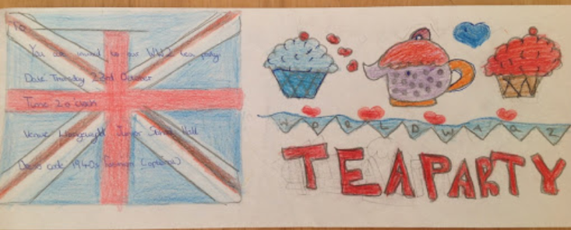 |  |  | Have a “stay at home” VE day party on Friday 8th May.  Put up your flags and wear your hat.  Have a picnic in the garden.
Queen Elizabeth will be making a VE day speech on Friday.
Design a fancy outfit for the Queen to wear.

Research VE Day and try to answer these questions:  What does VE stand for?  Why is it celebrated?  When is it celebrated?  Who was the King on VE Day?  Who was the Prime Minister on VE Day?  What makes VE Day important this year? | Make some decorations and a party hat.  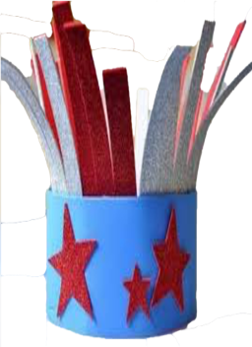
 |  |  |  |  | Bake some cakes for your VE Day party.

