Hinguar Primary School and Nursery - SECAT
Knowledge Organiser
Religious Education | Year 1 | Autumn | Big Question Who is a Christian and what do they believe?
Prior Knowledge |  | Application of Knowledge
You should know that we all have individual beliefs and that some people believe in and follow the teachings of the Bible.  Key Hinge Questions  - What do Christians believe about God?  - Why do Christians follow Jesus’ example?  - What does the Bible tell us about God?  - What does the Bible tell us about Jesus?  - How do Christians show they follow Jesus?  - Which symbols do Christians use to express ideas about God? |  | - Share stories that help to show how Christians think of God.  - Describe some of the beliefs Christians hold about God.  - Look at art and recognise some symbols and images used to express ideas about God.  - Listen to music that expresses ideas about God.  - Talk to Christians about what they believe.  - Express/reflect on own questions about God.  - Share Bible stories about the importance of Jesus.  - Explore how Christians follow teaching from the Bible to guide their own actions.
What will I know by the end of this topic? |  | Key Vocabulary
I can talk about the fact that Christians believe in God and follow the example of Jesus.  I can recognise some Christian symbols and images.  I can talk about some Christian beliefs about God and Jesus.  I can retell a story about what Christians may think about God and suggest what it means.  I can talk about issues of good and bad, right and wrong arising from stories.  I can ask questions about believing in God and offer my ideas.  I can make links between what Jesus taught and what Christians believe and do.  I can respond to a piece of Christian music and a Bible text that inspired it. |  | 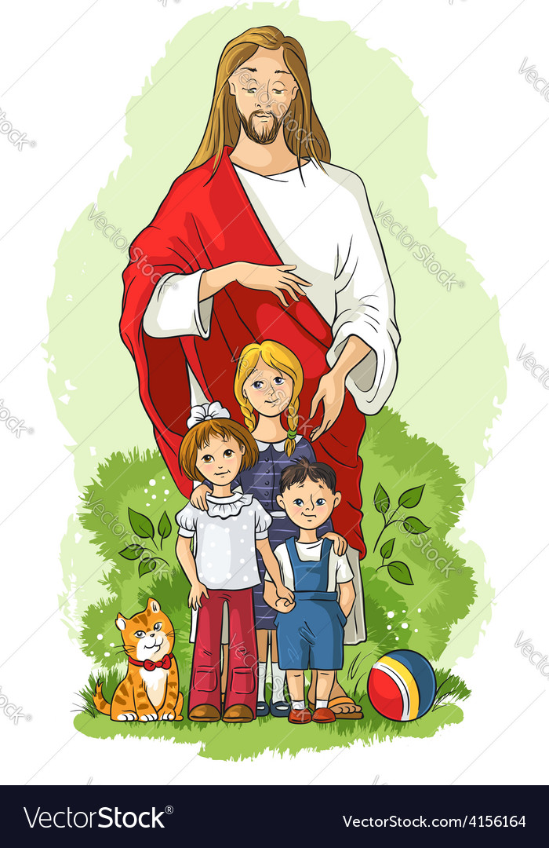  Christian |  | 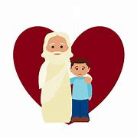  God
 |  | 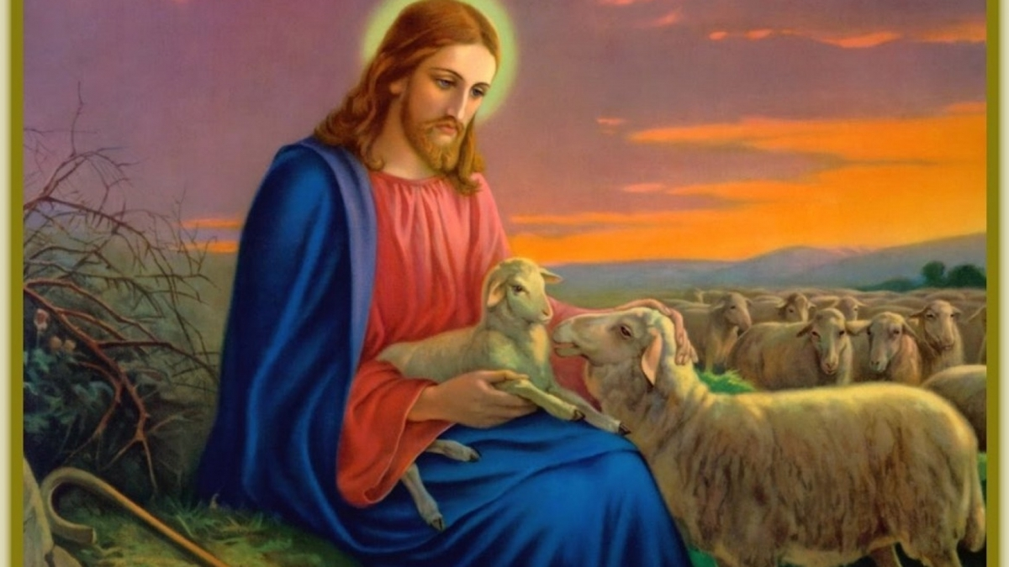  Jesus |  | 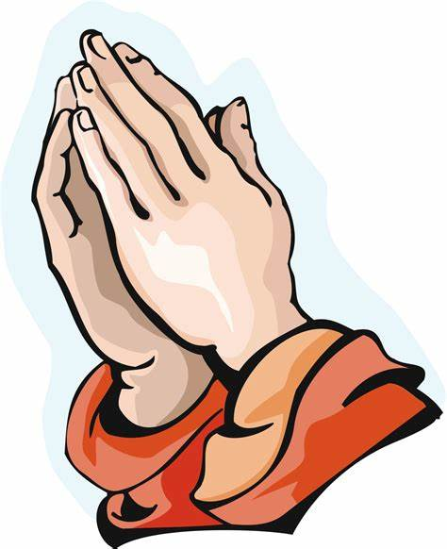  Prayer
 |  | 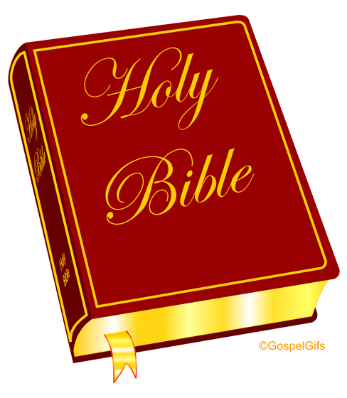  Bible |  | 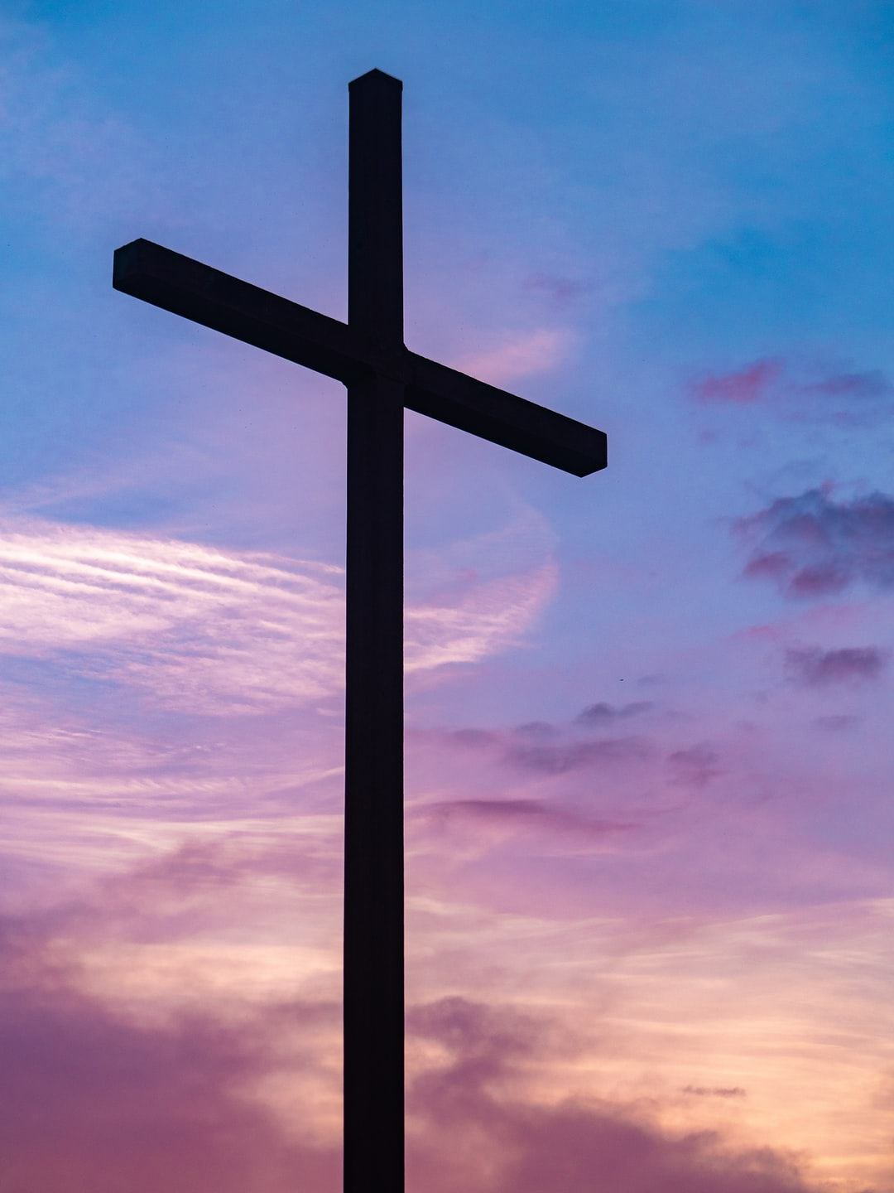  Cross

