Hinguar Primary School and Nursery - SECAT
Knowledge Organiser
Art – Flanders Field  Drawing and Collage | Year 6 | Autumn Term |  | Topic: World War II
Prior Knowledge |  | Application of Knowledge
Drawing -  - Use a variety of source material for their work.  - Work in a sustained and independent way from observation, experience and imagination.  - Show awareness of form within observed work.  - Explore the potential properties of the visual elements, line, tone, pattern, texture, colour and shape to embody ideas and serve their needs.  Collage -  - Textiles Develop skills of stitching-blanket stitch  - Join fabrics in different ways, including stitching.  - Use different grades and uses of threads and needles.  - Collage Use a range of media to create collage.  Key Hinge Questions  - How do you feel when looking at Flanders Field inspired artwork?  - How could you produce your own Flanders Field inspired artwork?  - What did you like about your artwork?  - How can you improve your artwork? |  | 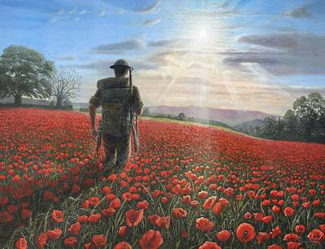  Drawing -  - Demonstrate a wide variety of ways to make different marks with dry and wet media.  - Identify artists who have worked in a similar way to their own work.  - Manipulate and experiment with the elements of art: line, tone, pattern, texture, form, space, colour and shape to embody ideas and serve their needs.  Collage -  - Describe varied techniques.  - Be familiar with layering prints.  - Be confident with printing on paper and fabric.  - Alter and modify work.  - Work relatively independently.
What will I know by the end of this topic? |  | Key Vocabulary
How to draw with wet and dry media.  Manipulate and experiment with drawing techniques.  Produce a collage using varied techniques.  How to use a variety of tools to produce required artwork.  How to review what they and others have done and say what they think and feel about it. |  | Line | A line is a mark made on a surface that joins different points. Lines can vary in length, width, direction and shape.
 |  | Tone | The relative lightness or darkness of a colour. Tone can also mean the colour itself.
 |  | Form | In relation to art the term form has two meanings: it can refer to the overall form taken by the work – its physical nature; or within a work of art it can refer to the element of shape among the various elements that make up a work.
 |  | Value | The brightness of colour.

