Year Six: Home Learning Grid for 29th June 2020

If you can use a computer or get online then:
- Log onto www.whiterosemaths.com and explore the Year 6 Home Learning

- Log onto www.purplemash.co.uk new tasks have been set for you.

- Log onto www.mymaths.co.uk - work will be updated regularly

- Practise your Times tables daily – you can find our Five Minute Frenzies on www.mathsdrills.com

- Try out the website www.Coolmathsgames.com

Have a go at some of these problem solving tasks below, you might have to think about it!
Gurmit paid £21 for five presents  For A and B he paid a total of £6.  For B and C he paid a total of £10.  For C and D he paid a total of £7.  For D and E he paid a total of £9.  How much did Gurmit pay for each present? | Time  If you have a digital clock, try to write the time in an analogue way, if you have an analogue clock, write the time digitally or on the 24 hour clock. Check the time together at regular intervals.  Calculate how many hours you spend in bed in a week?  Who sleeps the most in your house?  Have you found out what time your new school starts in September? How long does your journey take and what time will you need to leave your house to get there on time?  How many days did you spend at Hinguar Primary School?
Age old problems  1. My age this year is a multiple of 8.  Next year it will be a multiple of 7.  How old am I?  2. Last year my age was a square number.  Next year it will be a cube number.  How old am I?  How long must I wait until my age is both  a square number and a cube?  3. My Mum was 27 when I was born.  8 years ago she was twice as old  as I shall be in 5 years’ time.  How old am I now? | Anyone for tennis?  Two boys and two girls can play tennis.  Ali said: ‘I will only play if Holly plays.’  Holly said: ‘I won’t play if Ben is playing.’  Ben said: ‘I won’t play if Luke or Laura plays.’  Luke said: ‘I will only play if Zoe plays.’  Zoe said: ‘I don’t mind who I play with.’  Which two boys and which two girls play tennis?
PE
Make sure you continue to exercise every day even of you don’t feel like it! Try a new sport maybe yoga or tennis. Wimbledon would normally be starting in July, have a game of tennis with a family member or friend (socially distancing). Do you know how many years Wimbledon has been on? Do you have a favourite player? What are the rules for tennis?

Story starter!
Three weeks. That is how long the ship had been like this; empty, abandoned, alone…
Now, all was still. All was calm. The ship lay there, as if in a peaceful slumber, gently rocking like a baby’s cradle in the tranquil bay. The sea barely moved. It was covered in a thin layer of wispy mist that sat on top of the water like a comforting blanket, gently illuminated by the fading sunlight.
A bird landed gently on the mast of the lonely ship, pleased to have found a resting place after a long journey.
Everything seemed to have turned blood-red. The sun looked down on the bay from his position in the sky, soon to go to sleep himself, casting a crimson light over the clouds and the milky water in the bay.
What had happened here? Why was it so peaceful? Had it always been so?
Can you tell the story of the shipwreck, describing how it happened? Think about where the crew are now…Are they safe or in danger?
You could write the story from the perspective of one of the crew, or you could write as the bird sitting on the mast.

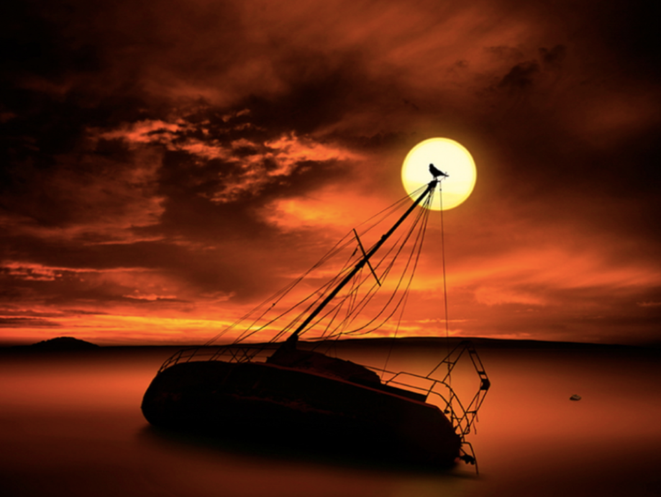

Question time!
What colour is the sea? Is it blue?
Why is this sea not blue?
Where have the crew gone?
How long has the ship been like this?
What’s the difference between a sea and an ocean? Is there a difference?
What’s the difference between a lake and an ocean?
If a millionaire is shipwrecked on an island, are they still a millionaire?

Sentence challenge!
Personification is when you give human qualities to an object or animal. It adds interest or understanding to a poem or story.
E.g. Lightning danced across the sky.
The wind howled in the night.
Can you use personification in your writing? Can you find any personification in my writing?

Perfect picture!
Think about how the ship became shipwrecked. Could you draw the scene? Could you describe it?

Become an Author  How would you like to write a story for a younger pupil at Hinguar? Whilst you can’t be in school your story could be!  If you would like to write a short story that would be suitable for Reception or Year 1 (5-6 year olds) and send it in to hlearning@hinguar.southend.sch.uk We will pass your stories on to the Teachers and they will read them to the class.  We would love to read your stories.  Think about children’s authors for that age Julia Donaldson wrote The Gruffalo, Room on the Broom, she uses rhyme and humour. What would you use to engage a young child? Don’t forget to use pictures as well. We look forward to reading your stories. |  |  |  | Memories at Hinguar  Write about a few of your favourite memories whilst you have been at Hinguar. You could write it as a poem or a song even.  What has been your favourite time or your funniest? Try and be descriptive in your writing.  Was it performing in Hinguar’s Got Talent or Annie or Beauty and the Beast?  Or the residential trips you have been on?  Was it becoming a prefect or your year 6 job?  Was it just a really fun lesson you had where you all enjoyed it?  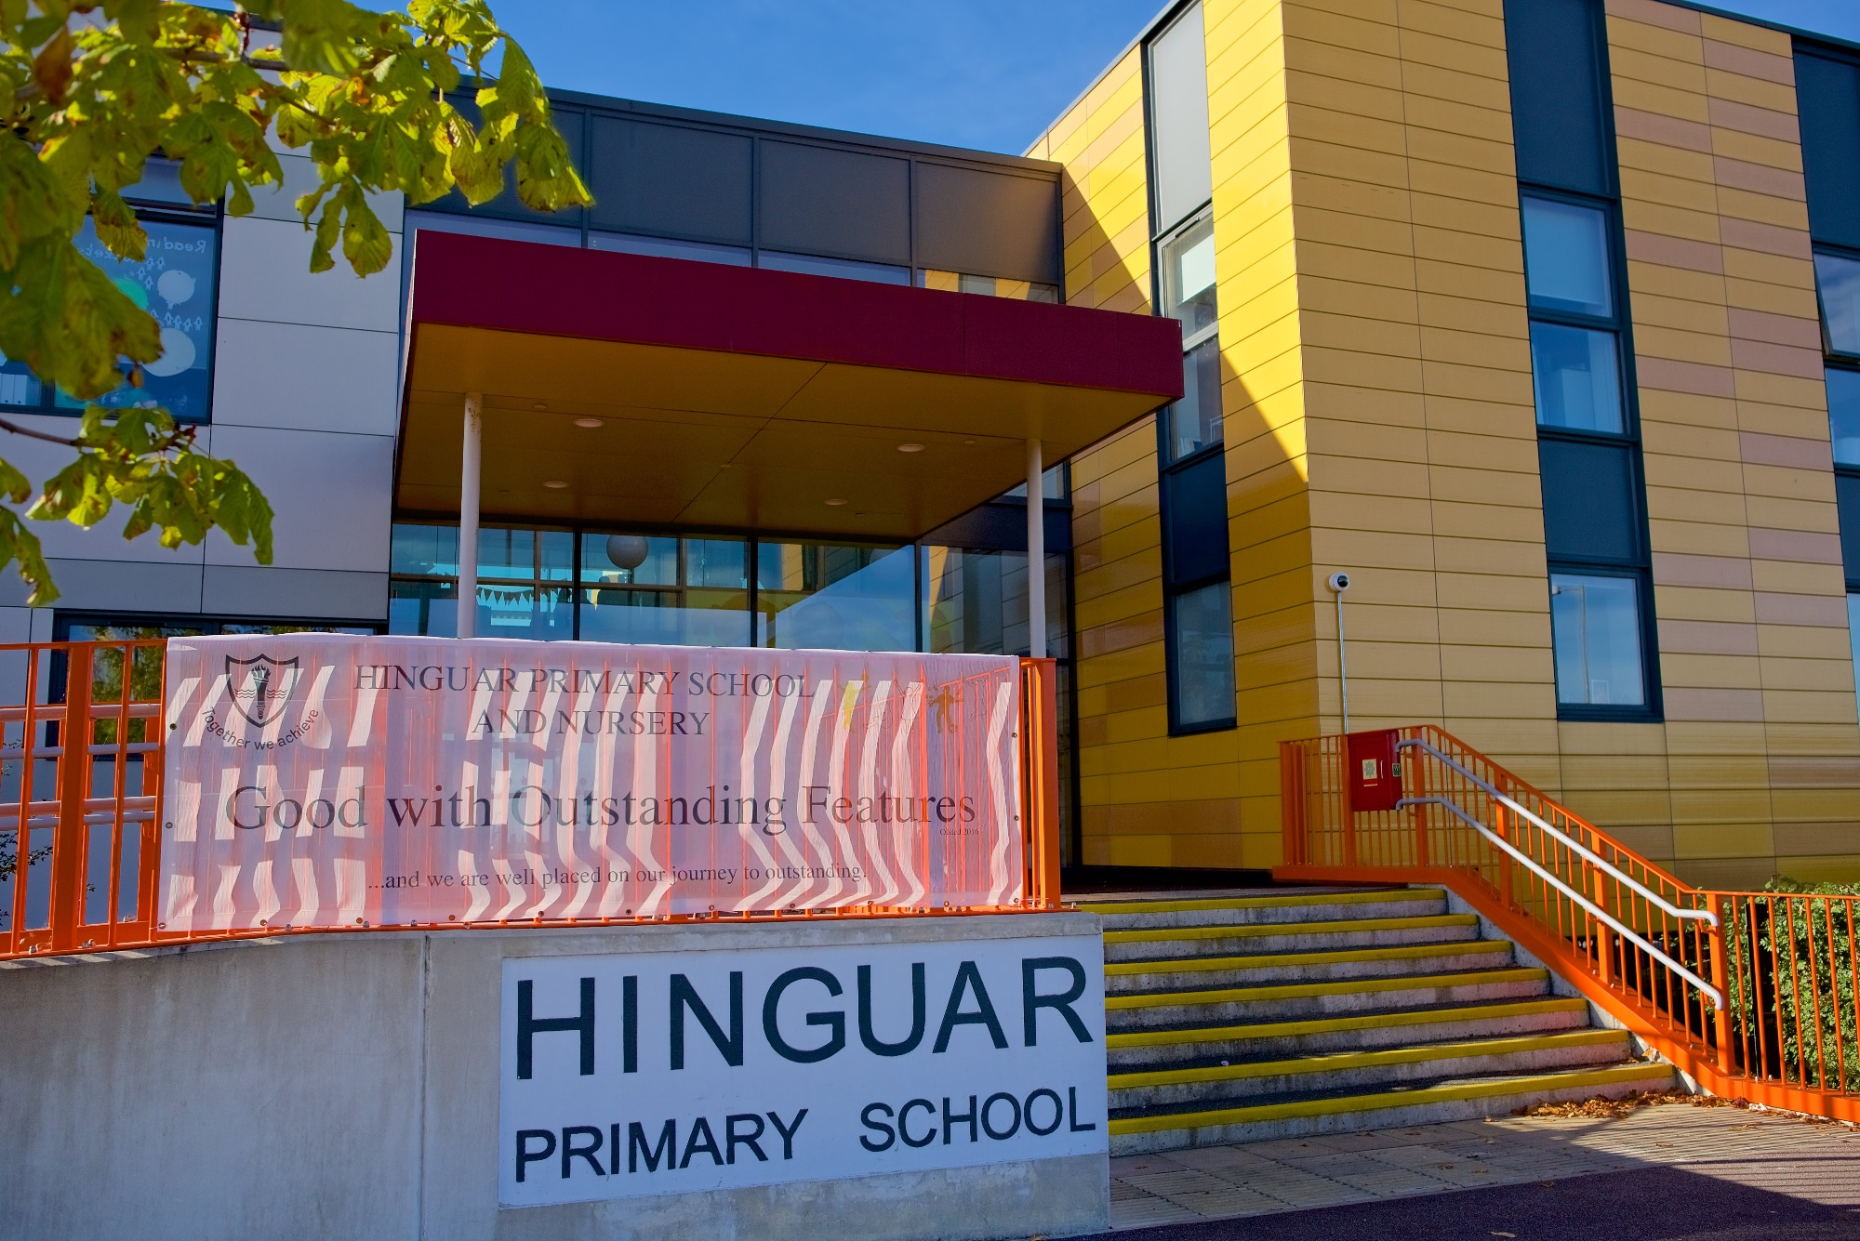
PSHE
British Red Cross have created a great website that has a series of lessons/ ideas to help with learning first aid
They say:
‘When you help someone with first aid, you are being kind. Children and young people can understand the importance of being kind by learning some simple first aid skills that could help save a life.
When we are injured or suddenly unwell, we would like someone to help us. Help children and young people gain the skills, confidence and willingness to act when someone needs first aid. This is an important part of building resilience and empowering us to look after others in our communities.’
All the activities can be used with our new First aid champions learning site which offers tailored learning to primary and secondary students
https://www.redcross.org.uk/get-involved/teaching-resources/first-aid-and-kindness
If you can’t access the website a PDF version will be attached for you.
Art  This is a great website from the Tate museum, where you can look at different Art and artists and it gives you loads of nice ideas to try  https://www.tate.org.uk/kids/make/paint-draw/make-wave-painting  The one above is done at the beach! A nice excuse to go to the seaside. |  | Science  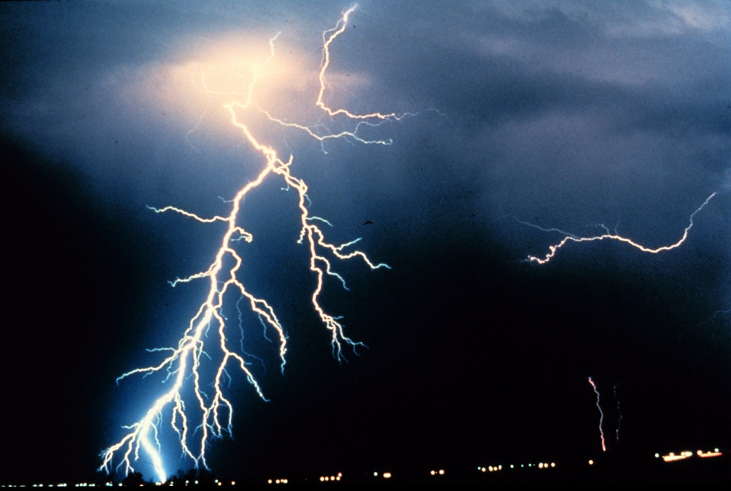  Electricity  - Write down everything you know about  electricity.  - Who invented electricity? When was this?  - Make a list of all things electrical in your home. Create a table to decide if they use batteries or are run off the mains?  - How many plugs do you have in your house?  - Where is your electric meter?  - What is it measured in?  - How much do you use a day?  - Try and spend a day without using electricity is this possible?  - Can you think of ways to save electricity?  - Make a poster showing what electricity is
Spellings
Learn 10 each week. Can you make a word search using your spellings? Why not ask a family member to complete it.
Groups 2 and 3  w/ b 29/6/2020  - produce  - present  - reason  - silence  - support  - transport  - surprise  - scratch  - freeze  - balance | Group 1  w/ b 29/6/2020  - caught  - taught  - autumn  - cause  - applaud  - naughty  - daughter  - clause  - astronaut  - author |  | Groups 2 and 3  w/ b 7/7/2020  - shoulder  - smoulder  - mould  - poultry  - soul  - shallow  - window  - blown  - known  - thrown |  | Group 1  w/ b 7/7/2020  - inaccurate  - inactive  - indefinite  - infinite  - incorrect  - insecure  - incomplete  - inedible  - inability  - indecisive

