Hinguar Primary School and Nursery - SECAT
Knowledge Organiser
Religious Education | Reception | Autumn | Big Question Which people are special and why?
Prior Knowledge |  | Application of Knowledge
Almost all of us have someone in our lives who is special to us. Some of us have many special people. We each have our own special qualities which make us unique.  Key Hinge Questions  - Who is special to you and why?  - What is a good friend like?  - How can you show that you are a good friend?  - What stories did Jesus tell about being a friend and caring for others?  - What stories do special people tell in other religions? |  | - Talk about people who are special to us.  - Meet special people who help us and ask them questions (People who help us)  - Meet a person from a religious faith  - Discuss the benefits and responsibilities of friendship  - Tell stories from the Bible about friendship  - Discuss stories of a key religious leader from another religion
 |  | Special People
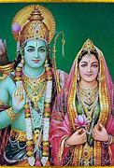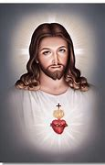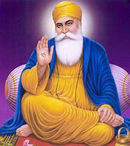
Rama and Sita Jesus Christ Guru Nanak

What will I know by the end of this topic? |  | Key Vocabulary
I can talk about people who are special to me.  I can say what makes my family and friends special to me.  I can identify some of the qualities of a good friend.  I can reflect on the question ‘Am I a good friend?’  I can talk about a story of Jesus as a friend.  I can recall stories about special people in other religions. |  | Family  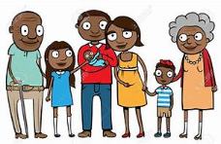 |  | Friends
 |  | Helping  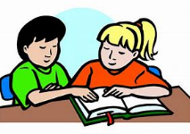 |  | Kindness  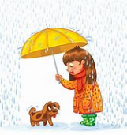
 |  | People Who Help Us  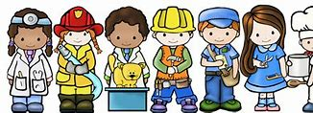 |  | Caring

