Eco Knowledge Organiser EYFS N/R
School Grounds
Three key questions
- Why is important to have good school grounds? |  |  |  | - How can we look after our school grounds? |  |  |  |  |  | - How environmentally friendly are our school grounds?
Vocabulary |  |  |  | Issues |  |  |  |  |  | Solutions
Environment  Inhabit  School grounds  Allotment | The world around us  Where they live  The place/area where the school  is including the playground and wildlife garden.  A plot of land for growing plants, vegetables, flowers, herbs and fruit. |  |  | Children today spend less than half the time playing outdoors that their parents did and are less likely to spend time outdoors at school.  They are growing up in an increasingly indoor and virtual world, ever more divorced from the real world around them.  This has a significant impact on their physical health, emotional wellbeing, social competence and their connection with the natural world and their local communities.  One of the best places for children to enjoy the outdoors, learn about the natural world and take vigorous exercise on a regular basis is in the school grounds.  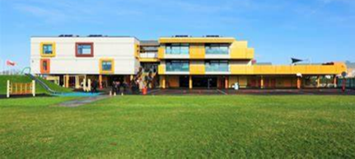 |  |  |  |  |  | We can look after the plants and animals that inhabit our school grounds.  We use the correct recycle bins.  We can make our playground look friendly.  We can treat our equipment with respect.  We can work with others to develop our school grounds  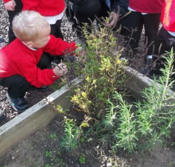  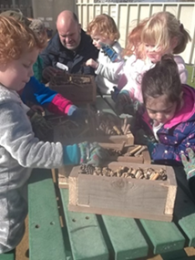  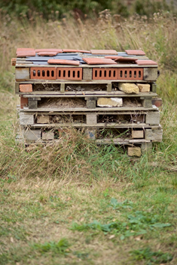
Curriculum links
PSED |  | Communication and language |  |  |  | Physical |  | Literacy | Mathematics |  |  | Understanding the world | Expressive art and design
Making relationships  Self-confidence and self-awareness  Managing feelings and behaviour |  |  | Listening and attention  Understanding  Speaking |  |  | Moving and handling  Health and self-care | Reading  Writing |  | Numbers  Shape, space and measure |  |  | People and communities  The world  Technology | Exploring and using media and materials  Being Imaginative
Chracteristics of effective learning
Playing and exploring – engagement |  |  |  |  | Active learning – motivation |  |  |  |  |  | Creating and thinking critically – thinking
Whole school initiatives
* School garden/wildlife area * Bug hotel/bird boxes/bird watching *Recycle bins *Pirate ship and Adventure trail
* Allotment *Swimming pool *Involvement of the whole school in the above * Work with Essex Wildlife Trust

