Knowledge Organiser – Year 4 – PSHE/RSE
– Health and Wellbeing – What strengths, skills and interests do we have?
– Self-esteem: self-worth; personal qualities; goal setting; managing set backs
What do I already know? | 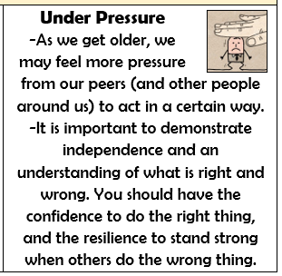  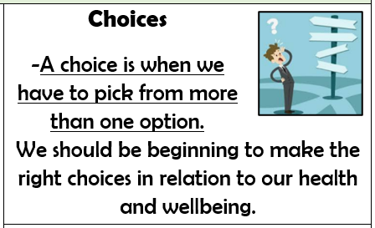
- Learning is how we learn to do new things, and it is not always easy.
- To be at our best, we should try to live healthily, understand our bodies, and help ourselves and one another.
- Everyone is good at something. We should understand what our talents are, and also list some things that we can improve upon.
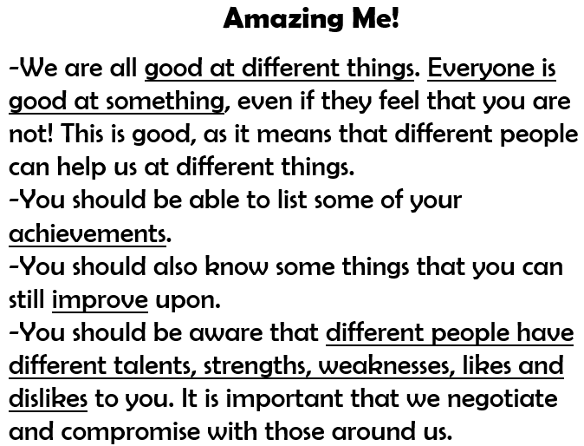

What should I be able to do at the end of the topic?
- How to recognise personal qualities and individuality
- To develop self-worth by identifying positive things about myself and my achievements
- How my personal attributes, strengths, skills and interest contribute to my self-esteem
- How to set goals for myself
- How to manage when there are set-backs, learn from mistakes and reframe unhelpful thinking
 | Key Vocabulary

