Eco Knowledge Organiser Year 1/2
Transport
Three key questions
1) How do we travel to school? |  |  | 2) What effect does our commute have on the environment? |  |  | 3) How is our food transported to us?
Vocabulary |  |  | Issues |  |  | Solutions
Pollution  Environment  Commute  Transport | A substance contaminating the  environment/air around us.  The surroundings in which with live and operate.  To travel some distance between two places – e.g., home and school.  To take or carry from one place to another by means of vehicle. |  | Many families travel to school by car, this causes many problems.  - It adds to the pollution in the air with many families travelling by car;  - It is unhealthy to travel by car as opposed to walking, cycling etc.;  - Lots of cars creates lots of traffic around the school grounds;  - Lots of cars on the roads around school cause the surrounding roads to  become more dangerous especially when cars are mounting the curb to  drop off children at school.  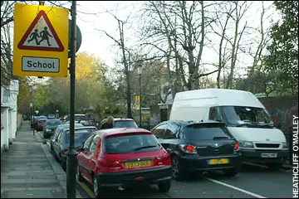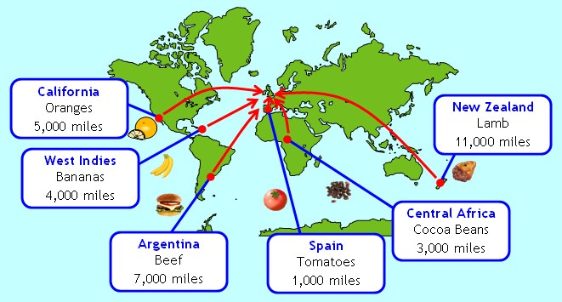  Some of the food we buy comes from very far away; we must think of the journey of our food and is it good for the environment? |  |  | We could walk, cycle or scoot to school as much as possible. If that is not possible, we could use public transport or car share. Another alternative is ‘park and stride’ where we can park the car further away from school in order to reduce traffic within the roads directly  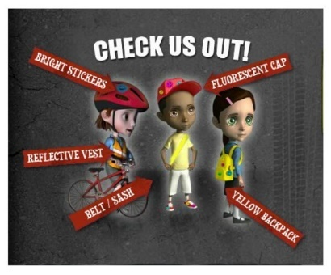  surrounding our school and also give ourselves some exercise in the meantime.  We can minimise how far our food has to travel by buying from local farmers and producers or buying fair trade food.
Curriculum links
English |  | Maths |  | Geography | Design and technology/Art and Design |  | Science
Make a poster about walking/cycling to school |  | Measure a commute to school in hours and minutes  Compare how long it takes for pupils to commute to school using various modes of transport  Collect and compare data on how pupils commute to school |  | Using a map explore different ways to get to school | Design a mode of transport that uses clean energy  Use large outdoor crates to create a mode of transport sculpture  Design a poster to promote the reduction of speed by vehicles outside of schools |  | Investigate how transport can pose a danger to living things  Explore reflective clothing and fluorescent lights
Whole school initiatives
* Golden lock competition *On site bike sheds *Bikeability training *Awareness assemblies *Road safety topic

