We hope our children and families are keeping safe and well in this unprecedented time. Thank you for your continued support and kind wishes.  Together We Achieve  Don’t forget MyMaths and Spag.com have been set for you and we will be updating them regularly. | Year 3 and 4 Homework Grid Summer Term 2020 | A reminder about some ideas to help at home, if and when needed.  9.00 Joe Wicks daily work out on YouTube (family exercise)  David Walliams has stories to listen to on https://www.worldofdavidwalliams.com/watch-and-listen/  You may also know that audible books are being released free. https://stories.audible.com/start-listen  https://whiterosemaths.com/ free daily lessons (This is the scheme of work we use for maths)  Themathsfactor.com is offering free Maths resources too.  Corbettmathsprimary.com has daily short maths questions in increasing difficulty from Bronze to Platinum.
English Writing -   | 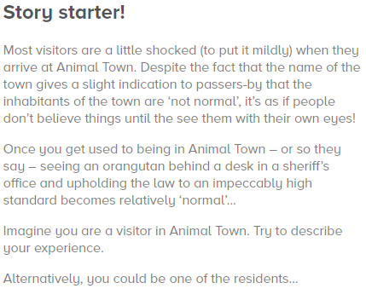 | Sentence challenge  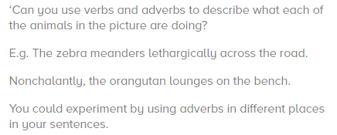
English Writing -   | 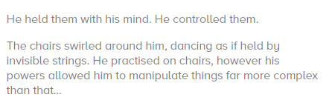  Can you continue the story? | Question time!  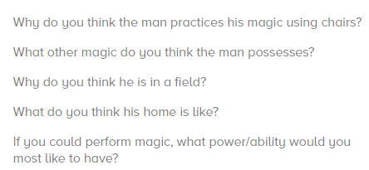
My Maths tasks are regularly updated.  Easter Maths Word Problems  1.Hattie’s Easter basket holds 50 eggs. How many baskets will she need to hold 650?  Extension:  Give them different amounts to practise with when doing these tasks.  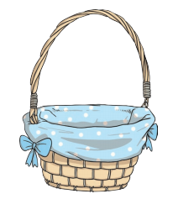 | 2.  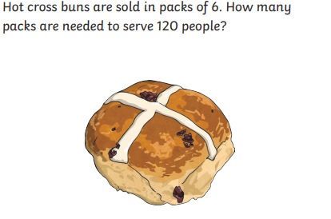 | 3.  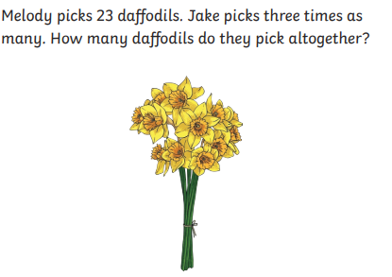
4.  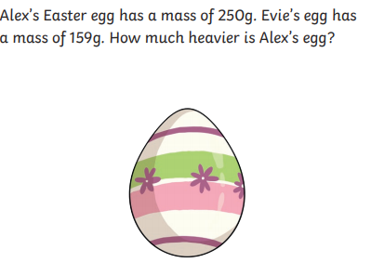 | 5.  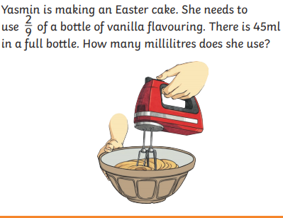 | 6.  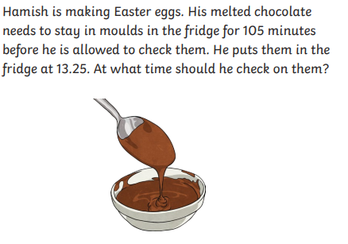
Creative Tasks (Art, DT, Food)  Can you create an amazing Easter egg/bonnet/decoration using any crafts, materials or Lego you have at home? | Can you create a board game to play with your family. Play some first to get some ideas. No cheating though! | Can you help prepare a meal with your family? Or do some baking together? Write out the recipe (English instructional writing) and measure out the ingredients (Maths – conversion and weight)
Easter Maths Problems answers
1. 13 4. 91g
2. 20 5. 10 ml
3.92 6. 15:10

