Hello Seahorse Class! We hope you are all safe and well. We are missing seeing your happy smiley faces at school but we hope to see you all soon. We hope you are enjoying being at home with your grown ups, and that you are helping out with jobs at home as well as lots of playing! The activities listed below are possible home learning tasks. Please feel free to email school if you need anything we will answer as soon as we can. Best wishes, Mrs Hawkridge and Mrs Newman
Research a country – can you find the country on a world map? How long does it take to travel to this country and what transport could you use to get there?  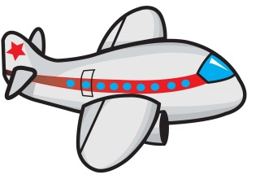 | Research a country – Can you draw this country’s flag? Or cook a traditional dish?  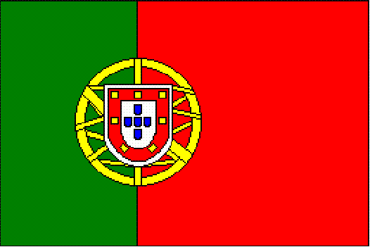 | Research a country – Can you learn to say hello, goodbye or count to 10 in the spoken language of your chosen country?  Hola!
Draw a picture of your favourite things to do at the seaside and label the picture.  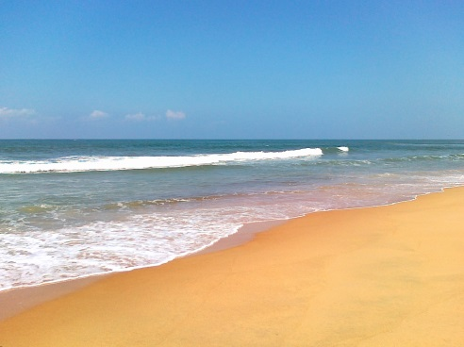 |   Please read/share a story 5 times a week. This can be recorded in your reading record. Key questions can include: What do you think will happen next? How is the character feeling? | Practice counting up and down in 2’s, 5’s and 10’s  2 5 10
Go on a 3d shape hunt around your home and write down what shapes you find.   | Discussion time – Talk about a favourite trip, why you enjoyed going on that trip, where would you travel to if you could go anywhere?  ? | Continue to use Education City and encourage your child to use technology around the home.

