Maths  If you can use a computer or get online then:  - Log onto www.whiterosemaths.com and explore the Year 5 Home Learning  - Log onto www.MyMath.coms - work will be updated regularly.  - Practise your Times tables daily – you can find our Five Minute Frenzies on www.mathsdrills.com  - Try out the website www.Coolmathsgames.com  Roll a dice to create a 3-digit number multiplied by 2-digit multiplication question. Work out the calculation. Repeat 6 times.  Can you use the digits 1-9 to create a 3-digit multiplied by a 2-digit question that will give you an answer nearest to 10 000? You can use the digits more than once. How close can you get if you only use each digit once? | English  Every day practise writing different Alan Peat sentences from the attached PDF of the posters we have in our class.    Look at this picture. Who is this?  What is he holding?  What is he about to do?  Write a short story describing this character  and where he is from.  Above the looming clouds the almighty God rose  with a terrifying bang.....  As quick as a flash the dark thunderous sky lit up......  Listen to this Greek Myth Persophone and Haydes, part one and part two. Write the last part, what do you think will happen? When you have finished writing your story, listen to it and compare to your own.  https://www.bbc.co.uk/teach/school-radio/ks2-primary-history-ancient-greece-persephone-and-hades/z4qvpg8  Watch the film Hercules, write a character description of Hercules.  Write an explanation about what your 3d Greek landmark is (See DT task).  Write a comic strip in the style of a Greek myth.  Write a poem or song or rap about something you enjoy.  Write a postcard or letter to a friend telling them what you have been up to, try and include your Alan Peat sentences when writing it. If you know their address you could post the letter and they might even write back to you.
PE

Make sure you exercise at least 30 minutes every day, either go for a walk or try Joe Wicks workout, or play tennis or football outside with your family. Exercise makes you feel happy and keeps you fit.

Obstacle Course
Can you make an obstacle course in your garden using objects already there? Challenge your family members to take part, time them to see who can complete it in the quickest time.

Year 5 – Summer Term Home Learning Pack: the tasks below are homework activities for your child to complete
while the school is closed. They should aim to spend some time every day working on one piece of work

Well Being  https://www.bbc.co.uk/cbeebies/joinin/seven-techniques-for-helping-kids-keep-calm  Are you feeling a bit fed up or bored or maybe angry at times? That’s ok it is a difficult time and it is ok to be going through lots of different emotions. Cbeebies have some different activities you can try for relaxing to help you calm down, if you are feeling stressed or anxious.  One is to could spot. Lie on a blanket or the grass and look up at the clouds can you make different shapes what can you see?   | Reading/GPaS  Read to someone at home and ask them to sign your reading record book at least 5 times a week.  Read to yourself for half an hour every day – you can read anything you like but sticking to a book will probably be more interesting!  Try reading some Greek Myths if you can find some.  Re-read a book you loved and recommend it to a friend.  If you can use a computer or get online the log onto www.spag.com regularly.
Outdoor Learning  Nature Sculptures  Be inspired by artists such as Andy Goldsworthy and create sculptures outside using purely natural material. Can you build a stick tower that can hold a rock the size of your fist? Make a sculpture using only leaves.  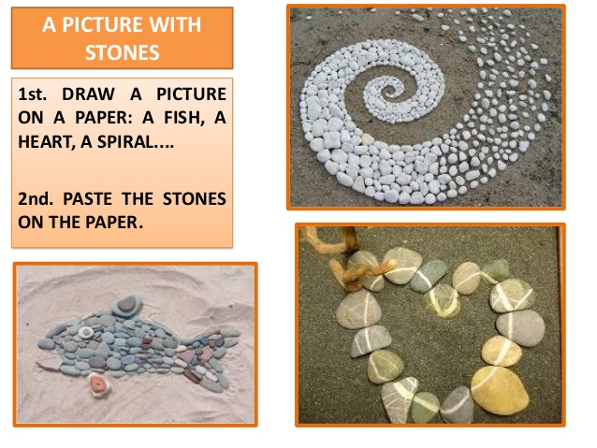 | Ancient Greeks  DT  Create a 3d model of an ancient Greek landmark.  History  Research where and when the Ancient Greek civilisation existed.  Use the link below to order these events in a chronological order or create your own timeline.  https://www.twinkl.co.uk/resource/t2-h-4421-ancient-greece-timeline-ordering-activity  Research the origins of the Olympic games and how the legacy still lives on in our modern Olympic games. Create a fact file to show your findings.  Draw a picture of what they used to look like.
Science
Tree ID
Develop a greater understanding of your natural environment. Take a walk to a local park, can you name the plants and trees growing there. How could you identify a particular tree?
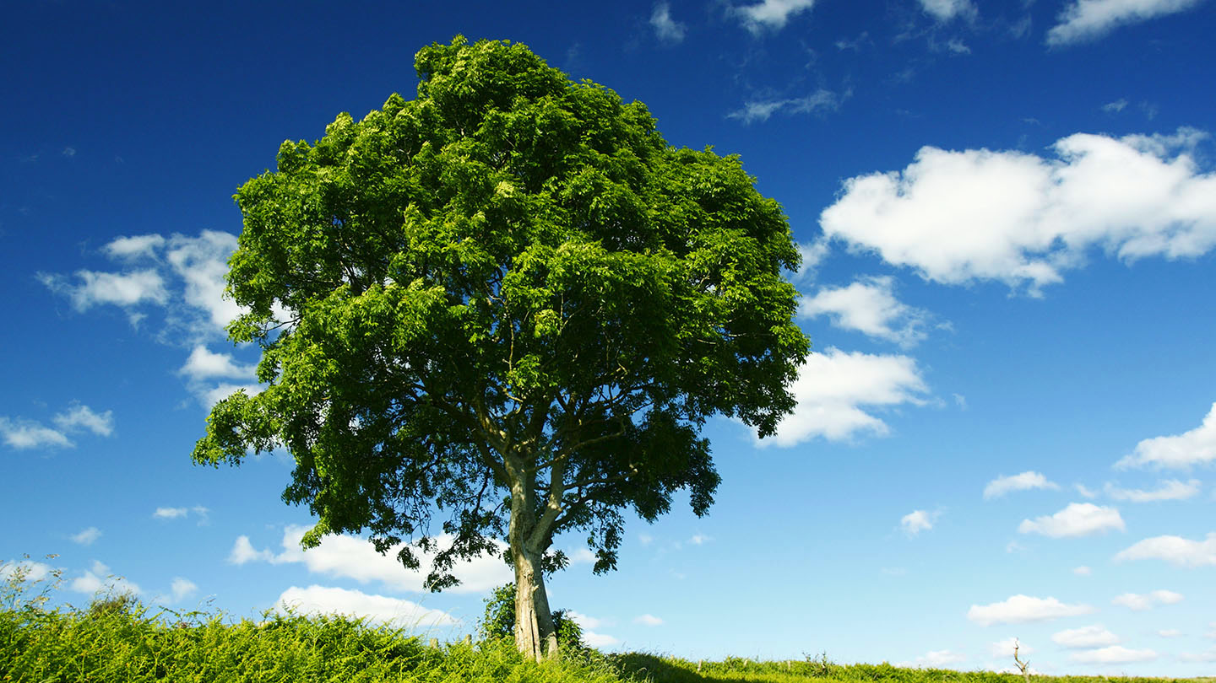

Equipment
-notepad
-magnifying glass
-crayons or pencils

Key Questions
Which tree has the smallest leaf? Which has the largest? Which tree is the most popular?
What kind of habitat do your trees provide?

What to do
- Use your sense of touch to investigate a tree checking it is safe first.
- Feel the bark is it rough or smooth? Can you notice a pattern? Create a bark rubbing to add to a journal containing your tree ID information. Do you know how to tell how old a tree is? Can you find out and record its age.
- Collect a leaf carefully, from the same tree. If possible find a leaf the tree has shed to avoid damaging the tree. Draw around it to record its outline. Does it have smooth or sharp edges? How are the leaves arranged around the stem?
- Make notes on the colour of the leaf. Add to your Tree ID in different seasons to create a comparison.
- Gather measurements so you can compare the leaves of different trees.
- What is the texture of the leaf? Is it smooth or rough? Soft or waxy? Try a leaf rubbing to record texture.
- Once your Tree ID is filled with information. Create a journal to collate the information of different trees.

https://www.woodlandtrust.org.uk/trees-woods-and-wildlife/british-trees/a-z-of-british-trees/
Use the link above if you need help identifying the trees.

The Ancient Greek Number System
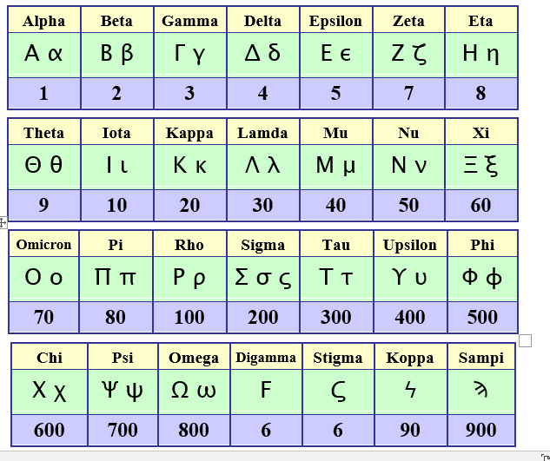
Can you use the Ancient Greek number system to write:

1. How many days we have been in lockdown?
2. How many houses down your road?
3. The number 378
4. How many days there are in June?
5. The ages of everyone in your family.

Finally, try doing ten arithmetic problems using this system. Why is this a difficult task?

