Year Six: Home Learning Grid for 15th June 2020

1. Circle the time that is 30 minutes before midnight.  12:30 am 12:30 pm  11:30 am 11:30 pm 3 am | 5. I collect some shells on the beach, I multiply the number I have  by 7.  I then subtract 7  Multiply by 9 and divide by 2.  I end up with the number 1953.  How many shells did I collect?
2. Put these times in order, starting with the shortest. | 6. Roll a dice to create a 4 –digit number multiplied by a 2-digit multiplication question. Work out the calculation. Repeat 6 times.
 | 7. Can you use the digits 1-9 to create a four digit multiplied by a 2 digit question that will give you an answer nearest to 10 000. You can use the digits more than once. How close can you get if you only use each digit once?
3. The time is  John has to be ready for school in half an hour.  Tick () the time when he has to be ready. | 8. If I am facing North and I turn clockwise through 180 degrees. Which direction am I facing?
4. The time is 10:35am.  Kate says,  ‘The time is closer to 11:00am than to 10:00am’.  Explain why Kate is correct. | 9. Write in the missing numbers.  3 × 4 × = 96  + 62 – 46 = 96
10. Write in the missing number.
32.45 × = 253.11

If you can use a computer or get online then:
- Log onto www.whiterosemaths.com and explore the Year 6 Home Learning

- Log onto www.purplemash.co.uk new tasks have been set for you.

- Log onto www.mymaths.co.uk - work will be updated regularly

- Practise your Times tables daily – you can find our Five Minute Frenzies on www.mathsdrills.com

- Try out the website www.Coolmathsgames.com

Reading  Read to someone at home and ask them to sign your reading record book at least 5 times a week.  Read to yourself for half an hour every day – you can read anything you like but sticking to a book will probably be more interesting!  Can you find a new author to read?  How many different authors do you think you have read in your lifetime? Who is your favourite?  Re-read a book you loved and recommend it to a friend.  If you can use a computer or get online, then log onto www.spag.com regularly or www.purplemash.co.uk where they are interactive reading books and quizzes and questions that are being set each week. |  | Art  Observational Drawing. Have a look at this artist Rob Biddulph on youtube https://www.youtube.com/watch?v=Mu_h8rNxgn4  Have a go at following his technique to draw an animal.  When you have mastered the technique can you try and draw something else maybe a different animal, maybe something from outside, a flower or a tree?  Maybe you could draw some animals to go into your zoo (Science task).
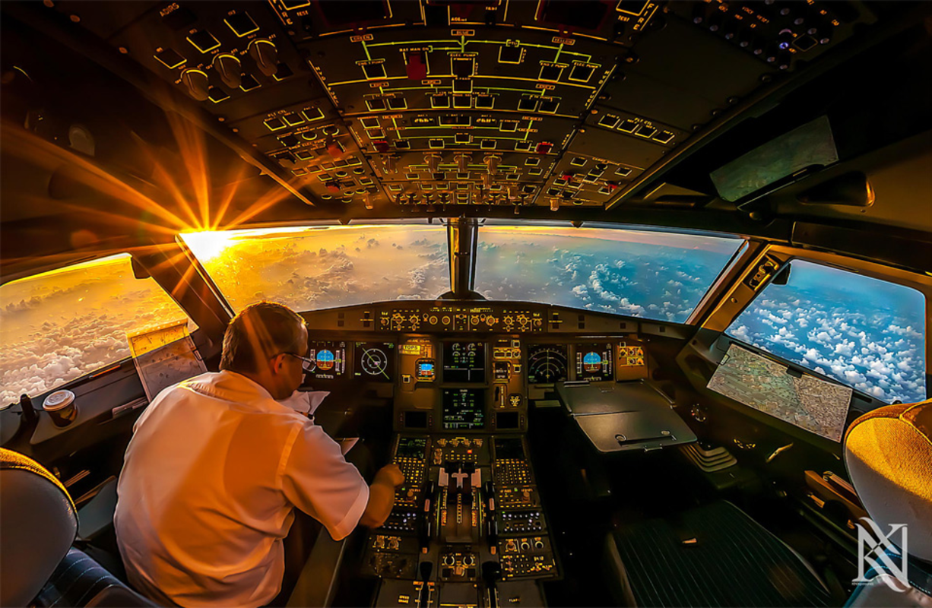

Story starter!
“There is no better feeling in the world than being up here” the pilot thought to himself. He pressed a series of buttons, ensuring the aircraft was on the right course, and sat back in his seat to enjoy the view. The sight that met his eyes never ceased to amaze him, no matter how many times he had done this flight…
Can you describe what you could see if you looked out of the cockpit window?
Alternatively, you could write a description of what it feels like to fly?
You could even write a story in the first person as the plane itself, embarking on an exciting journey.

Question time!
Have you ever been on a plane? If so, can you describe what it feels like?
If you have not, can you use your imagination to describe what it might be like?
What other modes of transport have you been on? Which was your favourite /least favourite?
Is there a mode of transport you would like to experience in the future?
How do you think the world was different before flying was invented?
How do you think transport will change in the future?

Sentence challenge!
Verbs are action/doing words.
Which sentence(s) contains two verbs?
The plane roared across the sky.
The pilot took a deep breath and pushed down on the throttle.
He glanced around him at the beautiful view.
The sun shone brightly at him and he squinted back at it.

Perfect picture!
Can you design your own mode of transport? It could be used in the past, present or future.

P.E.  Can you create your own work out? Think about having some cardio exercises such as star jumps, running, skipping as well as some strength exercises such as squats, press ups.  How long would each exercise need to be and how many of each would there be? Think about how Joe Wicks sets his work outs with rest time and timed tasks.  Add music to the routine think about which type of songs you would want playing during the exercises. What songs would you have for the cool down and stretch.  When you have completed it be the PE teacher and teach someone in your family the routine.  Make sure you are doing 30 minutes of exercise every day, go for a walk, or bike ride or follow a routine such as Joe Wicks. |  |  | D/T  You will need a needle and thread and material.  1)Design a drawstring bag for your phone. Think about the colours, style design you want it to have.  2)Make your bag, use the tutorials below to help.  https://www.lovesewingmag.co.uk/free-sewing-patterns/bags-and-accessories/item/285-drawstring-bag-tutorials/  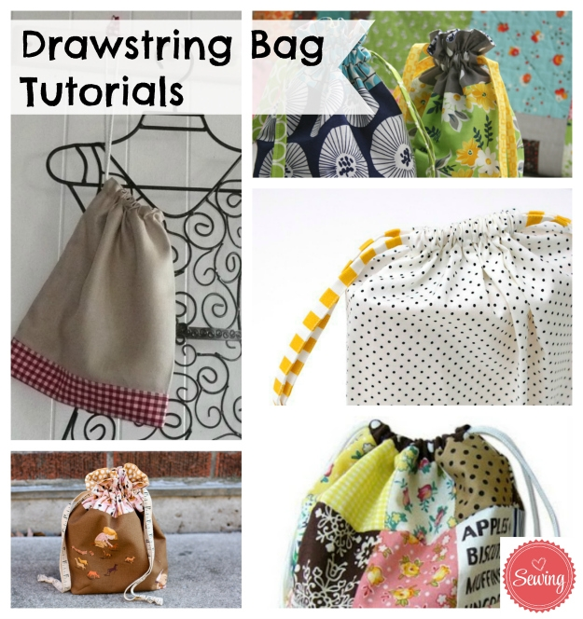
Well Being  https://www.bbc.co.uk/cbeebies/joinin/seven-techniques-for-helping-kids-keep-calm  Are you feeling a bit fed up or bored or maybe angry at times? That’s ok it is a difficult time and it is ok to be going through lots of different emotions. Cbeebies have some different activities you can try for relaxing to help you calm down, if you are feeling stressed or anxious.  One is to could spot. Lie on a blanket or the grass and look up at the clouds can you make different shapes  what can you see?   |  | Outdoor Learning  Wind Art  Take advantage of a windy day to create a masterpiece. Add drops of watered down paint to a paper plate and hold it to the wind. Watch as a super pattern is created. You could work on a larger sheet spread across the ground and held down with stones. Add the drops of paint but this time blow through a straw to create an interesting effect. What images can you see in the patterns made? Try adding some silhouettes before painting, then peel them off afterwards to add interesting detail.
Science
Classification
This is how taxonomists classify living things. They group similar things together, then split the groups again and again so they become smaller and smaller. Each group allows scientists to observe and understand their similarities and differences more clearly.
Imagine that a new zoo is going to open in your local area. You have been asked to sort and group the animals that will live in the zoo, so that similar species can be housed in enclosures near one another.
You will act as a taxonomist, so it is up to you to decide how to classify the animals and give reasons for your classification.
Look at the attached sheets for the animals.

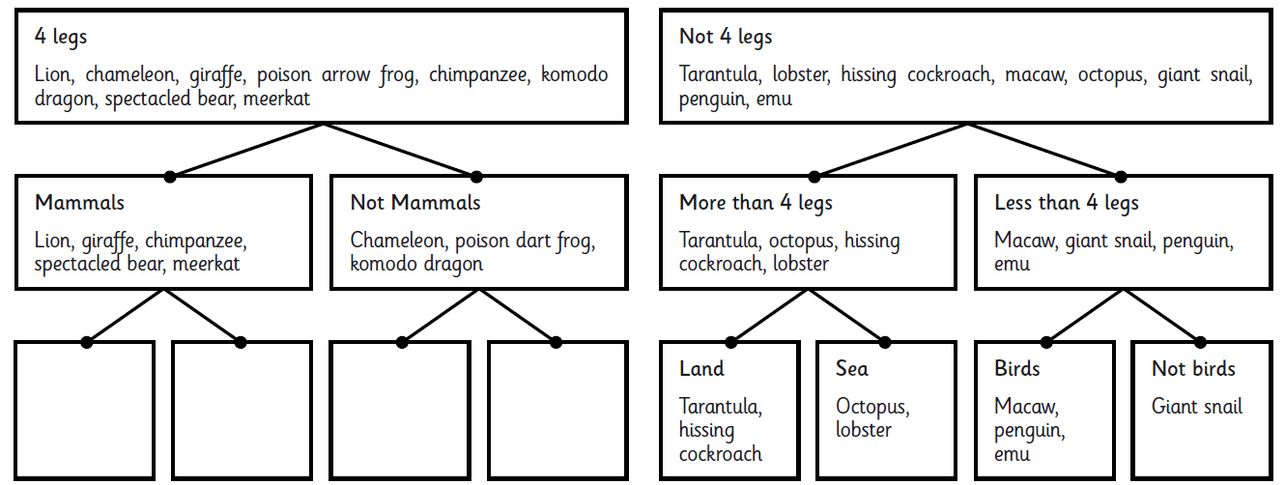
Design your own zoo. How would the layout of the
Zoo look? Where would your animals live? What
would your zoo be called?

Do you know what is happening with zoos at the
Moment? Are they going to be opening soon?

Geography

Can you draw a map of your local area, think about using a key and what would the scale be? What would you need to include on your map? Can you map out a new walk for you and your family to go on? Can you work out how far that is? Can you map your new walk to your secondary school if you can walk there?
Watch this clip if you need help.

https://www.youtube.com/watch?v=DlUB_5pUF6E

Spellings
Learn 10 each week. Can you make a word search using your spellings? Why not ask a family member to complete it.
Groups 2 and 3  w/ b 15/6/2020  - programme  - telegram  - hologram  - diagram  - grammar  - grammatical  - parallelogram  - monogram  - programmer  - program | Group 1  w/ b 15/6/2020  - interact  - interfere  - intercity  - international  - intermediate  - internet  - intergalactic  - interrupt  - intervene  - interlude | Groups 2 and 3  w/ b 22/6/2020  - challenge  - protest  - broadcast  - benefit  - charge  - function  - influence  - interest  - object  - damage |  | Group 1  w/ b 22/6/2020  1. antiseptic  2.anticlockwise  3. antisocial  4. antidote  5. antibiotic  6. antivenom  7. anti-ageing  8. antifreeze  9. antiperspirant  10. antigravity

