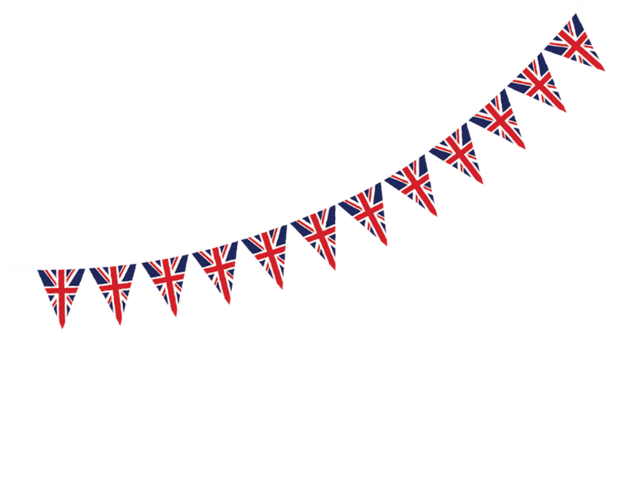  Maths  If you can use a computer or get online then:  - Log onto www.whiterosemaths.com and explore the Year 5 Home Learning  - Log onto www.MyMath.coms - work will be updated regularly.  - Practise your Times tables daily – you can find our Five Minute Frenzies on www.mathsdrills.com  - Try out the website www.Coolmathsgames.com  Use all four operations in maths to plan a VE day party.  Create a food and drink menu and include tablecloths and decorations, such as those mentioned in the text e.g. bunting. Give each separate item a cost and give yourself a budget. Remember that rationing was still happening so this may limit your choices. How many people can you afford to hold a party for?  Use your knowledge of co-ordinates and have a game of battleships (a bit like how we played the Pirate Game at Christmas – see the sheet at the end). The naval battles were important in World War Two, but did you know that they link to food shortages and rationing as Hitler targeted supply ships. As a result of this, many foods could not get through.  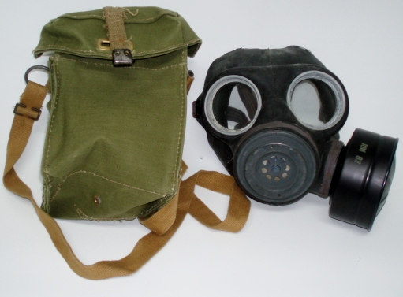  Use nets of shapes to make a gas mask carrier. Use a ruler to measure accurately in centimetres.  Use your measuring skills to weigh out the ingredients for a wartime recipe. There are some examples at the end of this document. | English  What do you think the children in this photo are thinking or feeling? Write a diary entry on V.E. Day from the point of view of a child who has been evacuated. If you want to challenge yourself, then write as one of the 10,000 children who were evacuated to the USA, Canada and Australia.  Draw a picture of an evacuee (or use a photo of one) in the middle of a piece of paper. On one side of the page write the thoughts and feelings of the mother and on the other side write the thoughts and feelings of the child. Are there any similarities? How do they differ?  Research how British soldiers who were fighting the war abroad received the news about the end of the war. Where were they? Write a letter home from their point of view. Link back to the word bank collected about joy, sadness and relief.  Write a letter to a relative who is a soldier describing the V.E. Day celebrations – maybe your family had a street party? Remember to tell them how much you are looking forward to having them home again now that the war has ended.  Create the script for a radio broadcast reporting on the end of the war in Europe.  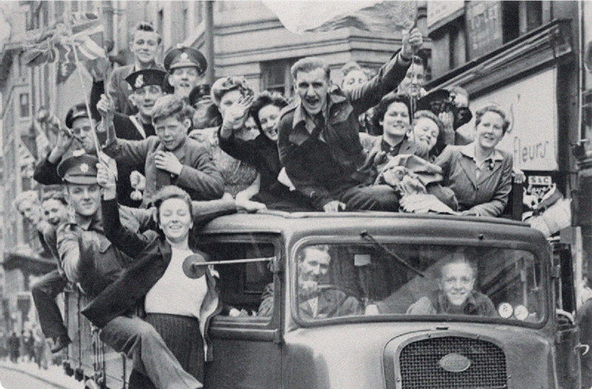  Look at new vocabulary from the separate information sheet e.g. bunting, national holiday, address (radio address), civilians, Axis powers, Allies etc. Discuss the meanings with your family.  Use the text to consolidate your knowledge of synonyms and antonyms. Pick five words and then recap the meaning of each word. Now think of appropriate synonyms and antonyms. You can make it a game and score one point for each word and two points if they spell it correctly.

Year 5 –VE Day Special Home Learning Pack: the tasks below are homework activities for your child to complete
while the school is closed. They should aim to spend some time every day working on one piece of work
Use the V.E. Day Information sheet to answer the following comprehension questions:  1. Name three ways in which the end of the war was celebrated.  2. Explain why the author writes that ‘it was a day of mixed emotions’.  3. Who were the:  a) Allies? b) Axis Powers?  4. Why did Japan enter World War Two? When did the war end in the Far East?  5. Find and copy the word which suggests lots of people headed to London.  6. How do you know that some evacuees found their new lives exciting?  7. Look at the section Preparing for the Party. How did the Government make sure the celebrations would be extraordinary?  8. How many services were at St. Paul’s Cathedral to celebrate the end of the war? Why were there so many?  9. Why was it so important that famous buildings across London were lit up on V.E. Day? Explain your answer using evidence from the text.  10. How did the palace ensure that the Queen was safe during the celebrations? |  |  | Reading/GPaS  Read to someone at home and ask them to sign your reading record book at least 5 times a week.  Read to yourself for half an hour every day – you can read anything you like but sticking to a book will probably be more interesting!  See of you can find a book set during World War II (Carrie’s War, Goodnight Mr Tom, Letters From the Lighthouse)  Re-read a book you loved and recommend it to a friend.  If you can use a computer or get online the log onto www.spag.com regularly.
Geography  Identify and label the countries on a world map that were involved in World War II.  Use a map of the United Kingdom to identify the major cities of London, Birmingham, Manchester, Belfast, Plymouth, Glasgow, Coventry and Hull.  Research the population of these places during the war and what was produced there. Why do you think those cities were the main targets for the Nazi bombing campaigns? | Science  ‘During the war, many homes had blackout curtains, which helped block out the light. Streetlights also had to be turned off. This was to prevent enemy planes from using the lights as guides to locate British  cities in order to bomb them.’  Investigate which materials are best at blocking light and why. | Art & DT (see the sheet attached for examples)  Design a propaganda poster. What message will you send? What are the popular images and colours that are used?  Investigate and make some war time recipes. Which key ingredients are missing? How does this affect the texture or taste of the food?  Look at the work of Henry Moore. Although he is most famous for his sculptures, during World War Two he made a number of sketches of the people using the underground as a shelter. Evaluate these images. How do they make you feel? What techniques has the artist used? Can you emulate his style? You could even try to sculpt your figures in modelling clay or saltdough. | Music  Learn some of the simple songs which were made famous during Wartime Britain e.g. Run rabbit, run or The White Cliffs of Dover. IF you can get online try using this link:  https://www.bbc.co.uk/teach/school-radio/history-ks2-world-war-2-clips-ww2-songs-index/zbg9gwx  Listen to a range of songs from the period, including In The Mood and Boogie Woogie Bugle Boy. What do you like/dislike about them? What  instruments were used?

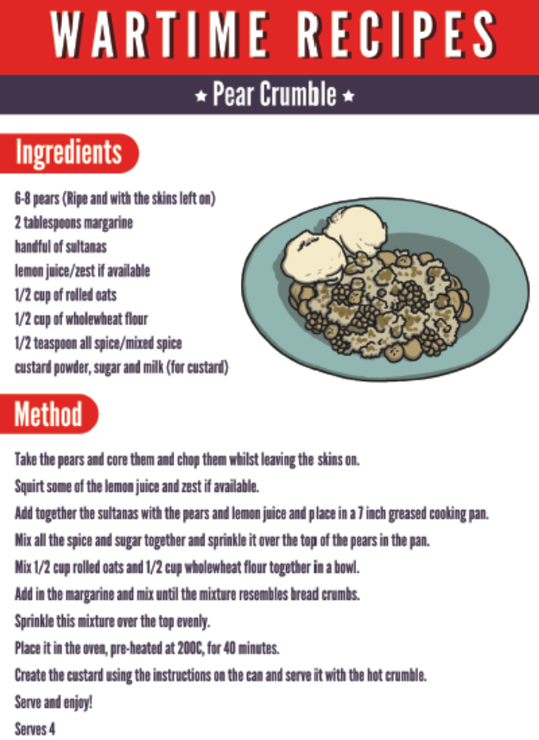
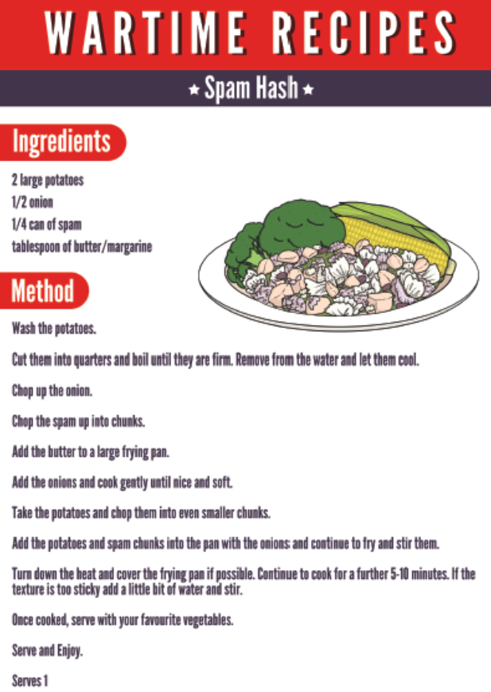
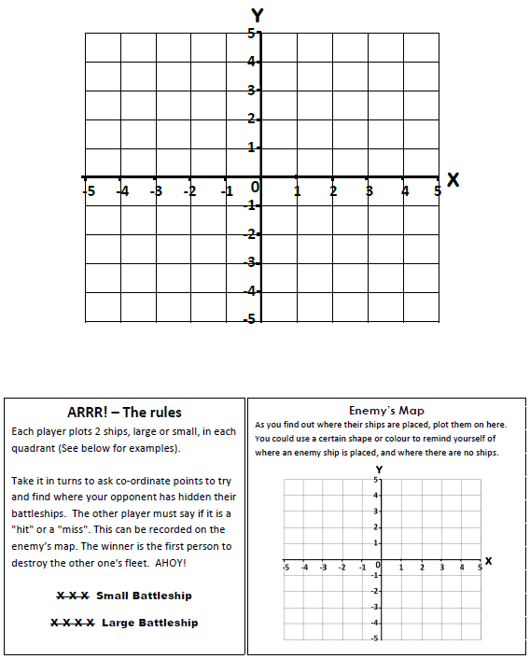
Battleships Game

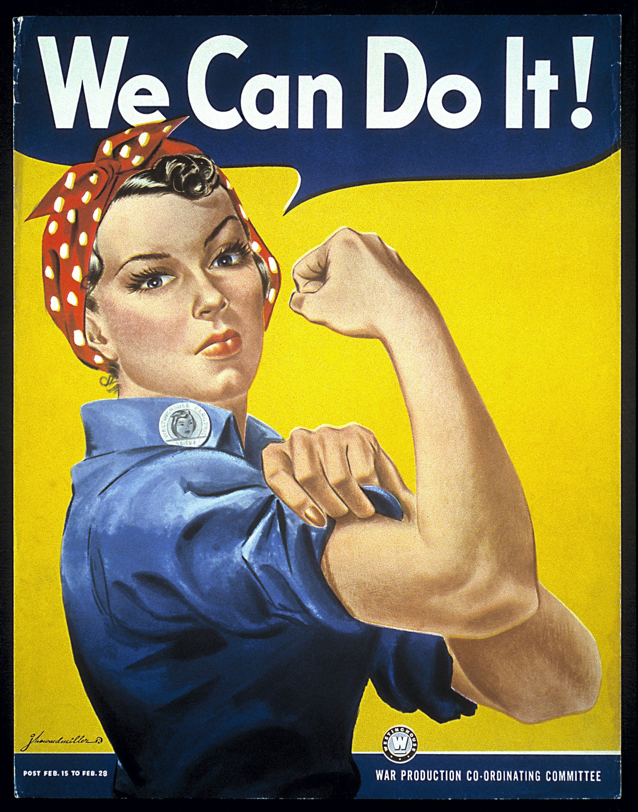
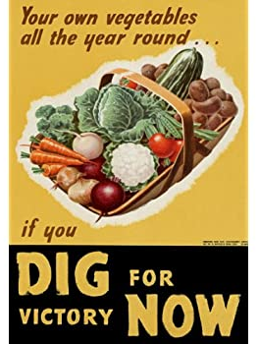

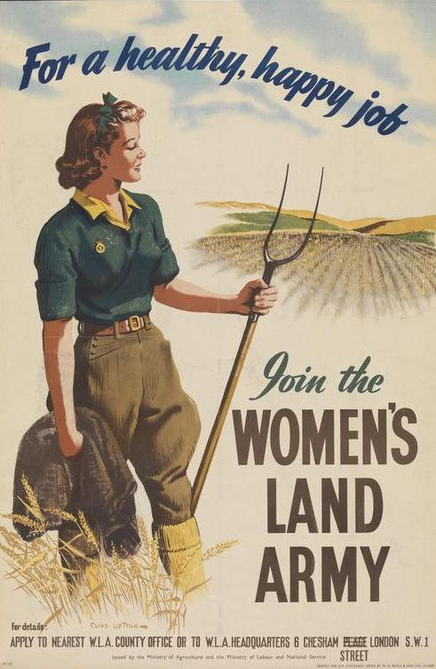
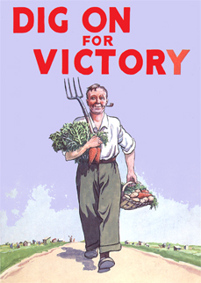
These are
propaganda posters from World War II.

These sketches are by Henry Moore. They are of people sheltering in the London Underground during the air raids in World War II.


