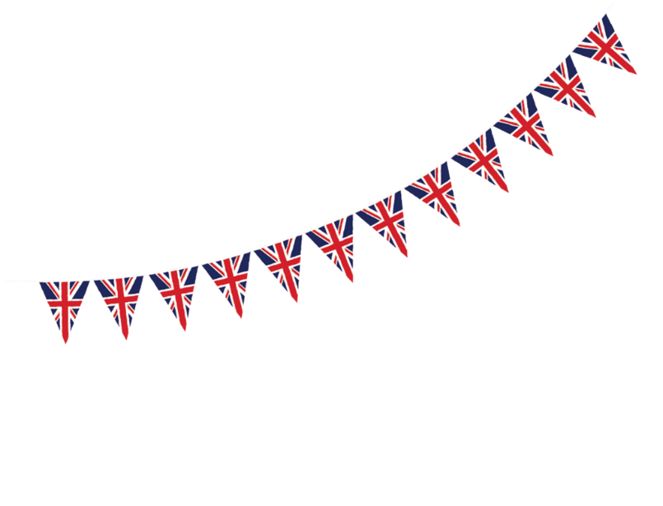
Celebrating
the end of
war in
Europe

The Second World War in Europe came to an end 75 years ago this week.
On the 8 May 1945, Victory in Europe Day, or VE Day, was declared. It marked the end of the Second World War in Europe, a terrible event that cost millions of lives and caused widespread destruction around the world.
The war lasted for nearly six years from September 1939 until May 1945. On 8 May, it was finally over in Europe. Crowds filled the streets and huge celebrations were held across the country. The date is remembered every year in the UK.
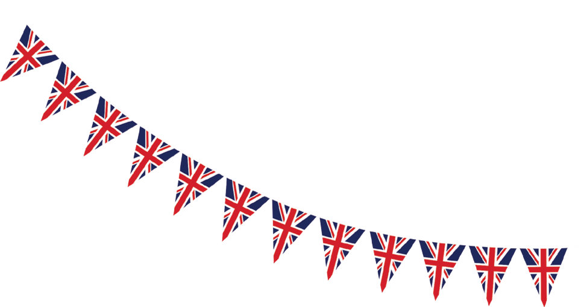
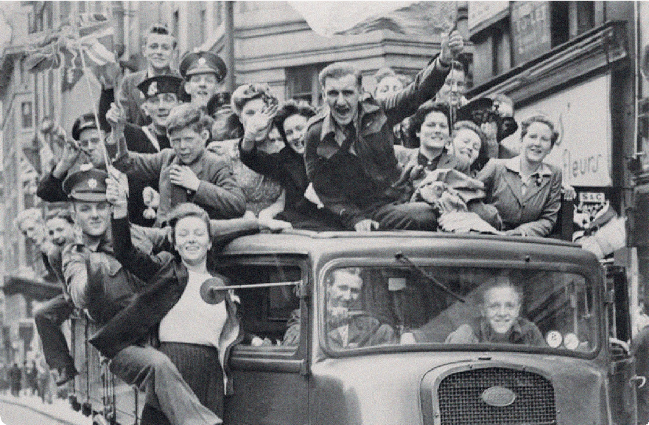
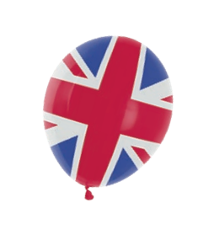

WWII: Who was fighting whom, and why?
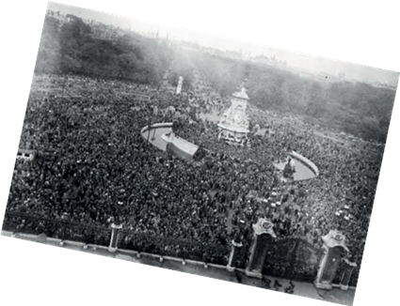
On one side were a group of countries known as the Axis Powers, which included Germany, Italy and Japan. On the other side were the Allies. They included Britain, Australia, Canada, China, France, India, New Zealand and the US.
The war started because Germany’s ruler, Adolf Hitler, wanted Germany to control Europe. On his orders, the German army invaded lots of countries. By 1943 Germany was starting to lose the war. On 7 May 1945, Germany surrendered.
Meanwhile, Japan wanted control of the Far East. The war in the Far East and the Pacific ended on 15 August 1945 when Japan surrendered. That date is called VJ Day or Victory over Japan Day.
A huge crowd gathered outside Buckingham Palace on VE Day in 1945, hoping to catch a glimpse of King George VI, his wife Queen Elizabeth and their daughters, Princess Elizabeth (now the Queen) and Princess Margaret. The King and Queen eventually appeared on the balcony eight times, delighting the crowds below.
What happened?
To mark the end of the war, parades, church services and street parties were held throughout the country, and colourful bunting and flags decorated villages, towns and cities. On VE Day, a lady called Nella Last wrote in her diary: “As if by magic, long ladders appeared, for putting up flags and streamers.”
Although London had been bombed heavily during the war, many people flocked there to celebrate. Around 50,000 people from all over the country made it to Piccadilly Circus by midnight on VE Day.
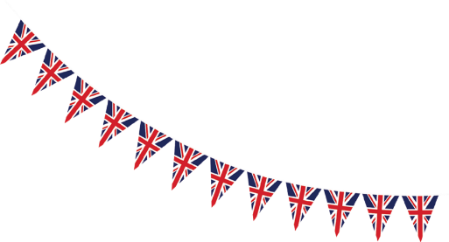
It was a day of mixed emotions. King George VI gave a radio address to the nation, to commemorate those who had died. “Let us remember the men in all the services, and the women in all the services, who have laid down their lives,” he said. The Prime Minister, Winston Churchill, made a speech on the radio announcing that the war was over, and declared a national holiday. “Long live the cause of freedom! God save the King,” he said
What was life like during the war?
For more than five years, British towns and cities were constantly bombed. In all, more than 67,000 civilians – ordinary people not in the armed forces or police – were killed and around 86,000 were seriously injured. Food and clothes were rationed, and by 1943, almost every household item was in short supply. Shortages continued for years after the war ended.
Millions of children were sent away from cities to live in the countryside during the war. These areas were at less risk of bombing. For some, being evacuated was exciting. Many city children had never seen farm animals before. When the war ended the children returned home to their families.
Preparing for the party
During the war there were shortages of food because men were taken from the fields to fight, and routes bringing supplies into the country were often blocked.
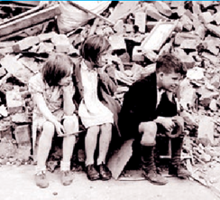
In January 1940, the Government introduced food rationing to ensure that everyone received their fair share of food despite the shortages
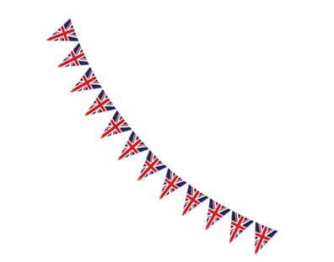
In the spring of 1945, as war appeared to be coming to an end in Europe, the Government began preparing for the country’s victory celebrations. In April, officials sent out suggestions to local authorities that included holding parties in local parks, putting up bunting, lighting searchlights and burning bonfires to make sure the celebrations were a success.
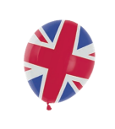
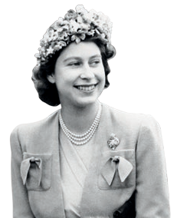
Queen Elizabeth’s memorable night
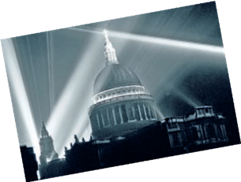
Queen Elizabeth II celebrated her 94th birthday in April this year, but on VE Day in 1945 she was a 19-year-old princess. The young princess asked her parents if she and her sister Margaret could go out and join the crowds. Amazingly, they agreed but only if the princesses went in a group with an army officer looking after them. The Queen pulled a cap down over her face so no one would recognise her. Margaret Rhodes, the princesses’ cousin,
went with them that night. She explained: “It was a mass of people all cheering and saying “Whoopee!” We walked right up to Leicester Square where everybody was kissing everybody and putting policemen’s helmets on their heads”.
The Queen has said of that night, “I think it was one of the most memorable nights of my life”.
V for victory
During the war, many homes had blackout curtains, which helped block out the light. Streetlights also had to be turned off. This was to prevent enemy planes from using the lights as guides to locate British cities in order to bomb them.
On VE Day, landmarks across London such as
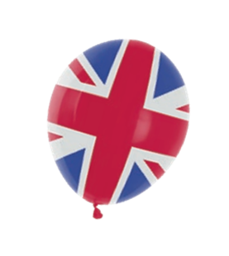
the Houses of Parliament and Buckingham Palace were lit up once again. Searchlights were used to create a “V” sign, which stood for victory, in the air by St Paul’s Cathedral.


