Dear Year 5,

Hello! What a strange, few weeks it has been! Firstly, I hope you are all well and not going too bonkers being on lockdown. It’s been pretty chilled in the Emmings Household, mostly because Charlie and Billy are extremely happy not to be in school (surprise, surprise). I think they are beginning to miss their friends a little now though, much as I am missing you guys and I am sure you are missing each other. The most difficult thing has been making sure we all get up at a respectable time in the morning and not stay up too late at night. We got very relaxed with our timetables over Easter but now we are trying to get back to a normal routine – not exactly the same but near enough 😊.

With two teenagers, myself and Mr Emmings all trying to share two computers, it has been tricky finding time to get all our work done. I can imagine that many of you are in the same situation, so even though I shall continue to set MyMaths, Yumu (Music/Charanga) and Spag.com work, I am attaching a new Home Learning Grid which you can pick and choose some work from (if you haven’t done everything on the first grid then you can keep working on that too!). Our new topic this term is the Ancient Greeks so there is some research work you can start doing while you are at home.

So that your brains don’t completely give up thinking while we are not in school, it’s really important that you do some Maths and some English every day. Keep practising your times tables every day and make up some numbers to practise long multiplication – use your imagination and think up some multistep word problems to calculate. If you can get online then go back over old MyMaths work that you’ve done before and try to improve your score. I am attaching the Alan Peat sentence posters so that you can practice using the sentences in your writing – try a different one every day and then at the end of the week try writing a paragraph which includes all of the ones you’ve been practising.

You will also find that I have attached a Life Experience Menu. This is a selection of a variety of skills which you can take time to experience – all of them will be useful at some point in your life and now is the perfect chance to start mastering them. Enjoy!

I know everything is a little bit weird at the moment, but I hope you are managing to keep your chins up and be positive. I am already looking forward to seeing you all again and hearing all the great stories of how you kept yourselves occupied.
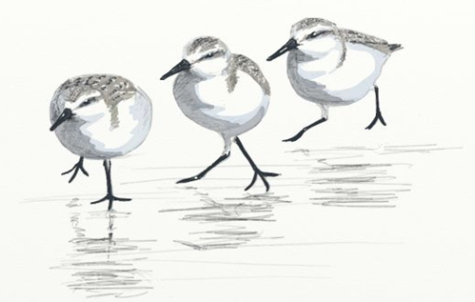
Please feel free to send any questions you may have to me via teachers@hinguar.southend.sch.uk or homelearning@hinguar.southend.sch.uk
This email address can also be used to send me information about the things you have been doing.

Above all else stay safe and well Sanderlings!

Much love,

Mrs Emmings x
Maths  If you can use a computer or get online then:  - Log onto www.whiterosemaths.com and explore the Year 5 Home Learning  - Log onto www.MyMath.coms - work will be updated regularly.  - Practise your Times tables daily – you can find our Five Minute Frenzies on www.mathsdrills.com  - Try out the website www.Coolmathsgames.com  Research the highest ten mountain peaks in the world and create and bar chart to represent your results. Work out the difference between the highest and lowest peaks on your charts. Can you write the measurement sin metric and imperial units?  See the Ancient Greek Number system on the last page and answer the questions. | English  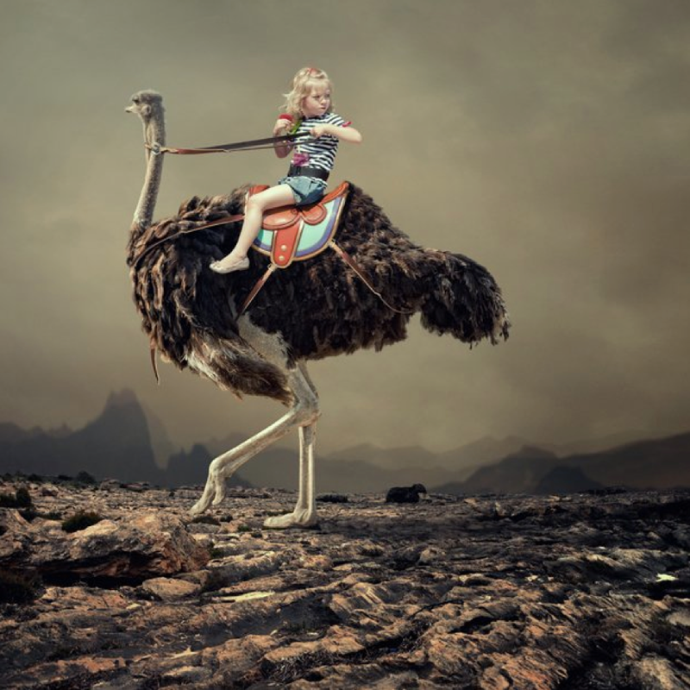  Every day practise writing different Alan Peat sentences from the attached PDF of the posters we have in our class.  She turned in the saddle and looked behind her. Emma could see the others gaining on her. Digging in her heels, she whispered some words of encouragement in the ostrich’s ears as it burst into full speed. They were making good time, but there was so far still to go…  Can you continue the story? Who is chasing Emma? Is this a race or is she on another adventure? Let your imagination run wild…  Write a persuasive piece of writing convincing the school of a change you think should be made when we return to normal school timetable (extra lessons on Saturdays, longer lunch hours, a different teacher for every subject etc).  Write your own version of a Greek Myth.  Research a Greek Myth and then write a narrative poem about it.  What is the most exciting thing that’s ever happened to you? Write a recount about your experience and be sure to describe how you felt during and after the event.  The Olympic Games were first held in Ancient Greece. If you could add any one sport, skill, or activity to the modern Olympics—and then compete in it—what would you choose? Do you think it would be popular with other people? Why?  Write a creative story about a world in which the animals take over and put all the humans in a human zoo. What kinds of educational exhibits might they have (grandparents, kids, etc.)? Would you enjoy living in the zoo? Why or why not?  Imagine you are an explorer who is the first person to climb a mountain that has never been climbed successfully before. Write a diary of your expedition.  Write a recount of a time when you were in a bad situation and finally saw a silver lining. What happened? Make it personal and include feeling and descriptions. Did anyone help you?
Science
Take a cutting from a plant and see if you can create a clone of the parent plant. Write instructions for someone else to do the same as you have done.

Plant a seed and record its growth – keep a photo diary to show what happens once the seed germinates and erupts through the soil.

Research and write a biography of Jayne Goodall, explaining why her work with chimpanzees was so important to the world. Discuss any other famous zoologists that your family may know – might you be able to watch them on television?

Look at the following page and you will see a diagram of a flower which has been bisected. Can you label any of the parts? Which parts do you already know and which do you need to research?

Year 5 – Summer Term Home Learning Pack: the tasks below are homework activities for your child to complete
while the school is closed. They should aim to spend some time every day working on one piece of work

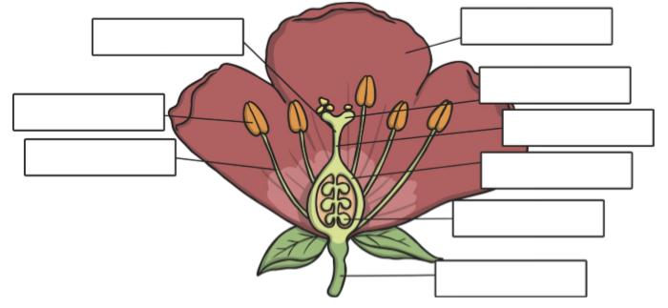 |  | Reading/GPaS  Read to someone at home and ask them to sign your reading record book at least 5 times a week.  Read to yourself for half an hour every day – you can read anything you like but sticking to a book will probably be more interesting!  Try reading some Greek Myths if you can find some.  Re-read a book you loved and recommend it to a friend.  If you can use a computer or get online the log onto www.spag.com regularly.
Geography  How many different mountain ranges can you name? Can you locate them on a map of the world? What is the highest peak in each range?  How many countries are there in the world? How many can you write down without researching? Now, how many capital cities from those countries can you list? | Music  Choose five countries from around the world and find out what genre (type) of music comes from that country. Can you learn to sing a song from one of the countries?  Write your own lyrics to the folk song Frere Jacques. You can write the lyrics in English – unless you are feeling brave enough to attempt using French words!  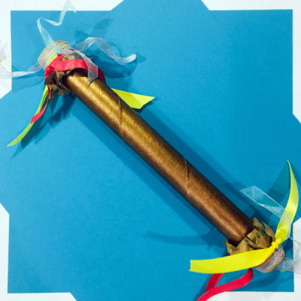  Bring an ancient sound often associated with indigenous cultures to your home with a homemade rainstick, and hopefully you’ll inspire a calming effect in your home! You can make one with a cardboard tube, some ribbons, paper, and pebbles or beans for the sound. | DT  Research some ancient Greek recipes and try cooking them for your family. Write an explanation of what the dish is and then write out the recipe.  Art  Using your sketching skills, draw a picture of a Greek Temple – try to include some traditional Greek columns (visit https://www.ducksters.com/history/ancient_greece/architecture.php)  Or look at these example:  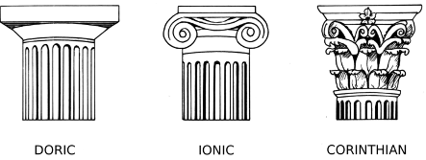  Create a collage entitled ‘Lockdown’ – what images would you include?  Examine closely or disect a real flower and use your art skills to create a botanical diagram of the different parts inside. You may like to visit this website for inspiration:  www.botanicalartandartists.com/famous-botanical-artists.html
Mini Projects
Research the gods of the Ancient Greeks.

Research the importance of Alexander the Great and the impact he had on the Ancient Greek civilization.

The Ancient Greek Number System
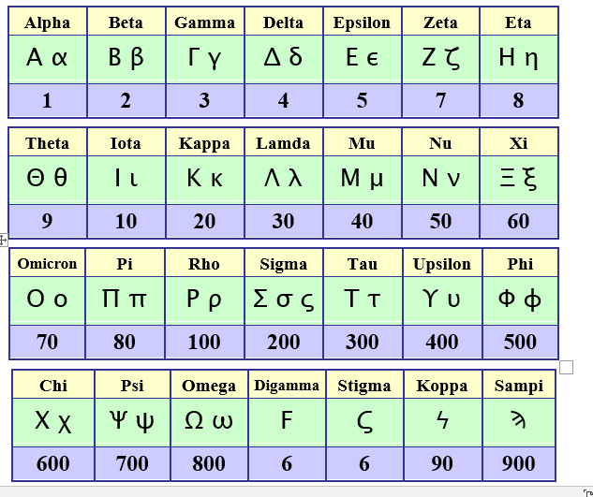
Can you use the Ancient Greek number system to write:

1. your age?
2. the date of your birthday?
3. the number of people living in
your house?
4. the number of children in your
class?
5. the number of children in the
school?
6. the age of a parent?
7. the number 550?
8. the number 443?
9. the number 824?

Finally, try doing ten arithmetic problems using this system. Why is this a difficult task?

