Dear Year 5,
Hello! What a strange, few weeks it has been! Firstly, I hope you are all well and not going too bonkers being on lockdown. It’s been pretty chilled in the Emmings Household, mostly because Charlie and Billy are extremely happy not to be in school (surprise, surprise). I think they are beginning to miss their friends a little now though, much as I am missing you guys and I am sure you are missing each other. The most difficult thing has been making sure we all get up at a respectable time in the morning and not stay up too late at night. We got very relaxed with our timetables over Easter but now we are trying to get back to a normal routine – not exactly the same but near enough 😊.
With two teenagers, myself and Mr Emmings all trying to share two computers, it has been tricky finding time to get all our work done. I can imagine that many of you are in the same situation, so even though I shall continue to set MyMaths, Yumu (Music/Charanga) and Spag.com work, I am attaching a new Home Learning Grid which you can pick and choose some work from (if you haven’t done everything on the first grid then you can keep working on that too!). Our new topic this term is the Ancient Greeks so there is some research work you can start doing while you are at home.
So that your brains don’t completely give up thinking while we are not in school, it’s really important that you do some Maths and some English every day. Keep practising your times tables every day and make up some numbers to practise long multiplication – use your imagination and think up some multistep word problems to calculate. If you can get online then go back over old MyMaths work that you’ve done before and try to improve your score. I am attaching the Alan Peat sentence posters so that you can practice using the sentences in your writing – try a different one every day and then at the end of the week try writing a paragraph which includes all of the ones you’ve been practising.
You will also find that I have attached a Life Experience Menu. This is a selection of a variety of skills which you can take time to experience – all of them will be useful at some point in your life and now is the perfect chance to start mastering them. Enjoy!
I know everything is a little bit weird at the moment, but I hope you are managing to keep your chins up and be positive. I am already looking forward to seeing you all again and hearing all the great stories of how you kept yourselves occupied.
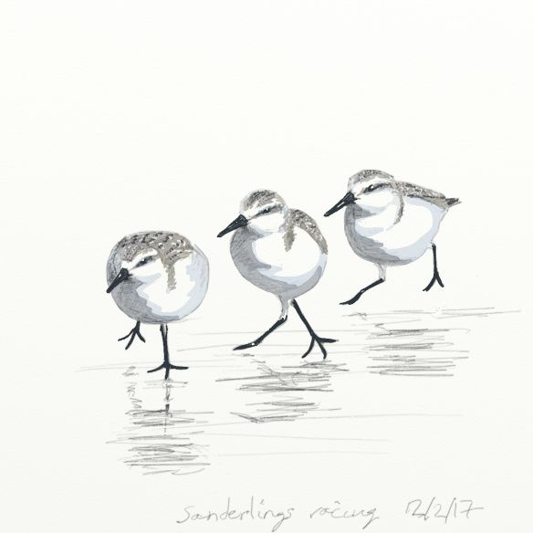
Please feel free to send any questions you may have to me via teachers@hinguar.southend.sch.uk or homelearning@hinguar.southend.sch.uk
This email address can also be used to send me information about the things you have been doing.
Above all else stay safe and well Sanderlings!
Much love,
Mrs Emmings x

