Year 3 Home Learning 29th June 2020
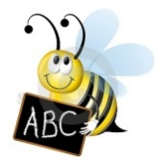  English – spellings  Continue to practise your spellings from the year 3/4 list (10 per week).  Get someone to test you.  Write a sentence using each of the words correctly.  Ask someone to make anagrams of the words and you unscramble them e.g. nasrom = Romans | Have a go at some of these short writing tasks, remember to join your letters and make it neat. Remember your . , ? !  - Write a recipe for ‘what makes a good friend’.  - Create a wanted poster for a bad/evil character from one of your favourite stories e.g. Mrs Trunchbull from Matilda  - Re tell a familiar story in less than 50 words, you must include information about the plot and characters.  - Write a diary about your week, remember to write in the correct tense. |  |  |  | Log on to www.mymaths.co.uk  Topmarks or cool maths for additional maths work.    Play: Dotty six  You need a partner, a 1-6 dice and a grid like this.  Take turns to throw the dice and draw that number of dots in one of the boxes on the grid.  Put all your dots in one of the boxes. You cannot split them up and you cannot have more than six dots in a box.  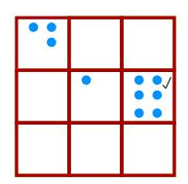  When a box is full, you could put a tick in the corner like this:  Keep going until there are three ticks in a row or column or diagonal. The winner is the person who puts the last tick.  Now, can you change the game to make your own version?
English – reading

Continue to read for at least 15 minutes per day. Can you come up with some questions about what you have read? Can you predict what will happen next in the story? What was your favourite part so far and why? Can you find some adventurous vocabulary that the author has chosen?

Read, learn, and perform a favourite poem; Michael Rosen has some wonderful performances online.

  https://www.trustlinks.org/week-1-mini-beasts/  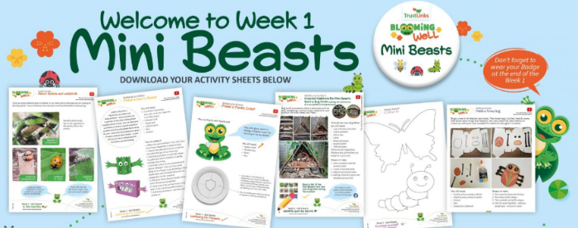  Visit this website for a whole week of outdoor learning.  Make a minibeast hotel for all the bugs in your back garden.  Make a den or tent in your garden and enjoy a picnic with your family.  Make a collage using materials you find on a walk. |  |  | Well Being  https://www.bbc.co.uk/cbeebies/joinin/seven-techniques-for-helping-kids-keep-calm  Are you feeling a bit fed up or bored or maybe angry at times? That is ok it is a difficult time and it is ok to be going through lots of different emotions. CBeebies have some different activities you can try for relaxing to help you calm down if you are feeling stressed or anxious.  Maybe try some of these activities:  - Take a selfie and write 5 things you like about yourself  - Write an A to Z of things that make you happy  - Karaoke challenge: Put on your favourite song, learn the words, and then perform with actions to your family.  - Make a relax box and put all the things in that calm you down.
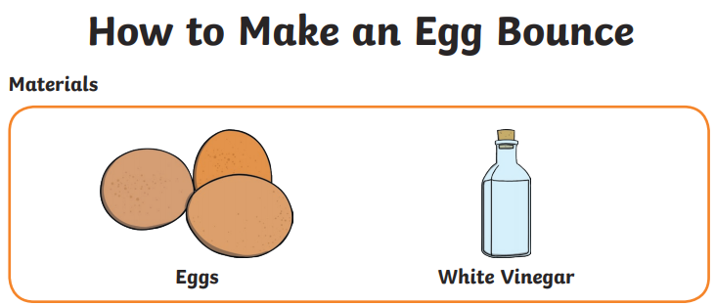  A little bit of fun!  Using only an egg and some vinegar try to make the egg bounce.  Predict what will happen.  Why it will happen  To try this investigation visit:  https://www.twinkl.co.uk/resource/t-t-11549-egg-science-experiments-at-home |  |  |  | PE  Do at least 30 mins exercise a day. Have you tried Joe Wickes’ workout at 9am Monday-Friday?  Try Cosmic yoga, there are loads of fun ways to learn yoga including Star Wars, Harry Potter and Minecraft.  https://www.youtube.com/watch?v=R-BS87NTV5I  Pick activities from Active May Grid  https://www.st-crispinsinfants.org.uk/kent/primary/st-crispins/arenas/websitecontent/web/active-may-full-colour(3).pdf  Play a fielding game with your family e.g. rounders, softball, cricket  Go for a short jog, brisk walk, or a cycle ride.
  White Rose Maths is the curriculum we follow for Maths they have daily lessons with visual resources and someone explaining it, it is a really good resource to use.  https://whiterosemaths.com/homelearning/year-3/ | Twinkl are also offering daily lessons with a daily timetable for free online. They have activities and tasks which are great to use as well. You can print worksheets off or just get them to work on paper. They also have links to live teaching videos.  https://www.twinkl.co.uk/home-learning-hub   |  |  | Teach yourself a new skill  This is a good time to practise something at home every day and try to improve.  Can you tie your shoe laces?  Can you ride a bike?  Can you learn a new language?  Can you bake a cake?  Can you sew?

