Underneath

Story starter!
On the surface, everything looked ordinary.
The boy in the boat was bored. He had lived beside this boring river with his boring family for his whole boring life. Nothing unexpected ever seemed to happen to him. He often went to bed at night and wished for something exciting in his life.
Little did he know, underneath the ground he walked on and the river he rowed his boat on, a marvellous, mysterious, magical menagerie of life stirred.
His life was about to become a lot more interesting…

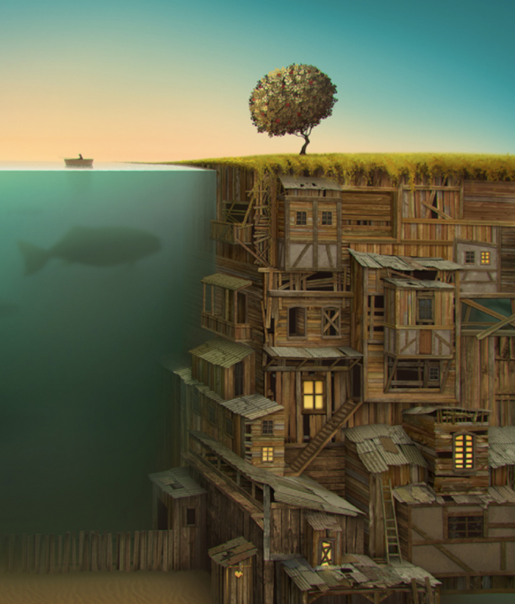

Question time!
Who is the boy and why do you think he is bored?
What do you think he has with him in the boat?
What do you think his family are like?
Where do you think their home is?
Who do you think lives in the city under the ground?
Why do you think the boy has never seen the people who live there before?
Why do they live underground?
Is there anything peculiar about the sea or the tree that is next to it?
What do you think is about to happen to the boy?

Sentence challenge!
Can you include some speech in your writing, using inverted commas?
E.g. “Have you found it yet?” asked the visitor.
“What?” replied the boy.
Remember to start a new line for a new speaker.

Sick sentences!
These sentences are ‘sick’ and need help to get better. Can you help? Could you add an adverb?
The boy rowed the boat. Underneath him was a big fish. It swam around, waiting.

Persuasive Writing
Here are some debates you can have with someone. Once you have discussed them write down points for and against for each argument. Then write down your own opinion.

“PE is the most important subject in school”

“Students should be banned from playing computer games”

For Against

My opinion:

Can you come up with your own debate?

Remember there are lots of tasks on My Maths and purple mash. |  |  | Time Yourself  How long does it take you to do different things? Brush your teeth/eat breakfast/go for a walk/have a shower/clean your room/do 10 star jumps/ hop around the garden etc. What can you do in two minutes?  Try at least 15 different things!
Fruit and Veg  Find a variety of fruit and vegetables. Estimate how much they weigh then weigh them accurately. Put the items in order of mass. Can you add any together to make 300g, 50g, 2Kg etc. Perhaps make a fruit salad or vegetable stir fry. How much did the peelings weigh? |  |  | Meters  At home find 10 items shorter/longer than a metre. Order objects according to length.
Times Tables Practise  Make some memory cards – have 2 sets of cards – one with question e.g. 6 x 4 and create a matching pair that is the answer e.g. 24. If you turn the correct ones over you can win those cards – the player with the most cards wins. Just remember to keep them in the same place so you can remember where they are if you need to turn them over again! |  |  | Convert Clocks  If you have a digital clock, try to write the time in an analogue way, if you have an analogue clock, write the time digitally or on the 24 hour clock. Check the time together at regular intervals.
Problem Solving
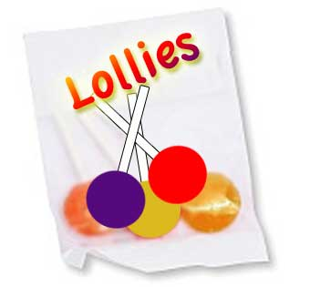
Frances and Rishi were given a bag of lollies.
They shared them out evenly and had one left over.
Just as they had finished sharing them their friends Kishan, Hayley and Paul came along.
They wanted some lollies too so the children shared them out again between all of them. This time they had two lollies left over.
How many lollies could there have been in the bag?
Here is a website that has some information about the history of the Garrison if you have access to the internet https://fortheloveofhistory.home.blog/2019/07/02/a-small-town-with-explosive-history-shoebury-garrison/  Now you have your front cover and your first chapter as well as a map. Your next few tasks for  your book are;  - Write your second chapter of your history book, focus on one key aspect of what the Garrison has been used for for example during the first world war, the war office decided to establish a British War Dog School at the Garrison, people were even asked to donate their pet dogs to be trained!  Remember to include paragraphs, sub heading, it has to be factual.  - Draw or take a photograph of the area you are writing about. |  |  |  |  |  | 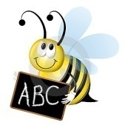  Spellings  Continue to practise your spellings from the year  3/4 list (10 per week). Get someone to test you.  Write a sentence using each of the words correctly.  Make a wordsearch using some of the words. Ask someone in your family to complete it and they could make one for you.
SCIENCE: STATES OF MATTER; SOLIDS LIQUIDS GASES |  |  |  |  |  | PARENTS, PLEASE NOTE THAT BBC BITESIZE KS2 OFFERS DAILY/WEEKLY TIMETABLES & ACTIVITES FOR ALL CURRICULUM SUBJECTS IF YOU WISH TO USE THESE. THEY ARE ALL FREE AND MATCH OUR YEAR 4 CURRICULUM. YOUR CHILDREN CAN REVISE SKILLS WE’VE ALREADY LEARNT OR TRY NEW ONES. https://www.bbc.co.uk/bitesize/dailylessons
  Bakeit: Why not use some melted chocolate to make your own chocolate crispy cakes? Mix some
  cornflakes or rice crispies into the melted chocolate, spoon the mixture into cake cases and leave to freeze solid. Enjoy!
  Researchit: Find out about how different materials are melted and their uses. For example, iron and
  glass.
  Makeit: Can you make some frozen yoghurt or ice cream? Add your favourite fruits and put it in the
  freezer to change into a solid.
  Twinkl are also offering daily lessons with a daily timetable for free online. They have activities and tasks which are great to use as well. You can print worksheets off or just get them to work on paper. They also have links to live teaching videos.  https://www.twinkl.co.uk/home-learning-hub | White Rose Maths is the curriculum we follow for Maths they have daily lessons with visual resources and someone explaining it, it is a really good resource to use.    https://whiterosemaths.com/homelearning/year-4/ |  |  |  | Geography  Can you name 20 different countries?  Can you name the capitals of these countries?  Draw the United Kingdom (use an atlas or the internet to help) if you were mapping your next holiday in the UK, how long would it take you to get there? Why would you choose that location?
Outdoor Learning
Mini beast Hunt
Go into your garden or a local park and look for mini beasts. You will need something to put them in if you have a plastic container remember to make air holes (Ask an adult for help) and a paint brush. Paper and pen to record.

Woodland habitat provides all sorts of places for small creatures to find a home. Each habitat will contain different species adapted to live in those surroundings.
Leaf Litter :- Collect a heap of rotting leaves. Carefully sift through the leaves. Make sure you wear gloves. Look for creatures and put them carefully into a bug box. Use the paintbrush to pick up the smallest. Use the lens to identify what you have found. Replace the leaf litter when you have finished.
Under logs :- Lift logs gently to investigate and return to original position afterwards. Make sure you leave habitats as you found them. Collect creatures and place into bug box
In rotten wood :- Find a rotting log and see how many different types of creatures are living under, or on the inside of it. Did you know that the rotting wood will eventually be returned to the soil, the nutrients becoming available to the roots of the living trees.

Make a chart of the mini beasts you have found you could even sketch them. Make sure you return them to where you found them.

Complete 30 minutes exercise each day, it could be going for a walk or playing football in your garden. Why not try a new sport? Wimbledon would normally be starting in July, have a game of tennis with a family member or friend (socially distancing). Do you know how many years Wimbledon has been on? Do you have a favourite player?   |  | Listen to a 5 different genres of music for example jazz, rock, classical, pop, indie, R’n’B.  Make a list of the different instruments they use  How does each genre make you feel?  Can you find out different artists for each genre?  Who is your favourite artist which genre of music is this?
MATHS ACTIVITIES  Practise your times tables up to 12x 12. Can you create a new x table game? Let me know and I will share with the class.  My Maths tasks have been set, go online and complete the tasks.  www.mymaths.co.uk |  |  |  | PURPLE MASH  www.purplemash.co.uk  Just login to purple mash with your log ins check your to do list. Click on the bell button at the top.  THERE WILL BE WEEKLY UPLOADS OF ACTIVITIES TO DO ON PURPLE MASH, SO CHECK IN EACH MONDAY FOR NEW GAMES/ACTIVITIES TO COMPLETE.

