Year 3 Home Learning 15th June 2020
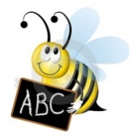  English – spellings  Continue to practise your spellings from the year 3/4 list (10 per week). Get someone to test you.  Write a sentence using each of the words correctly.  Ask someone to make anagrams of the words and you unscramble them e.g. nasrom = Romans | Have a go at some of these short writing tasks, remember to join your letters and make it neat. Remember your . , ? !  - Write a list all about YOU  - Write instructions explaining how to play an outdoor game  - Create a poster sharing ideas for being kind to others  - Write a poem about your favourite food. |  |  |  | Log on to www.mymaths.co.uk  Topmarks or cool maths for additional maths work.  Some other ideas you could do at home;  Design 3 different types of jumpers and 3 different types of trousers/leggings. How many combinations of outfits can you make? What about if we added 3 different types of shoes too? How many combinations could we have now?  Go and look in your sock drawer. How many different colours of socks do you own?  How many of them are patterned?  How many of them are plain?  Are there any other ways that you could put your socks into categories? Using this information express your sock drawer in fractions eg ¾ of my socks are patterned. ½ of my socks are white  When you have finished, make sure all of your socks are in pairs and put them in your drawer.
English – reading

Continue to read for at least 15 minutes per day. Can you come up with some questions about what you have read? Can you predict what will happen next in the story? What was your favourite part so far and why? Can you find some adventurous vocabulary that the author has chosen.

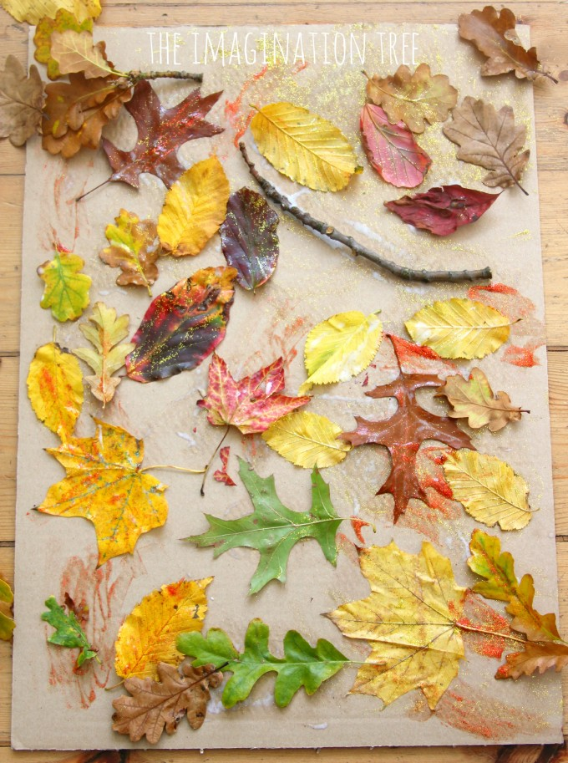  Nature Survey  Jot down how many different birds,  insects or flowers you can spot outside.  Record your results in a tally chart.  Make a Nature Collage  Collect natural objects found outside  such as leaves, twigs, pinecones. Create a scene by using them to make a collage, glue them to a piece of paper or just make them on the grass and take a photo of your final art work.  Obstacle Course  Make an obstacle course using objects in your garden or around your home. Challenge your family to see who can complete it in the shortest amount of time. |  |  | Well Being  https://www.bbc.co.uk/cbeebies/joinin/seven-techniques-for-helping-kids-keep-calm  Are you feeling a bit fed up or bored or maybe angry at times? That’s ok it is a difficult time and it is ok to be going through lots of different emotions. Cbeebies have some different activities you can try for relaxing to help you calm down, if you are feeling stressed or anxious.  One is to could spot. Lie on a blanket or the grass and look up at the clouds can you make different shapes what can you see?  
Animals and habitats  This is a great website with online and interactive lessons to have a look at. Click below to make your own duck  Can you label the duck and describe where they live, their habitat.  https://www.wwt.org.uk/uploads/documents/2020-04-22/wwt-make-a-duck-1.pdf  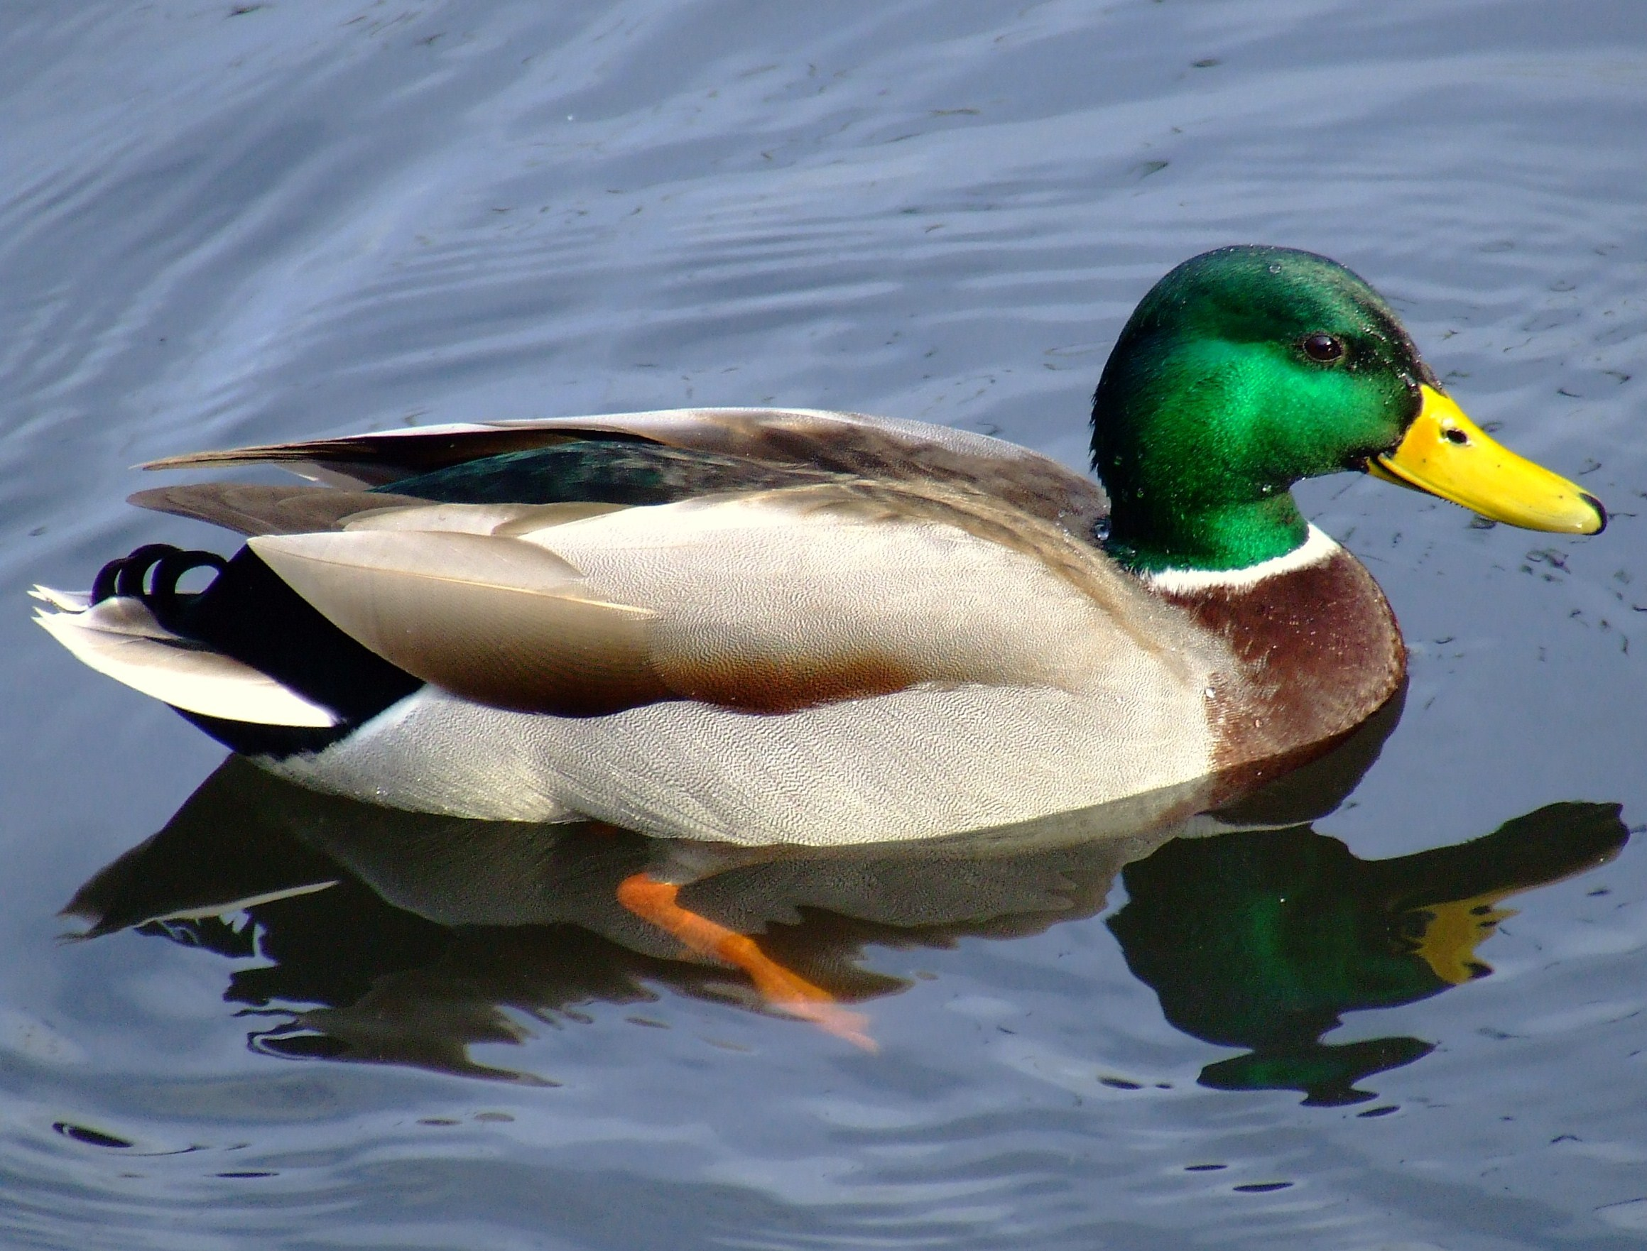   |  |  |  | PE  Do at least 30 mins exercise a day. Have you tried Joe Wickes’ workout at 9am Monday-Friday?  Try Cosmic yoga, there are loads of fun ways to learn yoga including Star Wars, Harry Potter and Minecraft.  https://www.youtube.com/watch?v=R-BS87NTV5I  Pick activities from Active May Grid  https://www.st-crispinsinfants.org.uk/kent/primary/st-crispins/arenas/websitecontent/web/active-may-full-colour(3).pdf
White Rose Maths is the curriculum we follow for Maths they have daily lessons with visual resources and someone explaining it, it is a really good resource to use.    https://whiterosemaths.com/homelearning/year-3/ | Twinkl are also offering daily lessons with a daily timetable for free online. They have activities and tasks which are great to use as well. You can print worksheets off or just get them to work on paper. They also have links to live teaching videos.  https://www.twinkl.co.uk/home-learning-hub |  |  | Teach yourself a new skill  This is a good time to practise something at home every day and try to improve.  Can you tie your shoe laces?  Can you ride a bike?  Can you learn a new language?  Can you bake a cake?  Can you sew?

