Year 3 Home Working Tasks 5
English – SPAG  Log on to www.spag.com  Using your password in your Home/School Book.  Complete the tasks set. More have been added. Revisit any that you have made mistakes on.  Why not try Super movers?  https://www.bbc.co.uk/teach/supermovers/ks2-english-collection/zmv4scw    English – spellings  Continue to practise your spellings from the year 3/4 list (10 per week). Get someone to test you.  Write a sentence using each of the words correctly. | English – reading  Continue to read for at least 15 minutes per day.  Look at the image below, using your inference skills write what you think is happening in the picture.  Predict what could happen next? Why?    Watch the video clip called Partly Cloudy.  https://www.literacyshed.com/partly-cloudy.html  Where you right? Did you predict correctly? | Maths  Log into https://app.mymaths.co.uk/  Work is added weekly and feedback is given.  Fancy something different?  Make a number poster that relates to you. See the example below:  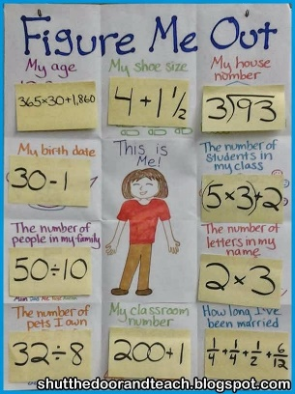  Do not forget to write the number sentences.
Music  https://www.bbc.co.uk/bitesize/subjects/zwxhfg8  From the selection pick at least three activities to learn about  - What are pulse and rhythm?  - What are duration and temp?  - What are melody and pitch?  - What is harmony?    - What is texture?  - Bitesize music quiz | Art and Design  Research and explore the work of Paul Cezanne and his still life art  Sketch at least three items in your house and experiment with tone and shade.  You could sketch your parents  Your favourite rooms  Something of importance to you.  Further sketching ideas and an online tutorial try:  https://www.youtube.com/watch?v=EJjKptSwyEY | PE  Be active for at least 30 mins exercise a day.    You could go for a bike ride with your family.  Have a jog around Gunners Park  Try making your own exercise video for your family to participate in.  Extra ideas visit:  https://www.st-crispinsinfants.org.uk/kent/primary/st-crispins/arenas/websitecontent/web/active-may-full-colour(3).pdf

