Year 3 Home Working Tasks 4
English – SPAG  Log on to www.spag.com  Using your password in your Home/School Book.  Complete the tasks set. More have been added. Revisit any that you have made mistakes on.  Why not try Super movers?  https://www.bbc.co.uk/teach/supermovers/ks2-english-collection/zmv4scw    English – spellings  Continue to practise your spellings from the year 3/4 list (10 per week). Get someone to test you.  Write a sentence using each of the words correctly. | English – reading  Continue to read for at least 15 minutes per day.  When you finish a book write a book review including.  • summary of story  • favourite character and why  • type of story (adventure, sci-fi)  • rate it  Create your own contents page for a non fiction book about you    Read your favourite book and create a glossary of any words you are unsure of. Test your family to see if they know the answers. | Maths  Log into https://app.mymaths.co.uk/  Work is added weekly and feedback is given.  Fancy something different?  Try these activites:  - Make a maths games  - Look through your kitchen cupboard and order items according to mass (g/kg) or volume (ml/l).  - Make a cake or biscuits and weigh out all ingredients and follow a recipe step by step.    https:// www.topmarks.co.uk/
Music  https://www.bbc.co.uk/bitesize/subjects/zwxhfg8  From the selection pick at least three activities to learn about  - What are pulse and rhythm?  - What are duration and temp?  - What are melody and pitch?  - What is harmony?    - What is texture?  - Bitesize music quiz | Art and Design  https://www.youtube.com/watch?v=v368l7nAltE  Create a landscape using any art medium you would like.  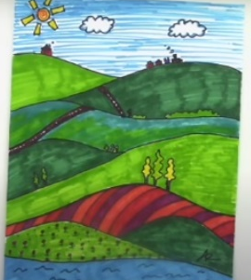  Try to include perspective and create different shades and tones of the colours used.  Watch the online tutorial to help you | PE    Do at least 30 mins exercise a day. Have you tried Joe Wickes’ workout at 9am Monday-Friday?  Try Cosmic yoga, there are loads of fun ways to learn yoga including Star Wars, Harry Potter and Minecraft.  https://www.st-crispinsinfants.org.uk/kent/primary/st-crispins/arenas/websitecontent/web/active-may-full-colour(3).pdf

