Year 4 Home Working Tasks Half Term
Hi Year 4 hope you are all well! We miss you! Hope you enjoyed the poem I (Mrs Smith) wrote I put it on facebook for you, hopefully your parents showed you it! Have you been keeping busy with these tasks? Don’t forget you can email us and attach pictures of any work you are doing. Thank you to those that have it is lovely to see! Don’t forget we have set lots of online tasks on Purple Mash, My Maths and SPAG to keep you busy too.
Maths Game
Have a go at ‘All Change Multiplication’. You will need a pack of cards with the Jokers, 10s and Jacks removed, and 2 pieces of paper with an ‘X’ and ‘=’ on them. Queens are worth 0 and Kings are the Wild Card!
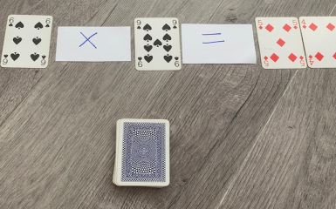
- Shuffle cards and give 8 to each player. 2 players is best. The remaining cards are put face down in a pile.
- First player lays down a multiplication number sentence which has a 2 digit product (answer)
e.g. 6x9=54 and then takes 4 cards from the pile.
- Next player does the same or can use some of the cards already put down e.g. could keep the 6
and lay 2,1,2 to make 6x2=12. They would then take 3 cards from the pile.
- If you cannot go take a card from the pile. The Wild Card (King) can be used to represent any
Digit 0-9. The next person can change the value of the Wild Card for their turn.
Winning the game;
- One player has used all their cards
- Or the draw pile has run out and nobody can go. In this case add up all the cards in your hand and the winner is the one with the least cards total. King is worth 10.

PSHE
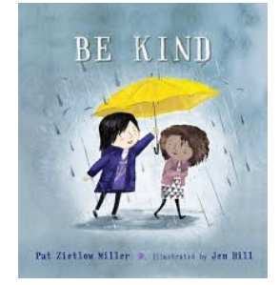
Following on from Mental Health Awareness week 18th-24th May here are some activities based on the book ‘Be Kind’ which you can watch on this link; https://youtu.be/I8eK0J2byJw

- Think about the key ideas in the book and design a poster to celebrate KINDNESS.
- Write a poem about kindness. It could be an acrostic, descriptive or narrative (story).
- Create and perform a play where the main character demonstrates acts of kindness. Write a
Part for the whole family.
- Draw your own Kindness Cup and think about who you are going to present it to and why.
- Research ways you could kind to the environment. Can you try any out at home?

D / T  Use building blocks, recycled materials, chairs, a deck of cards, or anything else you can to build a den, a tower, a vehicle or a robot.  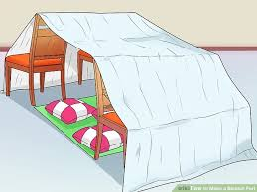 | Outdoor  - Create an obstacle course from items around your home / garden, this could include cushions to slides. Ask your family to complete it, time each person, who was the fastest? How could you make it harder?  - Collect some sticks can you build a pyramid with your sticks, can you make it stand up completely by itself?  - Draw a map of your garden  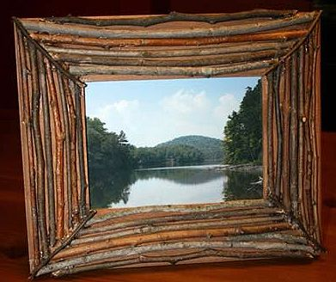
Art

Learn to love your outdoor space by framing artwork and photographs of your favourite scene. Get your creative juices flowing by using different media to capture snapshots of your outdoor environment. Then frame with sticks and create your very own art gallery.
You will need
- For your artwork: art materials (water colours, pastels, paper, sketchbook), camera or tablet
- For your picture frame: sticks, string, some interesting fallen objects from your favourite place.

