Year 4 Home Learning Grid – WATER- Summer 2020
Design a healthy dinner menu  You have a budget of £30. Research the price of food on an online shopping website and create a 3 course meal. How much did you spend? What was the cost per head?  Maybe you could ask your parents to buy the ingredients and you could make the meal.  Turn your dining room into a restaurant! Create a menu and dress up like a chef or waitor/waitress. If you have a brother or sister they could help you.   | Water  Watch the video on the water cycle  https://www.bbc.co.uk/bitesize/clips/z8qtfg8  Write your own detailed explanation of the water cycle with a detailed, labelled diagram. Can you think of a fun way to remember the cycle, maybe in a rap or a poem or a song?  Have a go at some of the experiments they suggest. Write up the experiment you did.  What else can you find out about water? Create a water project either by hand or typed on a computer. Can you upload your rap/ song that you made up about the water cycle. | Write a story in the style of David Walliams.  Read some of his stories think about his style of writing, what makes it funny? What key features does he include? Fronted adverbials, expanded noun phrases, speech, description?  Plan and write your own funny story, think about the settings, characters, opening, build up, resolution.  Organise your writing into paragraphs.  Try and include a few chapters, you could add a new one each week.  Remember to edit your story once you have written it, can you use more ambitious vocabulary?  Can you make your story into a book, create a front cover etc  Read your story to someone in your family, or record yourself reading it and send it to us via email.
Research a famous person of your choice.    For example: Jacqueline Wilson, Tayor Swift  Write a fact-file about key facts you learnt that were interesting to you. (If possible, complete on a computer if you wish and email it to the school.) | Spellings  Continue to practise your spellings from the year 3/4 list (10 per week). Get someone to test you.  Write a sentence using each of the words correctly.  Make a wordsearch using some of the words. Ask someone in your family to complete it and they could make one for you.   | Art
  Fill an ice cube tray with poster paint and stand a short craft or
  lolly stick in each one. Freeze overnight. Pop out of the tray and
  use immediately to create swirling patterns on thick art paper.
  Try creating multi-coloured paint lollies, or even some with
  glitter in! Shades of blue could create a lovely sea and river.
  For outside art, mix equal quantities of corn flour and water
  with plenty of food colouring.
  Freeze in an ice cube tray as before.
  Use to draw on the ground paving or on walls (with parents
  permission) – as the water evaporates the chalky colour will
  be left behind.
SCIENCE:  Living Things  Watch this clip and group the animals into a venn or carroll diagram.  https://www.bbc.co.uk/teach/class-clips-video/science-ks1-ks2-ivys-plant-workshop-grouping-living-things/zfjxcqt | PARENTS, PLEASE NOTE THAT BBC BITESIZE KS2 OFFERS DAILY/WEEKLY TIMETABLES & ACTIVITES FOR ALL CURRICULUM SUBJECTS IF YOU WISH TO USE THESE. THEY ARE ALL FREE AND MATCH OUR YEAR 4 CURRICULUM. YOUR CHILDREN CAN REVISE SKILLS WE’VE ALREADY LEARNT OR TRY NEW ONES. https://www.bbc.co.uk/bitesize/dailylessons  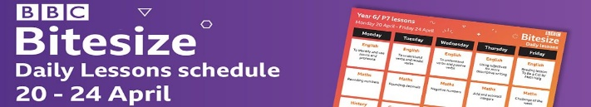
  Twinkl are also offering daily lessons with a daily timetable for free online. They have activities and tasks which are great to use as well. You can print worksheets off or just get them to work on paper. They also have links to live teaching videos.  https://www.twinkl.co.uk/home-learning-hub |  | MAKE A GRATITUDE JAR.  EACH DAY WRITE SOMETHING YOU ARE GRATEFUL FOR AND POP IT IN THE JAR!  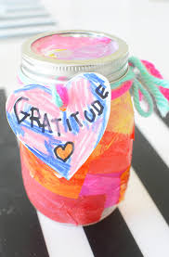
PE  Complete 30 minutes exercise each day, it could be going for a walk or playing football in your garden. Or completing the Joe Wicks workout, Mrs Smith’s whole family have been doing this every day! | Maths  Create a chart measuring how much water you use each day, record your results, then do the same for each member of your family. Put your results into a bar chart. Which area of the house uses water the most? Who uses the most water?  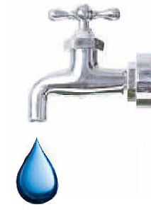 | COSMIC KIDS YOGA WEBSITE  Go into the ‘Zen Den’ and play the video ‘Be the Pond’. Remember Mrs Smith always saying ‘Be the Pond’!    It will help you relax and practice your mindfulness. Its very relaxing! There are plenty of other activities on Cosmic Kids you could explore too.
MATHS ACTIVITIES  Practise your times tables up to 12x 12. Can you create a new x table game? Let me know and I will share with the class.  My Maths tasks have been set, go online and complete the tasks.  www.mymaths.co.uk |  | PURPLE MASH  WILL BE WEEKLY UPLOADS OF ACTIVITIES TO DO ON PURPLE MASH, SO CHECK IN EACH MONDAY FOR NEW GAMES/ACTIVITIES TO COMPLETE.

