Year 3 Home Working Tasks 2
English – SPAG  Log on to www.spag.com  Using your password in your Home/School Book.  Complete the tasks set. More have been added. Revisit any that you’ve made mistakes on.  Why not try Supermovers?  https://www.bbc.co.uk/teach/supermovers/ks2-english-collection/zmv4scw  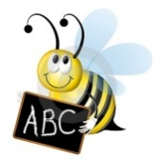  English – spellings  Continue to practise your spellings from the year 3/4 list (10 per week). Get someone to test you.  Write a sentence using each of the words correctly.  Ask someone to make anagrams of the words and you unscramble them e.g. ginuahr = hinguar | English – reading  Continue to read for at least 15 minutes per day.  When you finish a book write a book review including;  • summary of story  • favourite character and why  • type of story (adventure, sci-fi)  • rate it  Have a look at amazon book reviews for ideas and the type of language.  You could create a new book cover for the narrative you have just read.  Write a summary of the story but limit it to only 50 words. Can you include the plot, characters and brief summary?  Read a Roman myth  https://rome.mrdonn.org/myths.html |  | PHSE  Create a fact file, poster, poem to introduce yourself to me, Mrs Smith.  Things you could include are:  - Likes/dislikes  - Your family and friends  - What makes you, you!  - Interests and hobbies  - Hopes and dreams etc.  Mindfulness  Have you had enough of your little brother or sister running round and bugging you? If so, try this fantastic site. It’s free!  https://www.headspace.com/meditation/kids
Topic – project  History – The Romans  https://rome.mrdonn.org/  https://www.bbc.co.uk/bitesize/topics/zwmpfg8  Research and present in your own creative way;  - Who were they? Where did they come from? Why did they come? Maybe a map would help.  - What was daily life like? (Jobs, food, entertainment). Could you write a diary entry as if you were a Roman Soldier |  | 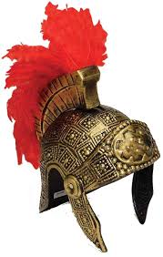  - Look at some artefacts, maybe sketch some. Do we still have them today?  - Can you draw and label a catapult? A Roman Solider and his armour?  - Research a famous Roman perhaps Julius Caesar or Nero  - Write some key dates using Roman Numeral.  - Create a timeline, ordering key events.
Science  https://buggyandbuddy.com/stem-activity-for-kids-popsicle-stick-catapults/  Make a Roman catapult and have a competition with your family as to who can catapult a ball of paper the furthest.  Investigate:  - Which type of paper is best? Tissue, kitchen roll, newspaper, plain paper.  - Does the size of paper matter?  - Does the size of the bucket matter?  Find a creative way to present your findings. | Art and Design  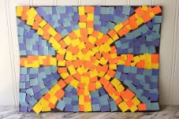  Research, plan and make a Roman mosaic representing something that represents you, it could be a hobby, an image of you and your family, a favourite book, place or even your favourite food.  Create a Roman artefact eg a goblet, shield, catapult or even a Roman coin. |  | PE  Do at least 30 mins exercise a day. Have you tried Joe Wickes’ workout at 9am Monday-Friday?  Brush up on your athletics skills; sprint, long jump, ball throw.  Try Cosmic yoga, there are loads of fun ways to learn yoga including Star Wars, Harry Potter and Minecraft.  https://www.youtube.com/watch?v=R-BS87NTV5I

