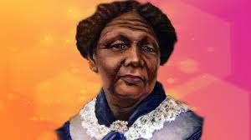
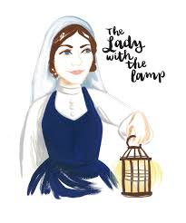
Year 2 – FAMOUS PEOPLE – 29th- 13th JULY 2020
You will be exploring several different people over the next two weeks. They will be significant people. This means they have changed events, improved people’s lives, changed people’s ideas or had a long lasting impact on their country or world! This can be a good or bad example to other people on how to live.
Whilst we have been keeping safe at home for the past few months, we have been thanking the NHS each Thursday to say thank you to our nurses and doctors who have helped us to get better if we get ill. This week you are going to explore three famous nurses who changed the way unwell people are cared for.
ENGLISH | HISTORY | MATHS | CREATIVE
WHO IS FLORENCE NIGHTINGALE?  Show an image of Florence Nightingale and ask ‘Do you know who this is?’  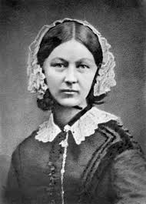  Watch: BBC clip  https://images.app.goo.gl/Nzv6rSS8w6wXshxs8  Write a fact-file about this famous nurse that treated many soldiers.  Include at least 5 new facts you have learnt. | https://www.florence-nightingale.co.uk/  Take a look at the web link above.  Make a poster of the things Florence Nightingale said need to happen in hospitals to make them better for patients.  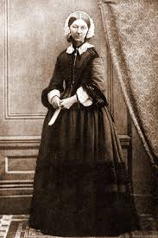  For more information on Florence Nightingale visit:  https://www.nationaltrust.org.uk/claydon/features/florence-nightingale-and-claydon-house  25 minute BBC horrible history programme:  https://www.google.com/url?sa=t&rct=j&q=&esrc=s&source=web&cd=&ved=2ahUKEwjMqITcgqTqAhVrURUIHQtlCQ4QtwIwBHoECAQQAQ&url=https%3A%2F%2Fwww.bbc.co.uk%2Fiplayer%2Fepisode%2Fb09vgbxj%2Fhorrible-histories-series-7-11-formidable-florence-nightingale&usg=AOvVaw3_6_sjZP6zpb3g-H7AYHHk | POSITION AND DIRECTION  https://youtu.be/iQYhlEadikw  Watch the power point to learn some key vocabulary for movement.  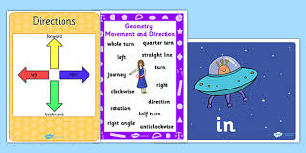  Complete the activities on BBC bite size.  Follow this link.  https://www.bbc.co.uk/bitesize/topics/z2grd2p/articles/zwv6b82 | 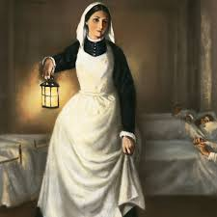  Create your own 3D ‘Fanoos’ (lamp) like the one used by Florence Nightingale in Scutari Hospital.    This video tutorial my help:  https://images.app.goo.gl/RdkX5xKLAH8cwKPT6
WHO IS MARY SECOLE?  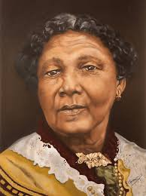  BBC Bitesize KS1 – Who was Mary Secole?  https://www.google.com/url?sa=t&rct=j&q=&esrc=s&source=web&cd=&cad=rja&uact=8&ved=2ahUKEwiJnZj7g6TqAhUktnEKHVTtCaAQFjAAegQIBBAB&url=https%3A%2F%2Fwww.bbc.co.uk%2Fbitesize%2Ftopics%2Fzns9nrd%2Farticles%2Fzjsxcqt&usg=AOvVaw2jU7cKItoP8SvnEUjKuPwX  Make a poster of the key words (adjectives) that describe Mary Secole… | National Geographic Website: Facts about Mary Secole.  https://www.google.com/url?sa=t&rct=j&q=&esrc=s&source=web&cd=&ved=2ahUKEwiJnZj7g6TqAhUktnEKHVTtCaAQFjAIegQICRAB&url=https%3A%2F%2Fwww.natgeokids.com%2Fuk%2Fdiscover%2Fhistory%2Fgeneral-history%2Fmary-seacole%2F&usg=AOvVaw2I7MxjUCAZirNU0A666za4  Read the above facts about Mary and make a BEFORE/AFTER poster about what Mary did before and after she was helping soldiers in the Crimean War. | FRACTIONS  https://www.bbc.co.uk/bitesize/topics/z3rbg82/articles/zq2yfrd  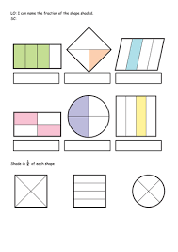  Complete the games and activities on fractions on BBC Bite size KS1.  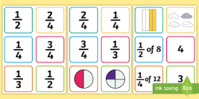 | 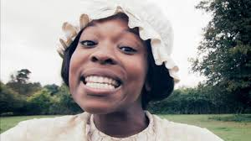  Watch CBBC Horrible History song about Mary Secole.  Learn the song and have a good sing-a long!  https://www.bbc.co.uk/cbbc/watch/horrible-histories-song-mary-seacole-song
WHO IS EDITH CAVELL?  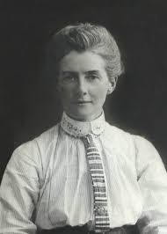  Read the power-point on Edith Cavell and how she helped at the Red Cross Hospital.  (attached as a zip file with this home learning grid)  Write a diary entry, as Edith Cavell talking about your day at work.  Remember a diary can include your thoughts and feelings.  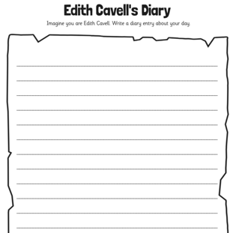 | https://www.cavellnursestrust.org/edith-cavell  ROLE-PLAY  Using the activity cards sent with this learning grid, act out some scenes Edith would have done in her every day life.  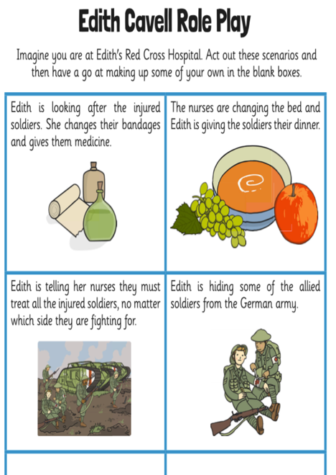  DISCUSS:  Was Edith a traitor or a hero during the First World War?  She helped soldiers from all different nations…should she have only helped the British? | Explore 2D shapes with Tessellation on BBC Bitesize.  https://www.bbc.co.uk/bitesize/topics/zjv39j6/articles/zgxwfcw  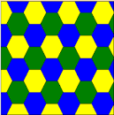  Watch a video clip of how to make your own tessellation pattern.  https://youtu.be/_Lg19NvW_sU   | WHO WAS INVOLVED IN THE FIRST WORLD WAR?  Look at a map of the countries involved in World War 1, 1914 (on the power-point).  Can you colour these countries on a blank map of Europe and label them?  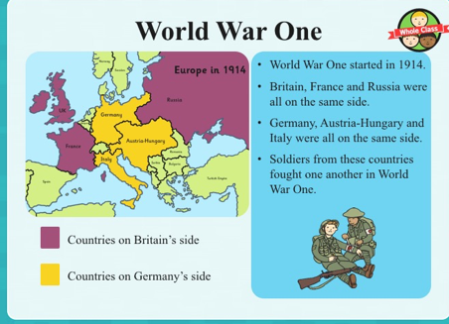
WHO IS QUEEN ELIZABETH II?  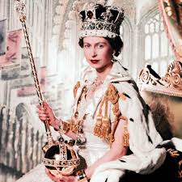 | WHO IS ALBERT EINSTEIN?  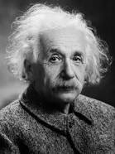 | WHO IS BARACK OBAMA?  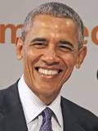 | WHO IS USIAN BOLT?  
WHO IS WILLIAM SHAKESPEARE?  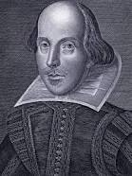 | WHO IS EMMELINE PANKHURST?  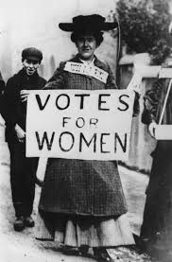 | WHO IS FALCON SCOTT?  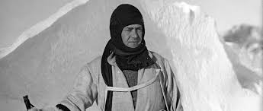 | WHO IS WILLIAM CAXTON?  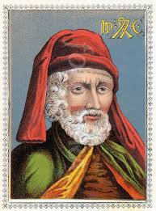

Dear Year 2,
Here are some more significant individuals for you to explore. Find out as much as you can about them. I can’t wait to look at your work you’ve been doing! Remember I have set lots of Maths, English and Science activities on Education City too…the new activities go live every Monday morning. Please remember to have some exercise each day too, indoors or outdoors! Have fun finding out these famous people! Mrs Mackay x

