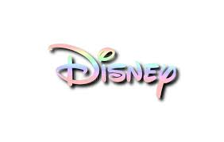
Year 2 – WALT DISNEY – 1st – 5th June 2020
ENGLISH | HISTORY/GEOGRAPHY | MATHS | ART/DT
WHO IS WALT DISNEY?  Show an image of Walt Disney and ask ‘Do you know who this is?’  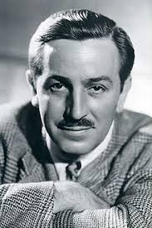  Then share some images of familiar Disney characters such as Elsa, Mickey Mouse, Donald Duck and Disney films such as Frozen, Pinocchio and The Lion King. Ask: ‘Who do you think this man might be?’ Explain that this is Mr. Walt Disney who was a famous artist who created cartoons. These cartoons were then turned into films. Show some old Mickey Mouse black and white.  Watch:  https://youtu.be/BBgghnQF6E4  https://youtu.be/kCZPzHg0h80  Write a review about what you thought about these early cartoons. What did you like? What didn’t you like? Why? | DISNEY CARTOONISTS  Watch the link of how the cartoonists created the first Disney animations in the 1930s.  https://youtu.be/M2ORkIrHUbg  Discuss how they did this, using flick picture books to create movement as there were no computers in those days so everything was done by hand. Even the sound was made by basic percussion instruments.  Make your own moving picture book: You’ll need some paper, a paperclip and a pencil.  https://youtu.be/Un-BdBSOGKY  (Please note the tutorial uses a light box to help him draw the next picture but you can easily do it without this by just lifting up the paper and look at previous one!)  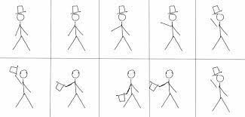 | 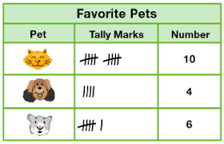  Create a tally table of your family’s favourite Disney characters.  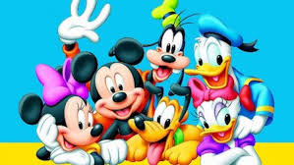  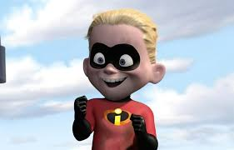  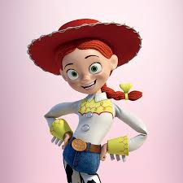  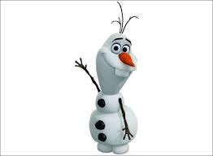 | 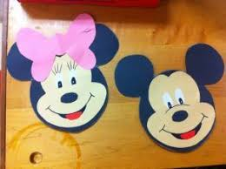  Create your own images of Mickey or Minnie Mouse in any choice of media. (sketching, painting or tracing).  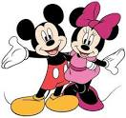
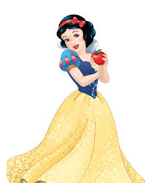  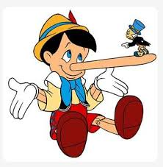  CARTOONS – SNOW WHITE & PINOCCHIO  Use the ‘Walt Disney power point’  https://youtu.be/VNZpDHlru3k  Talk about how Walt set up a company for people to enjoy the cartoons he drew. He drew Mickey Mouse and made a cartoon of him. It was one of the first cartoons ever. Walt even did Mickey’s voice. Discuss his early films such as Snow White and Pinocchio and the different characters he created for his cartoons.  Write a fact-file about Mr. Walt Disney.  (Include 5-10 new facts you have learnt) | Read the ‘Walt Disney’  power point from Twinkl website on the resource list with this grid.  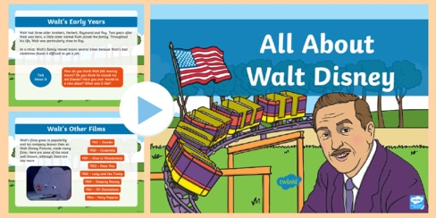  Discuss how Walt Disney changed the film industry. Identify that he was born in 1901 and created some of the most amazing animated films, even without the technology we have now.  Watch the link below to see all the films Disney has ever created! Choose you favourites and put them on a timeline in chronological order.  https://youtu.be/CNV3WLx5Ez4 | 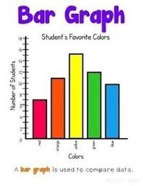  DISNEY BAR CHART  Draw a simple bar chart to show the tally results from yesterday.  Remember to write a title for your bar graph, and the titles on the sides of your graph ( eg: number of people and Disney characters) and use a ruler to draw the lines. | 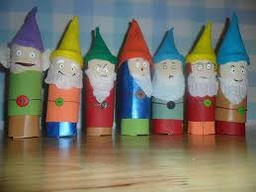  Could you make the 7 dwarfs from the Snow White film using toilet rolls or make a magic mirror using tin foil and gems? Let your imagination go!  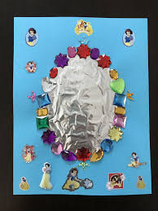
DISNEY LAND  Walt Disney built Disneyland parks so fans could meet his characters in real life. The castle is one of the most famous images that represents DISNEY. They also feature in many of the Disney films.  1. How many films can you think of that include a castle? Write these down in a list in your home-learning book.  2.Write a description of the castle, using adjectives, similes and conjunctions.  Eg: The castle shone brightly like a diamonds in the sky. It was grand, majestic and the turrets were sharp, like a spear! Purple, cream and yellow walls looked beautiful on the hillside. | 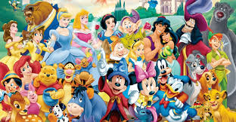  Create a poster of all the different characters you know.  Identify the similarities and differences between the characters. Eg: bad characters, good characters, how many are princesses or princes and how many are animals? | COMPLETE THE MATHS QUIZ WORKSHEET FROM  THE YEAR 2 HOME LEARNING SECTION ON THE SCHOOL WEBSITE. IT REVISES LOTS OF KEY SKILLS. | 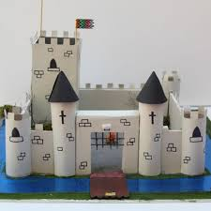  Design and make your version of the Disney Castle, you could use the junk modelling approach or make it all from cardboard and paint it in your own choice of colour!  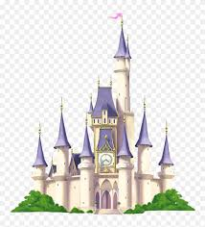
PUPPETS IN DISNEY  Write a set of instructions on how to make your shadow puppet or stringed puppet.  Think about how you are going to make your puppet. List the things you will need.  Then write your instructions with bossy verbs (imperative) Eg: Put, cut, fold, crease and draw.  Remember to use time conjunctions too… Firstly, secondly, thirdly, then, next, finally. | Watch the song from Walt Disney’s film Pinocchio ‘I’ve got no strings’:  https://youtu.be/iAykOz1gWi4  Talk about how the main character Pinocchio and other characters are all puppets made to move by a humans moving the strings attached to different parts of the puppet.  TASK:  ‘Disney would like you to design and make a new Disney character in the form of a shadow puppet.’ | TIME/ORDERING:  Find out how long your favourite Disney films are? Look at least 6 films.  Write them in a list of the longest film to the shortest film.  Eg: Lion King – 1hr 58mins | 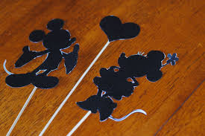  Make a shadow puppet based on a Disney character of your choice.  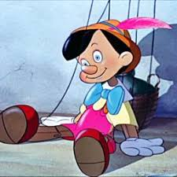  Or, make your version of Pinocchio with strings!
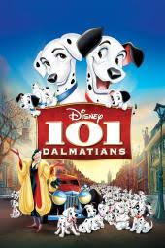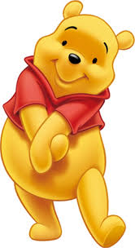  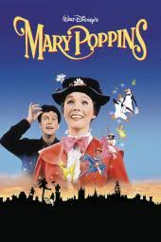  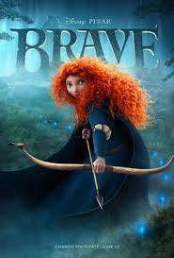  Disney SETTINGS:  Watch trailer clips of the films ‘101 Dalmatians’ ‘Winnie the Pooh,’ ‘Mary Poppins’ and ‘Brave.’ After viewing each clip, discuss the settings of the film, what were like and where they think this might be. Talk about how some of the settings are animated and some are live action.  https://youtu.be/HrB6zm1C-r8  https://youtu.be/QbFz--GCkOM  https://youtu.be/nOfH7uEojKk  https://youtu.be/TEHWDA_6e3M  Write a setting description of one of the above films, including lots of adjectives, adverbs, similes and alliteration. | 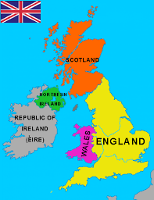  Display a map of the UK and locate where each film was set and why the films were set here.  Record these on the blank UK map provided.  Remind your child of the four countries and capital cities of the UK using the map and ask: ‘Which two countries haven’t had Disney films set in them?’ Identify that Wales and Northern Ireland haven’t had films set in them.  England = London Wales = Cardiff Scotland = Edinburgh Northern Ireland = Belfast | 2D SHAPE CHALLENGE:  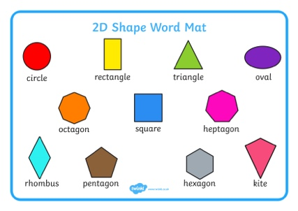  Draw Disney characters from just 2D shapes!  Remember when we did made snowmen at Christmas from 2D shapes?  You could start wit Olaf… an oval for the head and a circle for his body, use small thin rectangles for the arms, a triangle for his nose and small circles for buttons on his tummy!  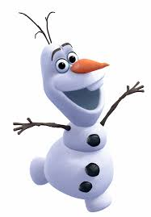  Get creative! | CHOICE TIME!  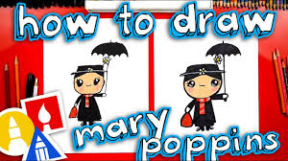  Follow the online tutorial to draw Mary Poppins.  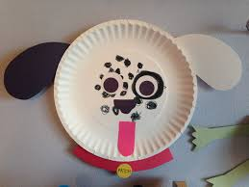  Make a Dalmatian puppy from a paper plate.  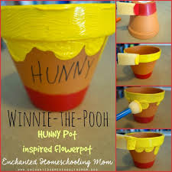  Paint an old pot to look like the honey pot Winne the Pooh liked to eat from.  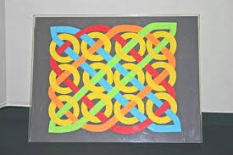  Design and colour your own Celtic pattern that are seen in the film –Brave.

