Year 1 & 2 May Half Term Challenges
ENGLISH | MATHS | MUSIC | SPORT
Read a favourite story and create a book review for it.  Would you recommend it? Why? Why Not?   | Design a new maths game. It could be something similar to Snakes and Ladders. You could have time challenges or times table facts.  Play your game with someone in your house.  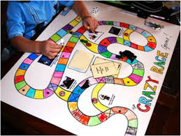 | Write your own song lyrics about what life is like during lockdown.   | Create your own obstacle course in your garden. How quickly can you complete it? Can you beat your time?  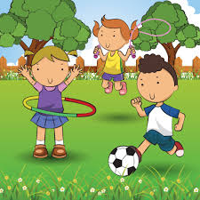
Create a new adventure for a character from a story you already know. Think about where the new adventure would take them and what challenges they may face.  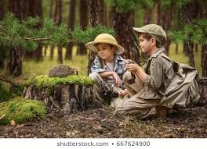 | Create a timetable of your day or your week.  Draw clocks to show the different times and then record what you are doing.  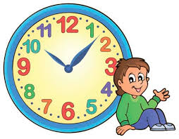 | Listen to some relaxing music. Draw pictures of what you are thinking and how you are feeling as you listen.   | Practice your throwing skills using a pair of socks made into a ball. Can you improve your aim? Can you improve your distance throwing? Challenge someone in your family.  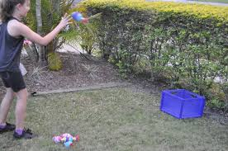
Create a fact sheet about something that interests you. Include key facts and information. Add some diagrams too.   | Create a secret code using numbers to represent the words and letters. Can anyone in your house crack your code and work out what your message says?  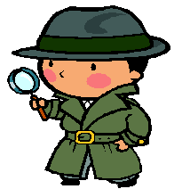 | Create your own dance routine to a song you like. Perform your routine to someone in your house.  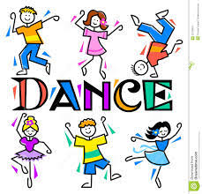 | Play animal races. Hop like a rabbit, Slither like a snake. Waddle like a duck. Which other animal movements can you include?  

