Keeping Active  To make sure you are keeping your bodies as well as your minds fit and healthy, how about joining the Body Coach and doing his 5 Minute Moves’ throughout the day. Alternatively, from 9-9.30 Monday to Friday join in with his live PE lesson  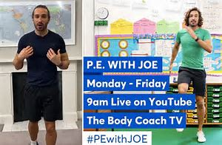  https://www.youtube.com/watch?v=d3LPrhI0v-w  Or try Cosmic Kids Yoga for more relaxing activities and mindfulness.  https://www.youtube.com/watch?v=YR1OxBk8BF4 | Keeping Active  If you prefer to exercise to music, ‘Go Noodle’ has lots of songs to dance to and Zumba Kids on Utube is another great tool to use to keep you active.  https://www.gonoodle.com/blog/gonoodle-games-movement-app-for-kids/  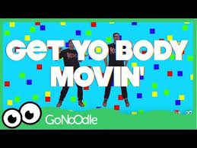  Zumba Kids (easy dance) - I like to move it  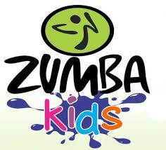 | Writing /Science/Geography  Explore what a habitat is and what our ocean habitats are like. You may wish to watch clips from CBBC Blue Planet II ‘ Our Blue Planet’ on iplayer Series 1: Eposide1 One Ocean. On BBC Bitesize KS1 there are mini clips to watch and quizzes to complete.  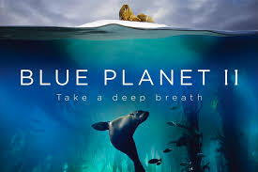  https://www.bbc.co.uk/bitesize/clips/zjynvcw  https://www.bbc.co.uk/bitesize/topics/zx882hv/articles/zsfkd2p  Exploring food chains: Video clip to watch & a quiz.  https://www.bbc.co.uk/bitesize/clips/z96r82p  http://www.bbc.co.uk/guides/z3c2xnb  Activity 1 – FACTFILE  Write a fact-file about the ocean habitat. Include pictures and full sentences. Try to use some of these conjunctions (and, but, because, for, nor, or, yet so)  Activity 2 – POSTER  Design a poster about the 5 oceans of the world. Include some pictures and what countries or continents can be found are near them.  PACIFIC, ATLANTIC, INDIAN, ARCTIC, SOUTHERN | Writing /PSHE/GEOGRAPHY  Activity 3 – POEM    Write a poem about how you feel during your time away from school. It may include many different emotions; you probably feel different each day- that’s OK.  Here are some emotions you may have felt: Worried, sad, scared, tired, bored, excited, relaxed, settled, calm, helpful, loving.  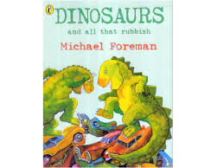  Activity 4: Read/ Listen to the story ‘Dinosaurs and all that Rubbish’ by Michael Foreman.  https://www.google.com/url?sa=t&rct=j&q=&esrc=s&source=web&cd=2&ved=2ahUKEwjoo5Kr2Z_pAhW1SBUIHexqBPcQwqsBMAF6BAgUEAk&url=https%3A%2F%2Fvimeo.com%2F223613105&usg=AOvVaw3s3aIaXdR4U12ht2x0bQZh  Write a letter to the rich man in the story and explain why it’s important that he must look after his planet ‘Earth’.  (Helpful Words: care, destroy, protect, animals, plants, people, healthy)
Ready, steady, cook!  Can you bake some sea themed cookies? Could you make them into shapes of a shark or a jelly fish? Maybe you write a list of ingredients and how you did it? |   VE day Celebrations  8th May 2020  English Heritage have a pack for a Stay at Home Street Party.  https://ve-vjday75.gov.uk/ has ideas for how to commemorate VE day at home.
PSHE  Treasure Chest of Positivity –  As a family can you find or make a special box//treasure chest. Everyone has to continue to add positive messages or positive things that have happened as the treasure. This could be the seeds you planted have started to grow. Or maybe you went for a walk and saw beautiful signs of spring or you spoke to a friend or family member over the phone or on the computer. It would be lovely to share these back in class later on.  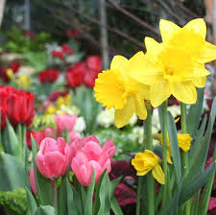  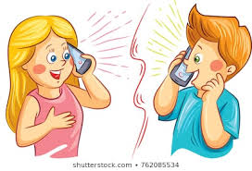  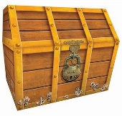 |  | ART  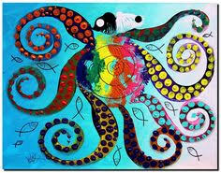  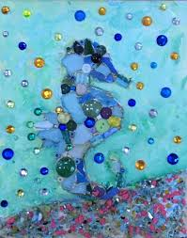  As we exploring the habitats of the ocean, please draw, paint or make any animal you may find in our seas and oceans. Use your imagination. Here some ideas below:  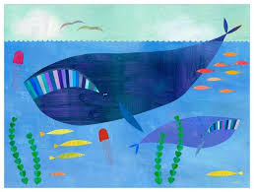  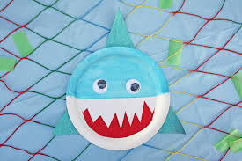  Make a paper whale  https://www.redtedart.com/easy-origami-whale-paper-crafts-kids/ | Spellings & SPaG  Please continue to practise the words from the Year 2 Common Exception Word list, sent home in the Home Learning folders. Maybe try applying these to some sentences or write a paragraph with your choice of 10 words.  You could explore ‘homophones’ words on BBC bitesize if you wish. These are words that sound the same, but are spelt differently. Eg: flower and flour or night and knight. Each hyperlink below leads you to learning screen and then a quiz.  https://www.bbc.co.uk/bitesize/topics/zqhpk2p/articles/zc84cwx  https://www.bbc.co.uk/bitesize/topics/zqhpk2p/articles/z3cxrwx  https://www.bbc.co.uk/bitesize/topics/zqhpk2p/articles/zc4jpbk
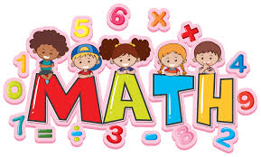  Maths  Would you like to take part in a competition?  If yes, log onto the’ Young Money Challenge’ competition link below.  https://www.young-enterprise.org.uk/youngmoneychallenge  Then download the Ages 4-7 category.  Your children will be discovering the environmental and financial benefits of conserving energy and water and exploring how they can share this learning with your friends and family.  You can then choose which activity you would like to complete and enter into the competition. The choices are:  - Design a sign for your home or for our school to remind people to use less energy and water.  - Make a poster of a superhero who both saves money and saves energy.  - Design a ‘Save the Planet’ poster showing the small actions we can all take to save the planet and save money.  We are exploring ‘Measurement’ on ‘Education City’ currently. This includes exploring weight, capacity and length and time. Below are some links to video clips and activities that will support some of these skills.  https://www.bbc.co.uk/bitesize/topics/zt9k7ty/articles/zp8crdm  https://www.bbc.co.uk/bitesize/clips/zk8jxnb  https://www.bbc.co.uk/bitesize/clips/zdw7tfr  As always, please continue to practise your 2x, 5x and 10x tables Year 2 – I’ll look forward to completing some ‘Times Table Award Challenges’ with you when we get back to school. |  | Geography  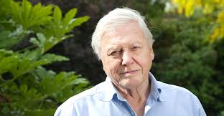  Research some facts about Sir David Attenborough.  Did you know he is a naturalist?  See if you can find out what this means and see what you can find out what he has done to help protect our planet and local environments.  The ‘National Geographic for Kids’ website has some super information.  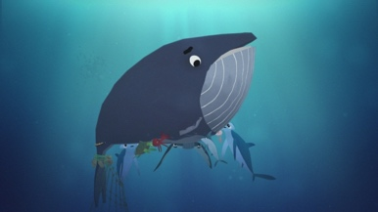  Watch the short 3 minute film called The Whale’s Tale  https://www.hopeworksproject.com/films/#  What was the problem? How was is it solved?  Design a poster to encourage people to look after our oceans better. | Science Experiments with Water  https://www.rigb.org/families/experimental  The above link is a great website for lots of science ideas at home, short video clips for what to do.  Floating and Sinking  1.Gather together a collection of “treasures”, a large bowl or sink/bath of water and somewhere to record your findings – paper, whiteboard, chalk board or photos.  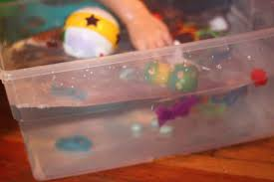  Feel each object and predict whether each one will sink or float.  Record the predictions in a table  Test each item by dropping it carefully into the water.  Record the results for each item in the table.  What do you notice about items that float or sink?  Can you make a sinker float?  2. Make a boat (recycle a container maybe), check it floats and then carefully place each object that sank inside the boat. They should now float! How many items can your boat hold?  Science with Maddie Moate is highly recommended: here’s a link to an episode called Float!  https://www.youtube.com/watch?v=PGWpJ5DFevc&list=PLmTANLv-GyXU-MYxomFbiueNTGVW7DVV8&index=4
RE  How should we care for others in the world and why does it matter?  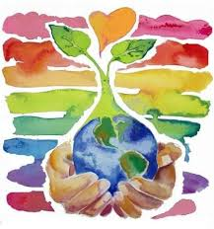  KINDNESS  Question: What is being kind?  How would you show kindness to your family or your friends? https://www.hopeworksproject.com/films/#  1.Write or draw a prayer/message to show the world that you care about it.  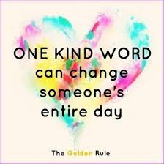  2. Write or draw a prayer/message to your family or friend that you care about them. |  | 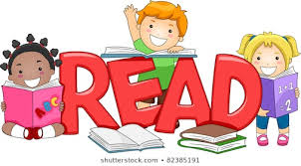  Get Reading!  Read whenever and wherever you can!  The books could be linked to our theme of ‘The Environment’ or anything else you like reading.  Why not send us your photos of all of the strange and wonderful places you find to read! | Music  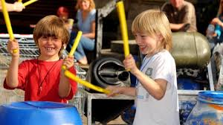  ‘Weapons of Sound’ is a teenage band that have made music from recycling and using old rubbish bins. Watch the clip below to be inspired.  https://www.bbc.co.uk/bitesize/clips/zndhyrd  Can you make your own musical instrument from recycled rubbish in your home? (Maybe old tins, plastic bottles etc…)  Maybe you could make your own tune and record it? I’d love to hear it!

