
Dear Class Seagull,

Hello everyone!

I hope you are all safe and well at home with your family. It is a rather strange time for everyone isn’t it? We can’t visit our family members or have play dates with our friends, but most of all, we can’t be together in class at the moment. We have all been away from school for five weeks now and are missing each other very much but hopefully we can all be together soon when it is safe. I am looking forward to that moment when I can finally see you all again.

I am feeling well children and my family are too now. Our pets at home are wondering why we are always here… My cat, Sophie is demanding I feed her all day long! She is very greedy, however she is enjoying the extra attention and cuddles she is getting now. Our two chickens have been enjoying the extra food scraps and have been very noisy too and they are now finally laying eggs!

I hope you all had a lovely Easter time and are enjoying the extra time spent with your family at home. I have enjoyed being with my family, including the love, laughter, arguing, sharing, helping and the mess! My daughters offered to bake some cakes last week, they left flour everywhere! Messy girls! I hope you have been kind to your brothers and sisters and parents.

I wonder who has done at least one kind deed today? Maybe you could start this now? Do you remember when we did this at school in December when we were counting down to Christmas? Maybe you could make your bed and tidy your toys away without being asked or help lay the table for dinner? It’s up to you to choose.

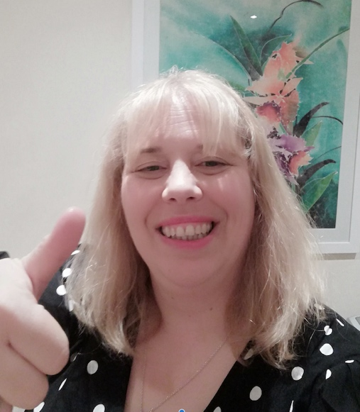
I have also put a little video message on the Hinguar Facebook Forum to say ‘Hello’ to you all too, if you can, take a peek, you’ll be in for a treat! Until my next message to you all, please remember that you can carry on with your learning by taking a look at the ‘Dinosaur’ & ‘Transport’ themed home-learning grids on our school website. Ask your parents to click on the tab at the top of the Hinguar website that says PUPILS, then click on the drop down menu that says HOME LEARNING. I have put lots of ideas and activities on there for you to choose from. Please do try to complete some of these tasks as it will help you to keep your brain healthy and alert. If you can, share your work on the new ‘home learning’ Hinguar email set up this week so I can enjoy looking at your wonderful work.

Take care children, stay home and keep safe.

Love from Mrs Mackay
x

