Year 2 Home Learning Grid – TRANSPORT- Summer 2 2020
Explore some famous inventors of transport:  What did they invent and was it successful?  Could you make a list or table of all the different inventions you discover?  Here are some ideas: gliding machine, submarine, paddle wheel steam boat, airship, helicopter, hovercraft, bullet train, Concorde, Boeing 707.  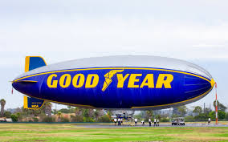 | Design and draw a new type of vehicle.  Will it travel through water or will it be a flying car?  How big will it be? Will it have wheels or wings, or both?  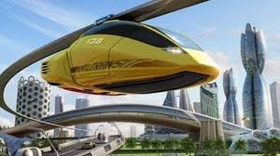 | Write a postcard or letter from space. Pretend you are the International Space Station and describe what its like on the ISS and what you are doing up there. To help,  look up Tim Peake, the UK astronaut, on the internet. Watch his amazing video clips for children about life in space. ‘Cosmic classroom’ is good video.  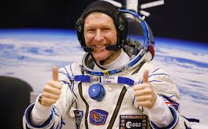
Research a famous astronaut.  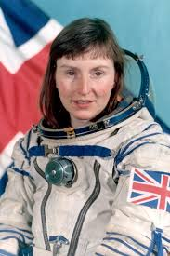  For example: Tim Peake, Von Braun, Yuri Gagarin, Helen Sharman or Dennis Tito.  Write a fact-file about key facts you learnt that were interesting to you. (If possible, complete on a computer if you wish and email it to the school.) | Make a poster about one type of transport.  IDEAS: a sports car, a spaceship or even a hot air- balloon!  Remember to include pictures, sub-headings and some exciting facts.  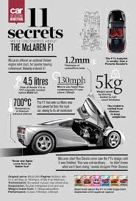 | 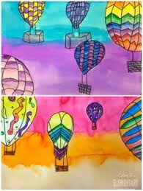  Can you make/draw a hot air balloon picture from paint or coloured paper. What design would you put on your balloon? Or a rocket blasting off into space?  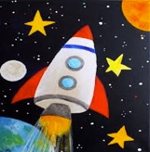
SCIENCE:  LOG ONTO BBC BITESIZE KS1 – SCIENCE  EXPLORE THE UNIT ON PLANTS  (There are videos and quizzes to complete.)  - What does a plant need to grow?  - What plants can you find outside?  - What are the parts of a plant?  - What is the life cycle of a plant?  If you have any seeds at home, try growing your own plants, maybe a sunflower plant or some cress. If you can, send me your pictures, if not, draw the growth and I’ll look at your work later. | PARENTS, PLEASE NOTE THAT BBC BITESIZE KS1 OFFERS DAILY/WEEKLY TIMETABLES & ACTIVITES FOR ALL CURRICULUM SUBJECTS IF YOU WISH TO USE THESE. THEY ARE ALL FREE AND MATCH OUR YEAR 2 CURRICULUM. YOUR CHILDREN CAN REVISE SKILLS WE’VE ALREADY LEARNT OR TRY NEW ONES.  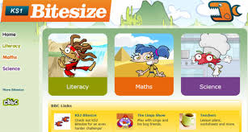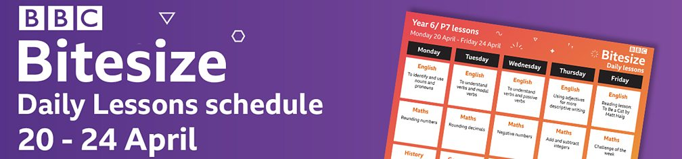
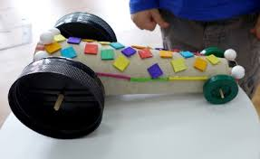  Make a 3D vehicle from junk modelling (recycled materials)  Use boxes, yoghurt pots and whatever you can find!  It could be a hot air balloon, a submarine or even a helicopter! | BIG QUESTION TIME:  Will humans be able to travel to the other planets, like Mars in the future? How will they get there? | MAKE A GRATITUDE JAR.  EACH DAY WRITE SOMETHING YOU ARE GRATEFUL FOR AND POP IT IN THE JAR!  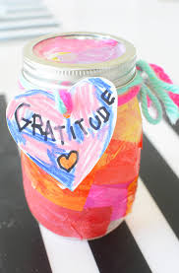
COOKING:  Bake your own ‘transport’ themed biscuits. Yummy! Remember to use your maths skills when measuring the ingredients.  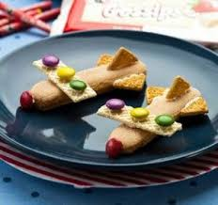 | MEASURING CHALLENGE  Measure 5 small objects different objects in your house with a ruler - measure them in centimetres (cm)  Measure 5 large objects (like your sofa and bed) and use a tape measurer. You can measure in cm again.  100 cm = 1 metre  Could you find more objects that are bigger than 1 metre.  (the size of Mrs Mackay’s brown teaching ruler we count on in class) | COSMIC KIDS YOGA WEBSITE  Go into the ‘Zen Den’ and play the video ‘Be the Pond’.    It will help you relax and practice your mindfulness. Its very relaxing! There are plenty of other activities on Cosmic Kids you could explore too.
FREE BOOKS - READING WEBSITE  WHEN TRYING TO RESEACH FACTS ABOUT TRANSPORT USE THE FOLLOWING LINK TO ACCESS HUNDREDS OF BOOKS TO HELP YOU AS WELL AS FICTIONAL STORIES.  ENJOY A GOOD BOOK!  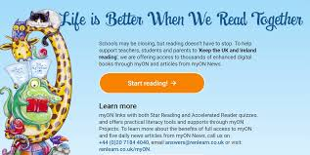  Just press the orange button  readon.myon.co.uk  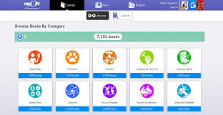 | MATHS ACTIVITIES  GO TO THE BBC BITESIZE KS1 WEBSITE.  CLICK ONTO MATHS. THERE ARE LOTS OF ACTIVITIES TO TRY. HAVE A GO AT THE FOLLOWING ACTIVITIES  (This works on a computer, tablet or phone)  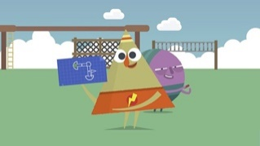  HOW TO USE DIRECTIONS AND TURNS.  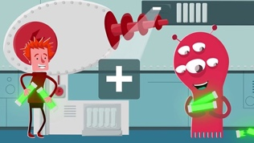  ADDING AND SUBTRACTION | EDUCATION CITY  THERE WILL BE WEEKLY UPLOADS OF ACTIVITIES TO DO ON EDUCATION CITY, SO CHECK IN EACH MONDAY FOR NEW GAMES/ACTIVITIES TO COMPLETE.  

