Hello Seahorse Class! We hope you are safe and well. The activities listed below are possible home learning tasks. Children in school will be completing similar activities. Please feel free to email school if you need anything we will answer as soon as we can.
Best wishes, Mrs Hawkridge and Mrs Newman

If you have the story – Sports Day with the Large Family read this together, or you can watch it here...  https://www.youtube.com/watch?v=DS1c4jQT9nY&t=325s  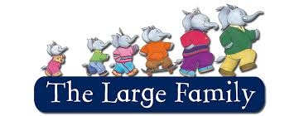 | Sports Day with the Large Family  Discuss the story and ask your child to recap the story in their own words. How did the story begin, what happened in the middle, how did it end?  Who is their favourite character and why? Can they draw their favourite activity from the Large family’s sports day? | Sports Day with the Large Family  Produce a sports day programme, can you include a range of activities, for example, skipping, running, throwing a bean bag etc. Can each event have a description and a diagram of how you do the activity? Remember to include the timings of each activity!
Sports Day with the Large Family  Now you and your family could take part in the sports day activities you wrote about in the sports day programme.  Who can do the most skips in 30 seconds? Who can run on the spot for 30 seconds? Remember to drink lots of water in between each activity! | Sports Day with the Large Family  Ordinal numbers – have a discussion about ordinal numbers (1st, 2nd, 3rd etc) You could link this to the sports day activities, i.e. who came in 1st place 2nd place etc. You could also talk about a routine you have at home e.g when brushing teeth, first you get your toothbrush, second you put toothpaste on the brush and so on ... | Sports Day with the Large Family  Sports day wouldn’t be complete without a medal and a certificate!  Can you design a medal for each person who took part and a certificate with their names on? Don’t forget to do one for yourself!  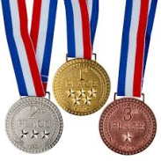
Health and Fitness  Please help your child to produce a ‘Mind Map’ linked to health and fitness. Subheadings could include food, drinks, exercise, sports, and one linked to personal hygiene and sleep.  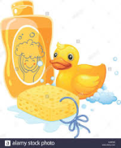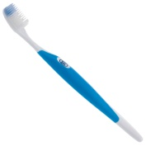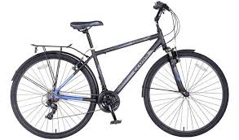 | Health and Fitness  Can you make a fruit smoothie or fruit kebab? When you have made it you could practice your writing by making a set of instructions. Don’t forget to use the correct vocabulary – first, second etc...  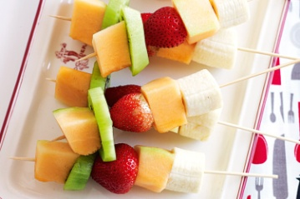 | Maths  In school we would now be working on addition and subtraction maths questions. You could start by using simple addition and use physical objects e.g. If I have one apple and I add another apply how many apples will I have altogether? Have the apples or other items for your child to count. Ask your child to then write the sum down in numbers  1 + 1 = 2. Let your child guide you by which numbers to try. We would try and use numbers up to 20.
Websites to explore / Additional resources
If your child enjoyed the Large family story there are plenty more with lots of different adventures for the Large family!

Some more adventures for the Large family
https://www.youtube.com/watch?v=JBxAxrqAaTY

https://www.youtube.com/watch?v=ua1O2JhPqfg

Jasper’s Sports Day – Another sports day related story
https://www.youtube.com/watch?v=fY8xD4PTHd0

There are lots of ordinal number worksheets on the Twinkl website
https://www.twinkl.com/search

Writing instructions Power Point Presentation
https://www.twinkl.co.uk/resource/t-c-7829-writing-instructions-powerpoint

Oak National Academy – online Reception Maths Lessons
https://www.thenational.academy/online-classroom/reception/maths#subjects

Hungry Little Minds
https://hungrylittleminds.campaign.gov.uk/

