Hello Seahorse Class! We hope you are safe and well. The activities listed below are possible home learning tasks. Children in school will be completing similar activities. Please feel free to email school if you need anything we will answer as soon as we can.
Best wishes, Mrs Hawkridge and Mrs Newman

If you have the story – The Rainbow Fish read this together, or you can watch it here...  https://www.youtube.com/watch?v=ifXlc0QI2kY  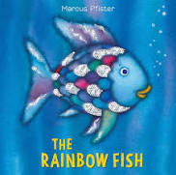 | The Rainbow Fish  Discuss what makes a good friend – draw a picture of your friend and label the picture with words that describe your friend.  Helpful  Kind | The Rainbow Fish  Make a friendship bracelet, you could use beads, loom bands, plait wool or cotton, use paper and decorate. There are lots of videos online how to make a variety of bracelets.  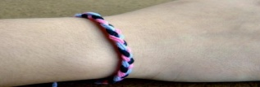
The Rainbow Fish  Make your own rainbow creature, it doesnt have to be a fish! You could use a paper plate, card, paper, recycled boxes etc  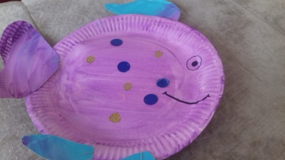 | The Rainbow Fish  Use books or the internet to find out two facts about a creature that lives under the sea.  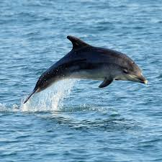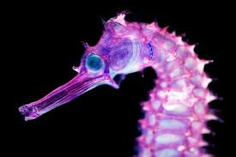 | The Rainbow Fish  Sinking and Floating Experiment -  Gather a few items from around the house and a large bowl of water, you could also do this experiment in the bath or paddling pool!  Ask your child to predict if the item will float or sink before trying each one individually. Use the link below if you would like to record the experiment.  https://www.twinkl.co.uk/resource/t-t-5448-float-or-sink-activity-sheet
The Rainbow Fish  Phonics challenge – The word fish has a diagraph at the end ‘sh’ - can you write a list of words with different diagraphs or triagraphs.  Some we have been learning include...  sh, ch, th, ck, ng, nk, igh, ay, oo, ee | The Rainbow Fish  Repeating patterns – In class we have looked at colour repeating patterns. Can you now show some examples of size or different objects in a repeating pattern?  See attached sheet for examples. | The Rainbow Fish  Imagine you are a fish, can you write an underwater adventure?  Remember to describe your character, explain what adventure they are going on and have a clear ending.  Where will your fish go? What will they see? How will they feel?  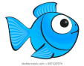
Websites to explore / Additional resources

Diagraphs
https://www.twinkl.co.uk/search?term=diagraphs+phonics

What is a trigraph?
https://www.twinkl.co.uk/teaching-wiki/trigraph

Tricky words song
https://www.youtube.com/watch?v=3NOzgR1ANc4

Oak National Academy – online Reception lessons
https://www.thenational.academy/reception/foundation/kind-friends-reception-wk3-1

Hungry Little Minds
https://hungrylittleminds.campaign.gov.uk/

Repeating Patterns
- 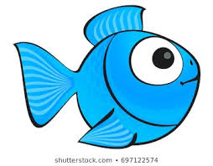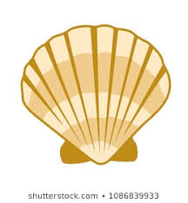

- 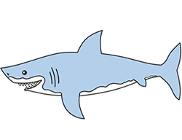

- Make your own repeating pattern up then ask someone in your house to continue the pattern.

