Creative | Physical and Well Being
Music  Click on the link below to practise our ‘Sing Up’ songs, some favourites are:  1,2,3 It’s Good to be me...  https://www.youtube.com/watch?v=igmU0b65WCU  I once saw an elephant...  https://www.youtube.com/watch?v=PGZlzrM0ChI  You could try learning a new one, Sing a Rainbow...  https://www.youtube.com/watch?v=5xlbwSJFDDU  Dance  Join in one of our favourite dances in class...  The Penguin Dance...  https://www.youtube.com/watch?v=uf0uKmKwnKs  Can you make up any of your own moves? Could you make up a song about a different animal? | The Bean Game - Gather everyone in your family to take part in one of our fun PE games. Start by walking around the room or on the spot, the leader calls out a variety of beans and everyone does the action relating to that bean, here are some of our favourite beans...  Runner bean – running on the spot, Broad bean – stretch your arms and legs out wide like a star, Baked bean – crouch down in a ball shape, French bean – Oh la la! Beans on toast – lay on the floor in a star shape, Evil Pea – Mwah ha ha  Floss and count! - Be active and practice counting with this fun dance...  https://www.youtube.com/watch?v=8hD26XpuUCc  Sticky Kids – Try out the listen and repeat routines  https://www.youtube.com/watch?v=DCFrmFQIdnY  https://www.youtube.com/watch?v=YHtugTBUM9M
Literacy | Mathematics
Character Review  Re-read your favourite story. Write a character description. You could draw the character, write down what they look like, things they enjoy, don’t enjoy, are they a happy person? cross? well behaved or naughty?  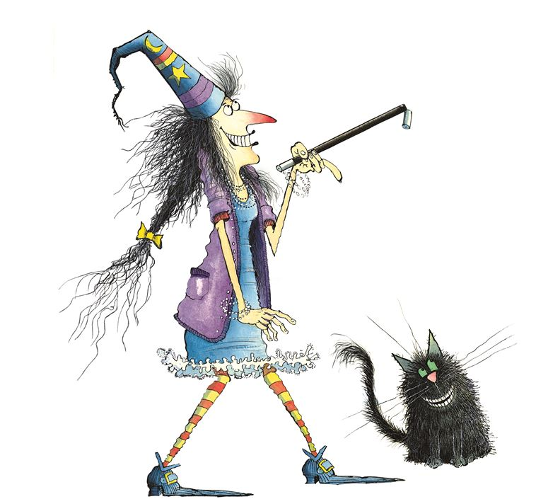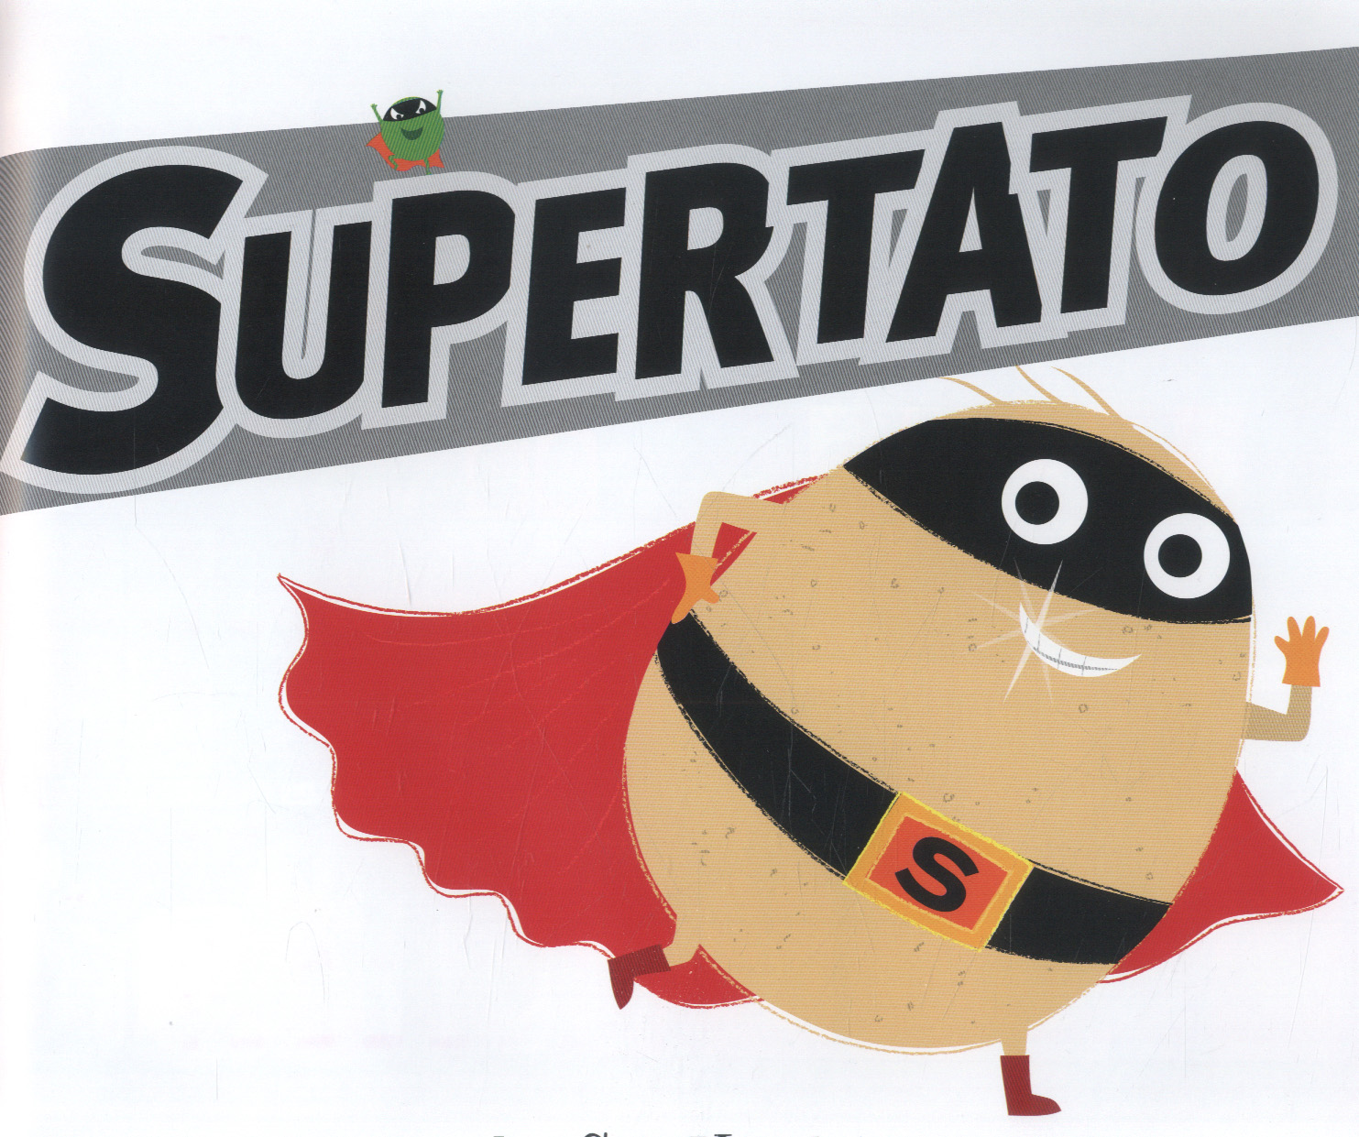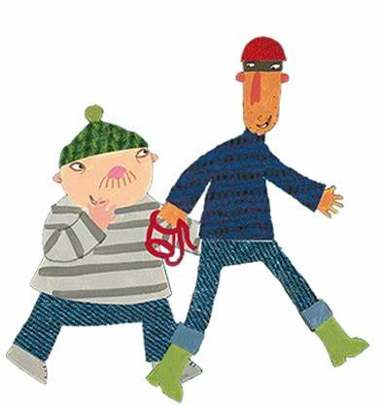  Could you then design a new outfit for the character? Or place your character in a new setting? Get creative! | Diary  Discuss with your child what a dairy is, show them different examples of dairies and calendars. Point out the different months and the days of the week, find birthdays and special dates for your family.  We often sing this day of the week song...  https://www.youtube.com/watch?v=8GKmCQOy88Y  Months of the year song...  https://www.youtube.com/watch?v=omkuE6Wa5kQ  Over the half term write a dairy of what you do each day, just a simple sentence and a picture would be great. Don’t forget to write the date each day!

