Hello Seahorse Class! We hope you are all safe and well. The activities listed below are possible home learning tasks. Please feel free to email school if you need anything we will answer as soon as we can. Best wishes, Mrs Hawkridge and Mrs Newman

To celebrate VE day use different materials to design a medal   | Create a 1940’s tea party. You may need to make food, drink, bunting, flags and music. Can you write a menu?   | Cut out and fold the attached spitfire. See how far it will fly, make different paper aeroplanes to see which one will go the furthest. How can you measure this?  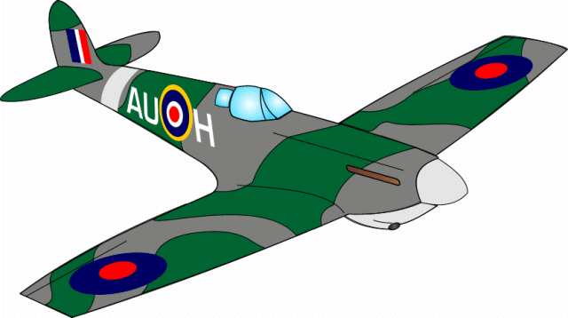
Watch a film and write a film review. Why did you like it? What were your favourite parts? What would you change? Can you rate it out of 5?   | Can you make a musical instrument? What could you use? Can you use your instrument to sing some songs?  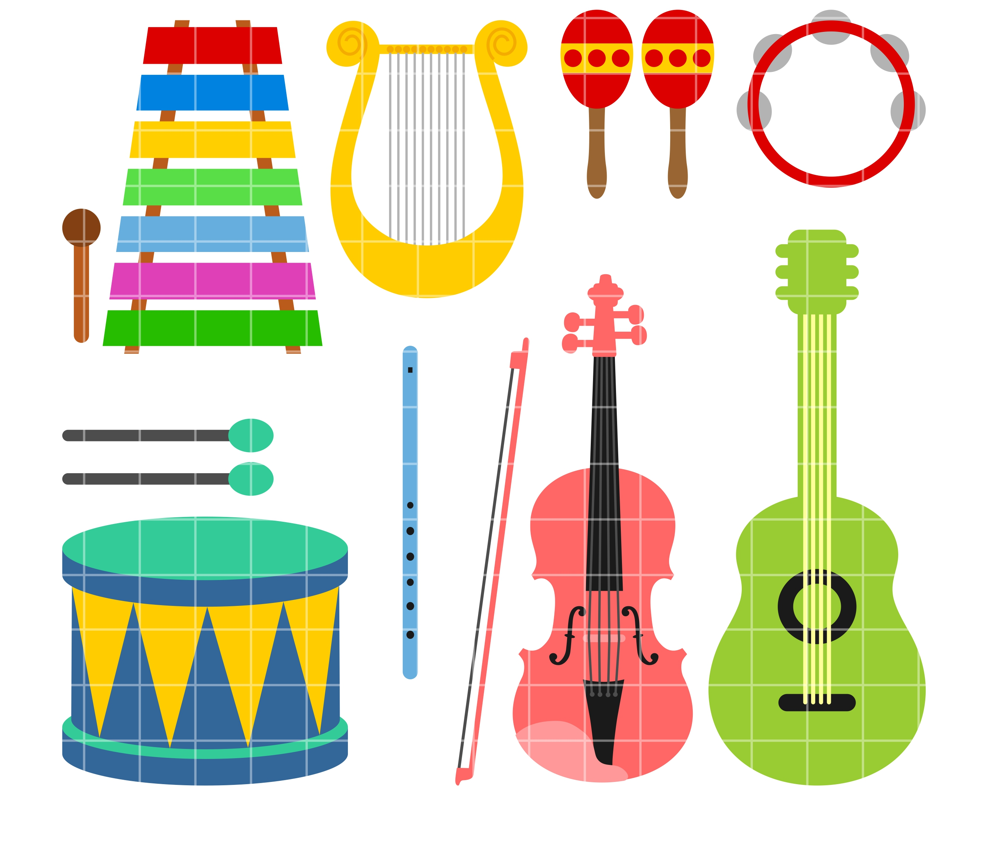 | How many items in your house tell the time? Are they the same? What numbers do you notice on your clocks? Can you make a watch or a clock? It doesn’t have to be out of paper!  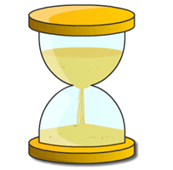
Using equipment from your home, make an assault course. Ask an adult to time you as you complete it. Can you go faster? Can you complete it in different ways?  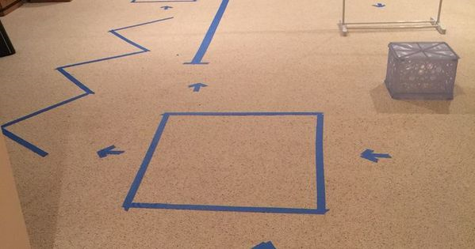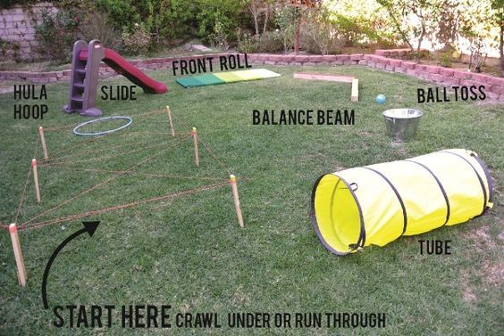 | Please read/share a story 5 times a week. Key questions can include: What were the characters feeling? How else could the story end?   | Continue to use Education City and encourage your child to use technology around the home.  

Can you write an email or letter to a member of your family or a friend?   | Become a scientist. See the attached sheet for your science investigation.   | Use your phonic skills to play hangman, or your number knowledge to create a hopscotch. Don’t forget to take turns.  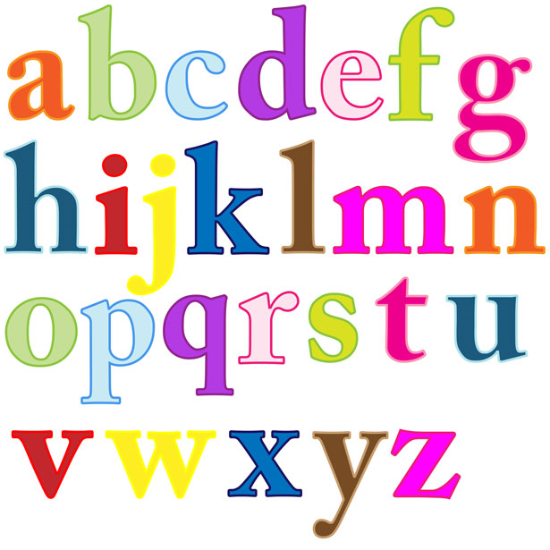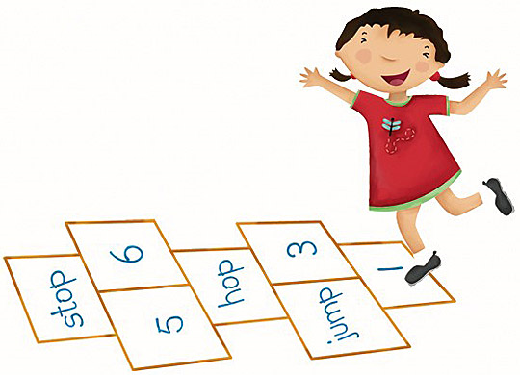
Websites to explore

What is VE day?
https://www.bbc.co.uk/newsround/48201749

Imperial War Museum – 10 photos of VE day
https://www.iwm.org.uk/history/10-photos-of-ve-day-celebrations

Visit the British Legion Website to explore VE day
https://www.britishlegion.org.uk/get-involved/remembrance/remembrance-events/ve-day-75

Explore Time with BBC Bitesize
https://www.bbc.co.uk/bitesize/topics/znyyscw/articles/zvrfpg8

Explore 3D shapes with BBC Bitesize
https://www.bbc.co.uk/bitesize/topics/zf33y9q/articles/zv4fpg8

Tricky words song
https://www.youtube.com/watch?v=3NOzgR1ANc4

Oak National Academy – online Reception lessons
https://www.thenational.academy/online-classroom/reception#subjects

Hungry Little Minds
https://hungrylittleminds.campaign.gov.uk/

