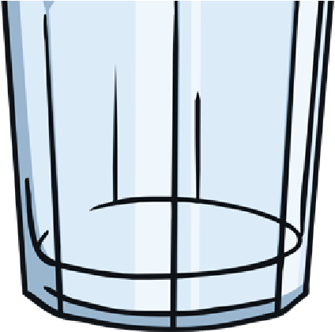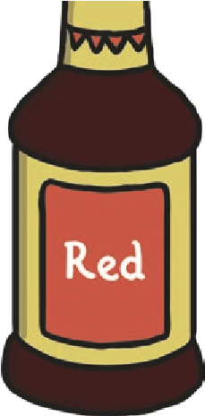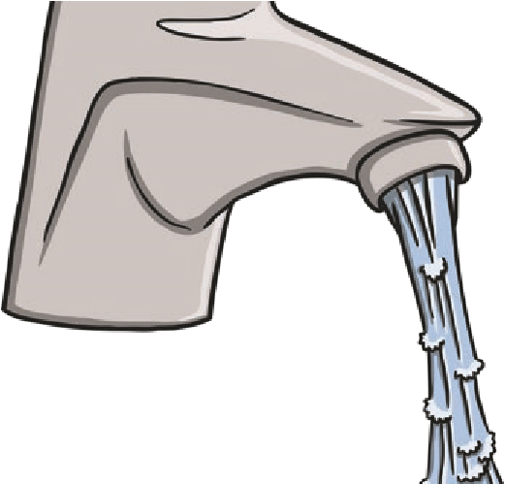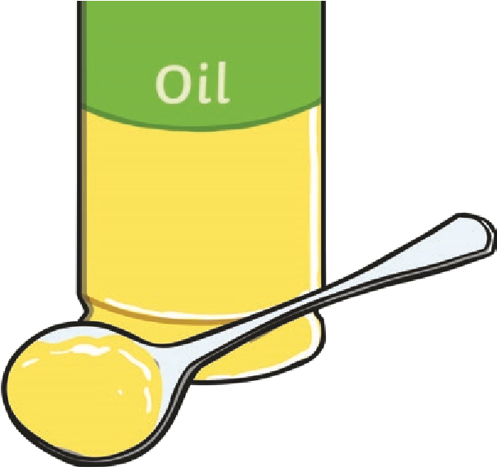

You Will Need
•
Warm Water
•
Oil*
•
A Tall Glass
•
Food Colouring
*
Please dispose of oil safely and responsibly.
This is a very cool, simple and fun experiment, and also completely safe, just don’t drink the water!
Method
- Fill the tall glass with warm water.
- Pour a small amount of oil into another container and add a few drops of food colouring.
- Give it a good stir, if it doesn’t mix, add a bit of water.
- Pour the food colouring and oil mixture into the warm water and watch the fireworks!
Oil and water don’t mix. Also oil is less dense than water (meaning there is less of it in the same volume) and therefore floats on top of water in a nice layer. The food colouring we used was water based and therefore does not mix with the oil, instead it sinks through the oil into the water below. Since the addition of the colouring makes the food colouring heavier than the water, it sinks to the bottom leaving trails (resembling fireworks) as some of the colour diffuses into the water.
The Science Bit

