Many of you have been telling me how you are enjoying sharing stories together. A popular trend is stories by Enid Blyton. I have found a few ideas for you to try at home if you wish to.
Mrs Whitehead
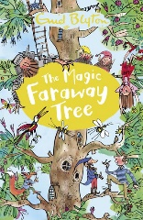The Magic Faraway Tree
Use Duplo, Lego or blocks to create your own faraway tree
Create your own story based on your Faraway Tree adventures
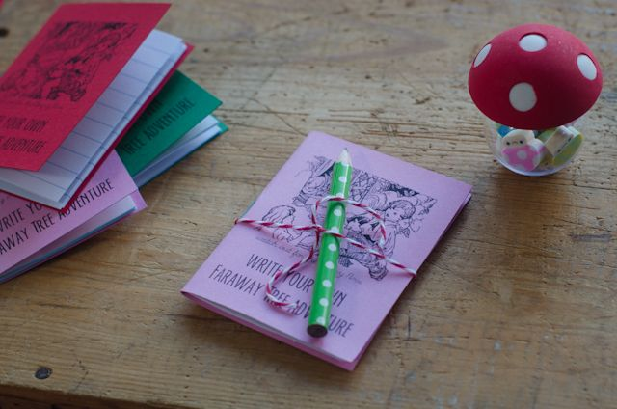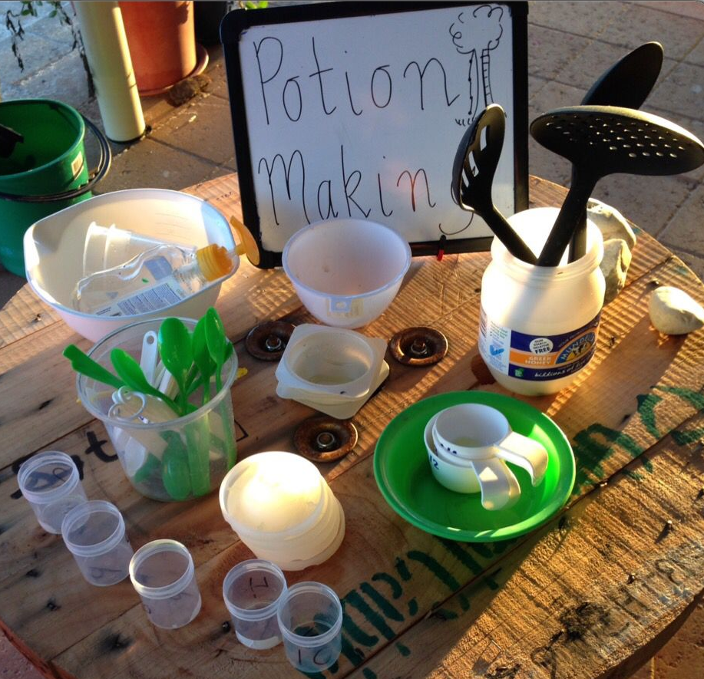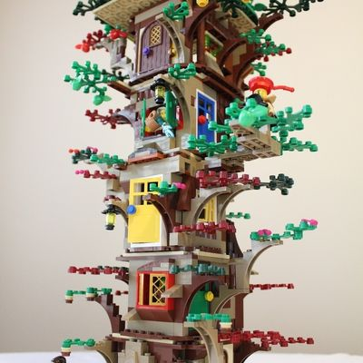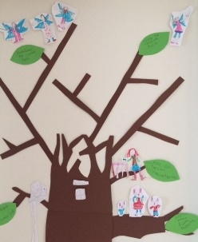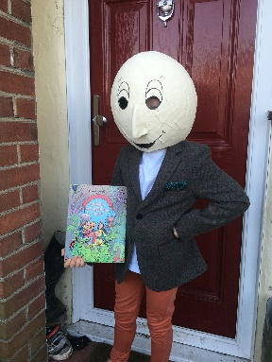
Create your own character outfit!
Be creative and create your own faraway tree! Include your own family in the tree!
Talk about capacity as you make a potion in the garden. Use food colouring, glitter, and water. Do not forget to label your bottles!

What is at the top of the tree?

My favourite land is | My Magic Faraway tree
My favouirte character is | My Magic Faraway tree



