Hello Seahorse Class! We hope you are all safe and well. The activities listed below are possible home learning tasks. Please feel free to email school if you need anything we will answer as soon as we can. Best wishes, Mrs Hawkridge and Mrs Newman

Take part in a scavenger hunt... see below for a list of things to find!  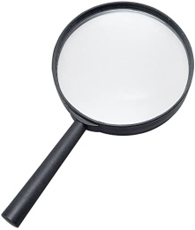 | Try and make a rainbow fruit or salad plate...  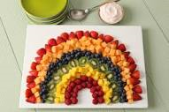 | Investigate different coins, discuss their shape, size, colour and worth. What could you buy at the shop with each coin?  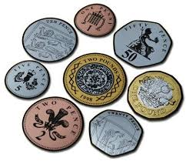
Set up a shop with some of your toys and books, take turns with your grown ups to play the role of customer and shop keeper.  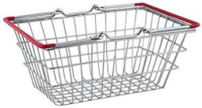 | 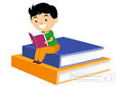  Please read/share a story 5 times a week.. Key questions can include: What do you think will happen next? How is the character feeling? | Can you make a list of rhyming words around your house? How silly can you make it?  You could make some silly soup like Mrs Newman on her video!
Watch the peer massage video attached... practice on your grown up and then take turns.   | Try Comsic Kids yoga, there are videos on You Tube and the children have been practicing some of the moves at school so they will be very good at it!  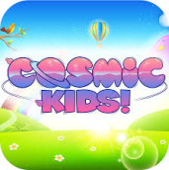 | Continue to use Education City and encourage your child to use technology around the home.
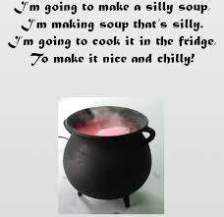
Scavenger Hunt - Indoors
- A toy with wheels
- A book for the first letter of your name in it
- A pair of matching socks
- 4 things that are different shades of blue
- Something very soft
- A toy smaller than your hand
- Something round
- 5 different teddies/blocks
- A photo of someone you love
- A toy that has three different colours
- An item that makes you feel cosy
- Something you can see through
- Something that can be recycled
- Something you can see yourself in
- A book with numbers in.

Scavenger Hunt – Outdoors
- 5 leaves that look different
- A stick that is longer than your hand
- A stone with a pattern on it
- A flower
- A flat stone
- 10 blades of grass
- Something you love to play with
- Something that is brown
- Something made of plastic
- Something that is heavy
- Something that is light
- Something that needs sun to live
- An item smaller than your thumb
- Something that starts with the letter ‘m’
- Something made out of two different materials

