Hello Seahorse Class!
I hope my letter finds you and your families fit and well. I am missing seeing you all and helping you learn and play. I am sure you are all very busy at home and I hope you have been helping your grown ups with jobs around the house!
It’s been lovely hearing from some of you by email, and seeing what you have been up to!
I have been very busy at home and in my garden. My children have been helping me knock a wall down and we have also planted some seeds, we hope to grow carrots, lettuce, tomatoes and sunflowers, maybe I’ll be able to grow one taller than me!
I have been doing some puzzles as well, one was of Harry Potter which was a bit tricky as it was a circle shape and the one I’ve just finished had Big Ben, red double decker buses and back taxis, can you guess which city in England this could be?
I have been taking part in lots of the Joe Wicks exercises but sometimes the next day my body is very achy! I have also been out on my bike for some exercise and fresh air.
I hope to see you all soon,
With Love From
Mrs Hawkridge
P.S Has anyone managed to make the paper plate craft activity?
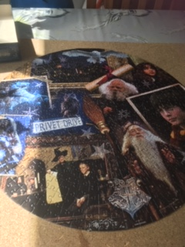
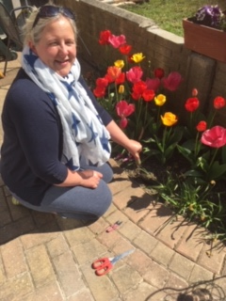 My circular Happy Potter puzzle
Do you know the name of the flowers I’ve been growing in my garden?

Hello Seahorse Class,
I hope you are all safe and well. Are you enjoying spending time with your families?
I miss seeing you at school, especially listening to what you are looking forward to doing in the day.
I have enjoyed reading your emails and seeing the fantastic work you have been completing at home. It all looks really interesting and I can see how much you have all grown in your photos.
Like Mrs Hawkridge, I have been in my garden making sure the flowers and plants are weeded and watered. I have been exercising in my garden too! I am up to 30 laps of the garden. To keep it interesting I have used big steps, little steps, side steps and jogged. I might time myself this week. What type of exercise have you been taking part in?
I made myself a noughts and crosses game out of card which I play with my son. He is very clever and tends to beat me most of the time! But that is fine as I enjoy playing the game. In the garden we also have a hoopla game, where you have to throw hoops on to pegs to earn points.
I have a puzzle I am hoping to start soon, it is 1500 pieces and will take me a while to complete.
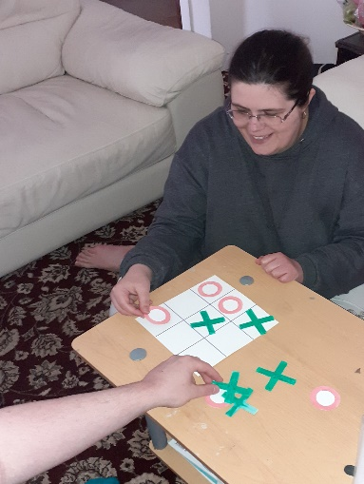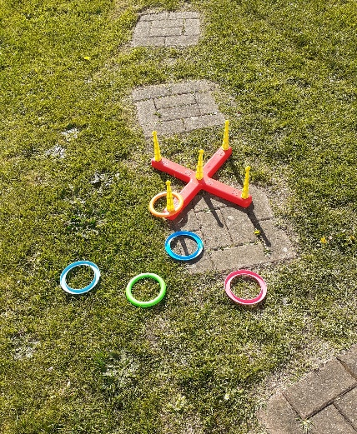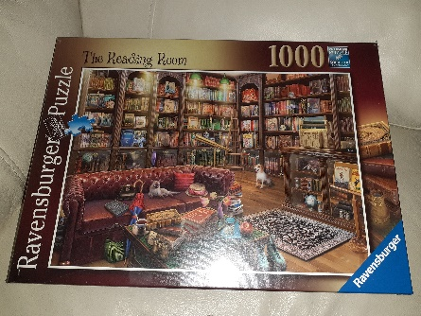
I hope to see you all very soon.
Take Care
Mrs Newman x

