Knowledge Organiser
Science | Year 6 | Term |  |  | Topic: Animals including humans
Prior Knowledge |  | Knowledge and application
Which things are living and which are not.  • Classification of animals  • Animals that are carnivores, herbivores and  omnivores.  • Animals have offspring which grow into adults.  • The basic needs of animals for survival (water,  food, air)  • The importance of exercise, hygiene and a  balanced diet.  • Animals get nutrition from what they eat.  • Some animals have skeletons for support,  protection and movement.  • The basic parts of the digestive system.  • The different types of teeth in humans.  • Respiration is one of the seven life processes.  • The life cycle of a human and how we change  as we grow |  |  | 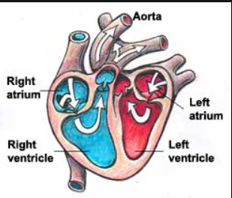  Mammals have hearts with four chambers. Notice how the blood that has come from the body is deoxygenated, and the  blood that has come from the lungs is oxygenated.  again. Human blood is red it is not BLUE: we just show it like that on a diagram  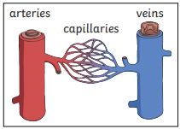  Capillaries are the smallest blood vessels in the body and it is here that the exchange of water, nutrients, oxygen and carbon dioxide takes place.  Blood transports:  • gases (mostly oxygen and carbon dioxide);  • nutrients (including water);  • waste products  The liquid part of blood contains water and protein. This is called plasma
What will I know by the end of this topic? |  | Key Vocabulary
Identify and name the main parts of the  human circulatory system.  • Know the function of the heart, blood  vessels and blood.  • Know the impact of diet, exercise, drugs and lifestyle on health.  • Know the ways in which nutrients and  water are transported in animals  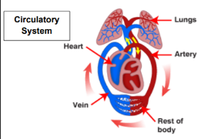  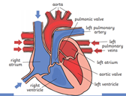 |  | Circulatory system |  | A system which includes the heart, veins, arteries and blood transporting substances around the body.
 |  | heart |  | An organ which constantly pumps blood around the circulatory system
 |  | Blood vessels |  | The tube-like structures that carry blood through the tissues and organs. Veins, arteries and capillaries are the three types of blood vessels.
 |  | oxygenated |  | Oxygenated blood has more oxygen. It is pumped from the heart to the rest of the body.
 |  | Deoxygenated blood |  | Deoxygenated blood is blood where most of the oxygen has already been transferred to the rest of the body.
 |  | drug |  | A substance containing natural or man-made  chemicals that has an effect on your body when it  enters your system.
 |  | alcohol |  | A drug produced from grains, fruits or vegetables when they are put through a process called fermentation
 |  | nutrients |  | Substances that animals need to stay alive and healthy
 |  | veins |  | Tubes that carry de-oxygenated blood back towards the heart
 |  | ventricles |  | The two lower chambers in the heart
 |  | arteries |  | Muscular-walled tubes that transport blood away from the heart to other parts of the body
 |  | atriums |  | The two uppermost chambers of the heart. Blood is pushed from the atriums to the ventricles
 |  | blood |  | Circulates in arteries and veins, carrying oxygen to and carbon dioxide from tissues of the body

