Knowledge Organiser
Science | Year 6 | Term |  |  | Topic: Light
Prior Knowledge |  | Knowledge and application
Certain things produce light, usually by burning (e.g. the Sun) or electricity (e.g. streetlights)  Shiny materials do not make light but do reflect it.  Shadows are caused when certain materials block light.  Light travels in straight lines. When light is blocked by an opaque object, a dark shadow is formed.  The further away the light source is, the smaller the shadow is. The closer the source of the light, the bigger the shadow. |  |  | We need light to be able to see things, Light waves travel out from sources of light in straight lines. These lines are often called rays of light.  Light from the sun travels in a straight line and hits the object. The light ray is then reflected off the object and travels in a straight line to the human eye, enabling us to see the object.  Light travels as a wave. But unlike waves of water or sound it does not need a medium to travel through. This means that light can travel through a vacuum- a completely airless space.
What will I know by the end of this topic? |  | Key Vocabulary
Know that light travels in straight lines.  Understand that because light travels in  straight lines objects are seen because  they give out or reflect light into the eye.  Know that we see things because light  travels from light sources to our eyes or  from light sources to objects and then to  our eyes.  Know that light travels in straight lines  and therefore, shadows have the same  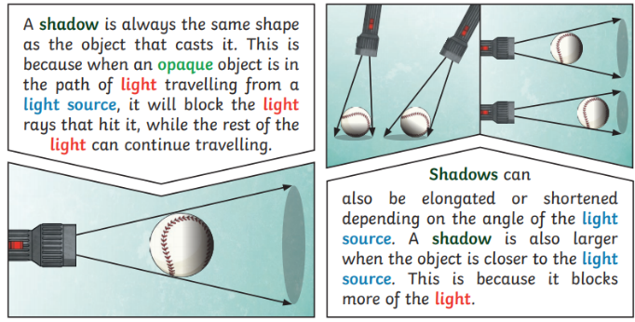  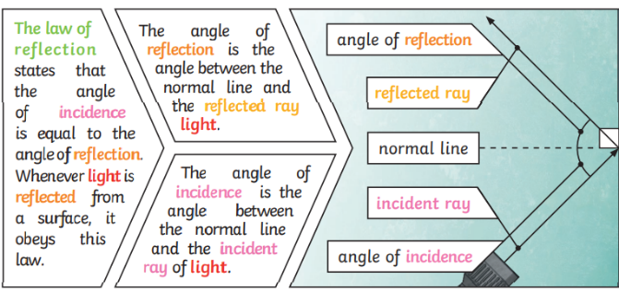  shape as the objects that cast them |  | Absorb |  | Take in or soak up by chemical or physical action
 |  | Angle |  | The direction from which you look at something
 |  | Light |  | A type of energy that makes it possible for the eye to see
 |  | Light source |  | An object that makes its own light
 |  | Opaque |  | Not able to be seen through; not transparent
 |  | Visible spectrum |  | Light that is visible to human eye. It is made up of a colour spectrum
 |  | Prism |  | A solid geometric figure whose two ends are similar, equal, and parallel rectilinear figures, and whose sides are parallelograms.
 |  | Incident ray |  | A ray of light that hits the surface
 |  | Reflected ray |  | A ray of light that has bounced back after hitting a surface.
 |  | The law of reflection |  | The law states that the angle of the incident ray is equal to the angle of the reflected ray.
 |  | Reflective |  | A surface that allows light or heat to bounce off it
 |  | Refraction |  | Light rays change speed when they pass across the boundary between two states of matter, such as gas and liquid. This causes them to change direction and this effect is called refraction
 |  | Shadow |  | A dark area or shape produced by a body coming  between rays of light and a surface
 |  | Translucent |  | (of a substance) allowing light, but not detailed  shapes, to pass through; semi-transparent
 |  | Transparent |  | (of a material or article) allowing light to pass  through so that objects behind can be distinctly seen

