Knowledge Organiser
Science | Year 6 | Term |  | Topic: Evolution and Inheritance
Prior Knowledge |  | Knowledge and application
Know the life cycle of different living things, e.g. Mammal, amphibian, insect and bird.  Know the differences between different lifecycles.  Know the process of reproduction in plants.  Know the process of reproduction in animals.  Know how to create a timeline to indicate stages of growth in humans. |  | Animals and plants produce offspring that are similar but not identical to them. Offspring often look like their parents because features are passed on.  Eye colour, hair colour is an inherited trait but so are things like the shape of your earlobes and whether you can smell certain flowers.  A habitat provides shelter, water, enough space and planet of food.  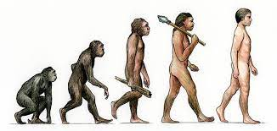  Evolution is the gradual process by which different kinds of living organisms have developed from earlier forms over millions of years. Scientists have proof that living things are continuously evolving-even today!
What will I know by the end of this topic? |  | Key Vocabulary
Evolution is a scientific theory used by  biologists. It explains how living things changed over a long time, and how they have come to be the way they are.  We know that living things have changed over time, because we can see their remains in the rocks (fossils)  We know that the animals and plants of today are different from those of long ago.  Evolutionary questions are still being actively researched by biologists.  Some environments provide challenges, yet some animals and plants have adapted to survive there.  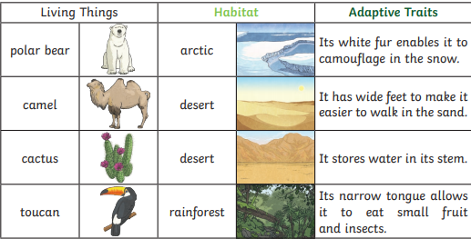  Sometimes adaptations can be disadvantageous. |  | Adaptation | Adaptation is the process by which animals,  plants and other living things have changed so  that they better suit their habitat.
 |  | Charles Darwin | Charles Darwin was an English scientist who. studied nature. He is known for his theory of evolution.
 |  | Chromosomes | Tiny structures inside cells made from DNA and  protein.
 |  | DNA | A substance that carries genetic information in plants and animals (short for deoxyribonucleic acid)
 |  | Evolution | The theory that all the kinds of living things that  exist today developed from earlier types.
 |  | Genes | Genes that are passed on to you determine. many of your traits, such as your hair colour and skin colour.
 |  | Gene mutation | Random changes between parent and offspring
 |  | inheritance | When living things reproduce, they pass on.  characteristics to their offspring. This is known as inheritance
 |  | Natural selection | The idea that living things survive better (and  reproduce more) if they that are better adapted. to a habitat. First proposed by Charles Darwin
 |  | Off-spring | Babies: all living things produce offspring of the same kind, but normally offspring are not identical to their parents
 |  | reproduce | Give birth / make seeds / eggs
 |  | variation | The difference between individuals within a species
 |  | fossils | The remains or imprint of a prehistoric plant or animal embedded in rock and preserved.

