Knowledge Organiser
Science | Year 6 | Term |  | Topic: Electricity
Prior Knowledge |  | Knowledge
Electricity is a form of energy that can be carried by wires and is used for heating and lighting, and to provide power for devices.  • Sources of light and sound may need electricity to work.  • Where electricity cones from  • Which appliances need electricity  • What a circuit is, the components of a  circuit and how it works.  • What electrical conductors and insulators are.  • What happens when a switch is added to a circuit. |  | Series Circuit  A circuit that has only one route for the current to take. If more bulbs or buzzers are added, the power has to be shared and so they will be dimmer or quieter. If just one part of this series circuit breaks, the circuit is broken and the flow of current stops.  What will make a bulb brighter or a buzzer louder?  More batteries or a higher voltage create more  power to flow through the circuit.  Shortening the wires means the electrons have  less resistance to flow through.  What will make a bulb dimmer or a buzzer quieter?  Fewer batteries or a lower voltage give less power to the circuit.  More buzzers or bulbs mean the power is shared by more components.  Lengthening the wires means the electrons have to travel through more resistance
What will I know by the end of this topic?
Know that the brightness of a bulb is associated with the voltage.
Compare and give reasons for variations in how components function.
Use recognised symbols when representing a simple circuit in a diagram.
Construct simple series circuits.
Be able to answer questions about what happens when different components are tried: switches, bulbs, buzzers and motors.
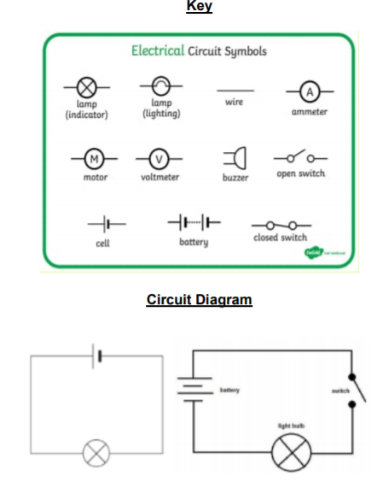
 |  | Key Vocabulary
 |  | circuit | A pathway that electricity can flow aroun
 |  | symbol | A visual picture that stands for soethig else
 |  | Cell/battery | A device that stores energy as a chemical until it is needed. A cell is a single unit. A battery is a collection of cells.
 |  | current | The flow of electrons, measured in amps
 |  | amps | How electric current is measured.
 |  | voltage | The force that makes the electric current move through the wires. The greater the voltage, the more current will flow
 |  | resistance | The difficulty that the electric  current has when flowing around a circuit.
 |  | electrons | Very small particles that travel  around an electrical circuit

