Knowledge Organiser
Science | Year 5 | Term |  | Topic: Animals including humans
Prior Knowledge |  | Knowledge and application
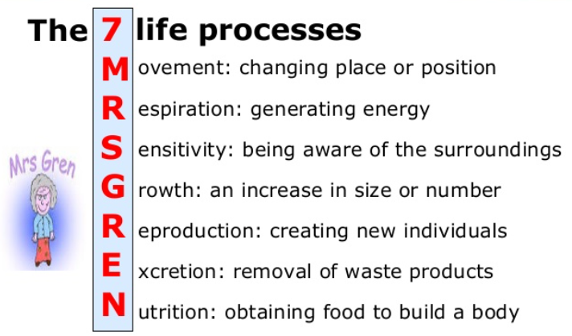 |  | What are the main stages of the human life cycle?  foetus - an unborn animal or human being in the very early stages of development  newborn - this is a baby that has just been born.  infancy - this is a period of rapid change. Many toddlers learn to walk and talk at this stage.  childhood - children learn new things as they grow. They become more  independent.  adolescence - this is when the body starts to change and prepare itself for adulthood. Hormonal changes take place over a few years.  early adulthood - this is when humans are usually at their fittest and strongest.  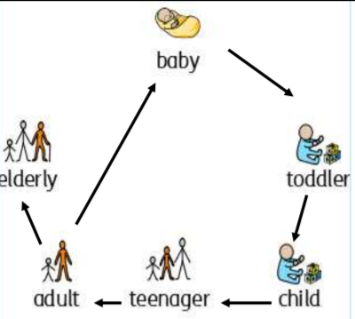  middle adulthood - changes such as hair loss may happen. There are also some  hormonal changes again and the ability to reproduce decreases.  late adulthood - there is a decline in fitness and strength  Puberty is the change that happens in late childhood and adolescence where the body starts to change because of hormones.
What will I know by the end of this topic? |  | Key Vocabulary
I know the main stages of the human life cycle. I can name these stages and can explain what happens during each one.  Puberty is the change that happens in late childhood and adolescence. It is where the body starts to change because of hormones.  During puberty, the bodies of boys and girls begin to change.  Some changes include growth in height,  more sweat, hair growth on arms and legs, under the armpits and on genitals, and growth in parts of the body such as male genitals and breasts.  During puberty, females begin to menstruate.  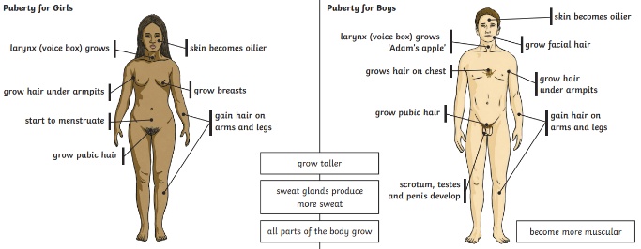 |  | Gestation | The process in which babies grow inside their mother’s body before they are born.
 |  | Genitals | The reproductive organs
 |  | Hormones | A chemical, usually occurring naturally in your bod, that makes an organ of your body do something
 |  | Infancy | The period of your life when you are a very young child.
 |  | Adolescence | The period of your life in which you develop from being a child into being an adult
 |  | mature | When a child or young animals matures, they become an adult
 |  | Life cycle | The series of changes that an animal or plant passes through from the beginning of its life until its death
 |  | Life process | There are seven things that tell us that living things are alive.
 |  | puberty | The stage in someone’s life when their body starts to become physically mature
 |  | reproduction | When an animal or plant produces one or more individuals similar to itself.
 |  | menstruation | The approximately monthly discharge of blood by non-pregnant women from puberty to the menopause
 |  | menopause | The time during which a woman gradually stops menstruating, usually when she is around 50 years old.
 |  | Life expectancy | The length of time on average a particular animal is expected to live.

