Knowledge Organiser
Science | Year 5 | Term | Topic: Living things and their habitats
Prior Knowledge |  | Knowledge and application
Animals can be grouped into vertebrates (and then further into fish, reptiles, amphibians, birds and mammals) and invertebrates.  Some examples of life cycles (including those of plants and humans)The processes of dispersal, fertilisation and germination.  Reproduction is one of the seven life processes.  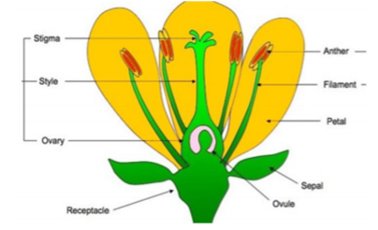  Parts of a plant, their features and what their  functions are. |  | Humans develop inside their mothers and are depedent on their parents for many years until they are old enough to look after themselves.  Amphinibans usch as frogs are laid in eggs then, once hatched, go through many changes until they become and adult.  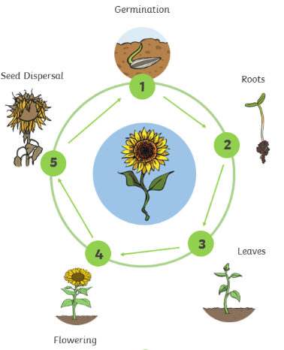  Some animals, such as butterflies, go through metamorphosis to become an adult.  Birds are hatched from eggs and are looked after by their parents until they are able to live independently.  Some living things, such as plants, contain both the male and female sex cells. In others, such as human, they contains either the male or female sex cell.  Most plants contain both the male sex cell (pollen) and female sex cell (ovules) but most plants can’t fertilise themselves. Wind and insects help to transfer pollen to a different plant. The pollen from the stamen of one plant is transferred to the stigma of another. The pollen thentravels down a tube through the style and fuses with an ovule
What will I know by the end of this topic?
Be able to describe the differences in the life cycles of a mammal, an amphibian, an insect and a bird.
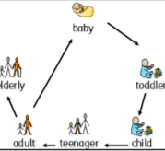
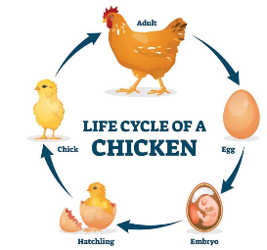
To describe the life processes of reproduction in some plants and animals.

Know that reproduction is when an animal or plant produces one or more individuals similar to itself.

Know what metamorphosis is and which type of animals go through it.

Know about the work of a famous naturalist.

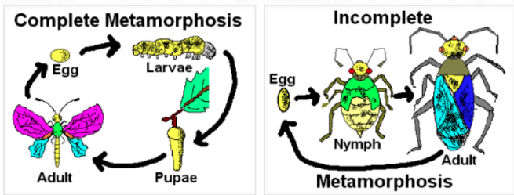
Know the different types of reproduction including sexual and asexual reproduction in plants, and sexual reproduction in animals.
 |  | Key Vocabulary
 |  | gestation |  | The period of time that a mammal carries her off-spring, or babies, inside her body before giving birth.
 |  | fertilisation |  | Male and female gametes meet to form an embryo or seed
 |  | gamete |  | The two types of male and female cell that join together to make a new creature
 |  | embryo |  | An animal or a plant in its earliest stage of development.
 |  | metamorphosis |  | A person or thing develops and changes into something completely different.
 |  | Life cycle |  | The series of changes that an animal or plant passes through from the beginning of its life to its death.
 |  | reproduction |  | When an animal or plant produces one or more  individuals similar to itself
 |  | pollination |  | To pollinate a plant or tree means to fertilise it with pollen. This is often done by insects
 |  | germination |  | The development of plant from a seed.
 |  | ovary |  | A female organ which produces eggs
 |  | ovule |  | A small egg.
 |  | stigma |  | The part that gets pollen from pollinators such as bees.

