Knowledge Organiser
Science | Year 5 | Term |  | Topic: Forces
Prior Knowledge |  | Knowledge and application
That some forces need contact between two  objects but magnetic forces can act at a distance.  Know that magnets attract some objects but not others.  The strength of the force determines how far and fast an object moves.  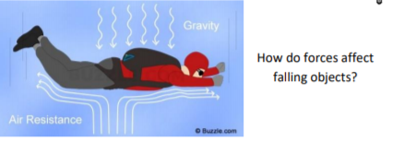  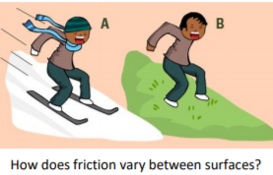  Friction is the resistance of motion when there is contact between two surfaces. |  | Mass is how much matter is inside an object. It is measured in kg.  Isaac Newton is famously thought to have developed his tehory of gravity when he saw an apple fall to the ground from an apple tree.  Weight is how strongly gravity is pulling an object down. It is meaaured in newtons (N).  Water resistance and air resistance are forms of friction. Fricition is sometimes helpful and sometimes unhelpful eg air resistance is helpful as it stops the skydiver hit the ground at high speed, Friction on a bike chain can make the bike harder to pedal so it is unhelpful.  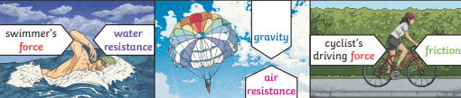
What will I know by the end of this topic? |  | Key Vocabulary
Be able to explain that unsupported objects fall  towards the Earth because of the force of  gravity acting between the Earth and the falling  object.  Know what gravity is and its impact on our lives.  Gravity is the force that pulls objects to the  centre of the Earth.  Identify and know the effect of air resistance.  Air resistance pushes up on the parachute,  opposing the force of gravity. This makes the  parachute land more slowly.  Identify and know the effect of water resistance.  Water resistance is the friction that is created  between water and an object that is moving  through it.  Identify and know the effect of friction.  To recognise that some mechanisms, including levers, pulleys and gears, allow a smaller force to have a greater effect  Know who Isaac Newton and Galileo were.  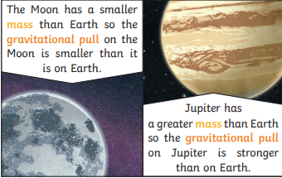 |  | Newton | Newton developed the theory of gravity and made breakthroughs in the area of optics, such as the reflecting telescope.
 |  | Galileo | Galileo developed the telescope to enable close observation of the night sky
 |  | Friction | Friction is a force between two surfaces that are sliding, or trying to slide, across each other.
 |  | Gravity | Gravity is a force which tries to pull two objects towards each other.
 |  | Air resistance | Air resistance is a type of friction between air and another material. e.g. when an aeroplane flies through the air.
 |  | Water resistance | If you go swimming, there is friction between your skin and the water particles.
 |  | streamlined | When an object is shaped to minimise the effects of air or water resistance.
 |  | Earths gravitational pull | The pull that Earth exerts on an object, pulling it towards Earth’s centre. It is the Earth’s gravitational pull which keeps us on the ground.
 |  | buoyancy | An object is buoyant if it floats. This is because the weight of the object is equal to the upthrust.
 |  | Upthrust | A force that pushes objects up, usually in a fluid
 |  | motion | The action or process of moving or being moved

