Knowledge Organiser
Science | Year 5 | Term |  | Topic: Earth and Space
Prior Knowledge |  | Knowledge and application
There are four seasons (autumn, winter, spring and summer).  The Sun is a source of light but the Moon is not.  Know that a shadow is caused when an object blocks light from passing through it.  To know the history of space travel.  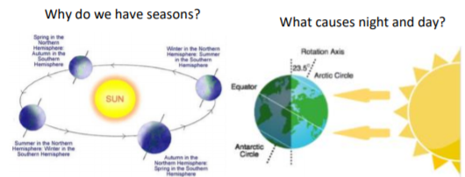 |  | Mercury, Venus, Earth and Mars are rocky planets. They are mostly made up of metal and rock. Jupiter, Saturn, Uranus and Neptune are mostly made up of gases (helium and hydrogen) although they do have cores made up of rock and metals.  The Moon orbits the Earth in an oval shapes path while spinning on its axis. At varios times in a month, the Moon appears to be different shapes. This is because as the Moon rotates round Earth, the Sun lights up different parts of it.  The Sun does not move across the sky at all, it is the Earth that rotates during the day.  The Earth rotates (spins) on its axis. It does a full rotations once in every 24hrs. At the same time that the Earth is rotating it is also orbiting around the sun. It takes a little more than 365 days to orbit the Sun. Daytime occurs when the side of Earth is facing the Sun. Nightime occurs when the side of Earth is facing away from the Sun.
What will I know by the end of this topic? |  | Key Vocabulary
I can describe the movement of the Earth, and other planets, relative to the Sun in the solar system.  I can describe the movement of the Moon in relation to the Earth.  I can describe the Sun, Moon and Earth as approximate spherical bodies.  I can describe day and night in relation to the Earth’s rotation.  I know that the Earth orbits the Sun in one year.  We can see the Moon because the Sun’s light reflects off it.  The Moon orbits the Earth in approximately 28 days.  Changes to the appearance of the Moon are evidence of this.  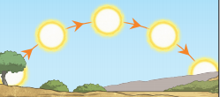  The Sun appears to move across the sky from East to West and this causes shadows to change during the day.  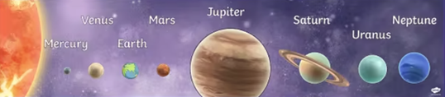  Changes to shadow length during the day and changes to sunrise and sunset times over the year are evidence supporting the movement of the Earth. |  | orbit | An orbit is a repeating path that one celestial body takes around another
 |  | Solar system | The solar system is made of the eight planets that orbit our sun; it is also made of asteroids, moons, comets and lots more.
 |  | axis | An imaginary line that a body rotates around e.g. Earth’s axis runs from the North Pole to the South Pole
 |  | rotation | Rotation is when a shape is turned around a fixed point
 |  | spherical | Something spherical is like a sphere in being round, or more or less round, in three dimensions.
 |  | satellite | Any object or body in space that orbits something else, e.g. the moon is a satellite of Earth
 |  | Sun | A huge star that Earth and the other planets in our system orbit around.
 |  | star | A giant ball of gas held together by its own gravity.
 |  | moon | A natural satellite which orbits Earth or other planets.
 |  | planet | There are 8 planets in our solar system, they are Mercury, Venus, Earth, Mars, Jupiter, Saturn, Uranus and Neptune
 |  | Geocentric model | A belief people used to have that other planets and the Sun, orbited around Earth
 |  | heliocentric | The structure of the Solar System where the planets orbit around the Sun.
 |  | lunar | anything related to the moon.

